

# Acknowledgement

I would like to express my deepest gratitude to my FYP supervisor, Ms. Mary Ting, who has been supporting and guiding me towards the accomplishment of this project. I am thankful for her resolve and sheer dedication and commitment for my academic growth through her packed schedule by allowing me to have time to talk and ask for advice regarding my project. Her feedbacks and advice has allowed me to fix, improve and steering this project to the right direction.

I would also express my appreciation to Dr. Dewi Octaviani who has been a wonderful lecturer and FYP manager that provides clear and clarity guidance to all the students. With the help of Dr. Dewi during the briefing and investigation sessions, I am able to come up with the idea of this project and am assured about the viability of the project. Dr. Dewi has also provided excellent briefing, guidance, and reference on how to complete the Final Year Project.

Finally, I would also honor my family and friends who have been alongside me and supporting me throughout all the hard times. Every person has been very impactful towards the accomplishment of this project, and I am forever grateful to all of them by staying by my side.

# Abstract

Corn has been one of the main food resources that has been highly consumed by humans. The existence of crop diseases poses a lethal threat to food security and also terrestrial and ecosystem damage as well, relating to one of the Sustainable Development Goals (SDG) 15 about Life on Land.

This research aims to tackle this issue by developing an efficient and accurate technological solution to detect and predict corn crop diseases. Utilizing data-driven solutions based on corn leaf images, an image recognition solution is developed through image classification and object detection. Through the data mining methodology of CRISP-DM, the researcher can perform data understanding and data preprocessing phases on the image datasets. These include performing basic EDA and preprocessing such as normalizing the image. Feature Extraction, a crucial step in image recognition and classification, is able to extract multiple features from the image namely color features, texture such as Gabor Feature, Haralick Feature, and also Contour detection. Through this step, the researcher aligns the aim of this project to SDG 15 by mitigating any risk of crop damage which can further lead to degrading terrestrial life.

*Keywords: Image Recognition, Image Classification, Object Detection, Feature Extraction, Gabor Feature, Haralick Feature, Contour.*

**Sustainable Development Goals 15: Protect, restore and promote sustainable use of terrestrial ecosystems, sustainably manage forests, combat desertification, and halt and reverse land degradation and halt biodiversity loss**

Table of Contents

Acknowledgement 2

Abstract 3

1 Introduction 14

1.1 Introduction 14

1.1.1 Significance of Corn Crops 14

1.1.2 Relation to Sustainable Development Goals 15 14

1.1.3 Approach on the Issue 15

1.2 Problem Background 15

1.3 Project Aim 17

1.4 Objectives 17

1.5 Scope 17

1.5.1 Dataset 17

1.5.2 Deliverables 17

a. Data Understanding and Data Preprocessing 17

b. Feature Extraction and Image Processing technique 18

c. Model Training 18

d. Model Evaluation 19

1.5.3 Constraint & Project Boundaries 19

1.6 Potential Benefits 20

1.6.1 Tangible Benefits 20

1.6.2 Intangible Benefits 20

1.6.3 Target user 21

1.7 Overview of the IR 22

1.8 Investigation Report Plan 23

2 Literature review 25

2.1 Introduction 25

2.2 Domain Research 25

2.2.1 Understanding Corn Disease and Implication for Detection 25

2.2.2 Technological Solution on Detecting Corn Disease 27

2.2.3 Image-based Method of Maize Diseases Detection 27

2.2.4 Computer Vision: Further Options for Corn Disease 29

2.2.5 Challenges in Computer Vision 30

2.2.6 Bounding Boxes: Effect on Quality of Data 31

2.2.7 Feature Extractions: An Analytical Approach for Image 31

2.2.8 Machine Learning Algorithms for Prediction 33

2.2.9 Object Detection Models in TensorFlow 37

2.2.10 Model Evaluation Method 39

2.3 Similar Systems/Work 43

2.4 Technical Research 51

2.4.1 Python Programming Language 51

2.4.2 Jupyter Notebook in Visual Studio Code 51

2.4.3 Pandas, NumPy, matplotlib: Tools for data analytics 52

2.4.4 Scikit-learn 54

2.4.5 Tensorflow and Keras 54

2.5 Summary 55

3 Methodology 58

3.1 Introduction 58

3.2 Methodology 58

3.2.1 Introduction of CRISP-DM 58

3.2.2 Selected Methodology 59

3.2.3 Steps and Phases of CRISP-DM and Relation to Image Processing 60

3.3 Data Collection 61

3.4 Data Understanding 62

3.4.1 Data Import and File Directory 62

3.4.2 Image Distribution of both dataset 65

3.4.3 Initial Preprocessing: Merging both datasets 67

3.4.4 Sample Images of all Classes 69

3.4.5 Image and Class Distribution for the Merged Dataset 70

3.4.6 Pixel Intensity of Each Class label 71

3.4.7 Color Analysis 72

3.4.8 Image Resolutions 76

3.5 Data Preprocessing/ Data Preparation 79

3.5.1 Image Resizing 80

3.6 Feature Extraction Process 81

3.6.1 Edge detection 82

3.6.2 Contour Feature 83

3.6.3 Gabor Feature 92

3.6.4 Gray Level Cooccurrence and Haralick Feature 95

3.6.5 Feature Extraction to CSV File 98

3.7 EDA and Processing for Extracted Feature 101

3.7.1 EDA and Overview of the Data Frame 101

3.7.2 Imputing missing and invalid values 126

3.7.3 Normalization of Variables with High Standard Deviation 127

3.7.4 Outliers and Skewness 127

3.7.5 Undersampling the data 128

3.7.6 Detail Exploration of the Processed Data 129

4 Conclusion 138

4.1 Achievement of the Investigation Report 138

4.2 Justification of the Investigation/Research 138

4.3 Further Exploration and Improvement 139

5 References 140

6 Appendix 152

6.1 Appendix A: PPF 152

6.2 Appendix B: Fast Track Ethics Form 168

6.3 Appendix C: Log Sheets 172

6.4 Appendix D: Gantt Chart 176

List of Figures

Figure 2.2.1‑1 Corn leaf infected by Common Rust (Mishra et al., 2020) 26

Figure 2.2.1‑2 Corn leaf infected by Northern Blight (Mishra et al., 2020) 26

Figure 2.2.3‑1 Dataset of corn disease classification (Mishra et al., 2020) 28

Figure 2.2.3‑2 Process Flow of Supervised Learning for Image Data (Mahadevkar et al., 2022) 28

Figure 2.2.4‑1 Types of Computer Vision (Khan & Al-Habsi, 2020) 29

Figure 2.2.6‑1 Example of a good, annotated image (Kuznetsova et al., 2020) 31

Figure 2.2.8‑1 Elbow Method to determine K values (Yuan & Yang, 2019) 34

Figure 2.2.8‑2 A graph of SVM (Chandra & Bedi, 2021) 35

Figure 2.2.8‑3 Random Forest Architecture (Zhang et al., 2020) 36

Figure 2.2.8‑4 Layer of CNN by (Hussain et al., 2019), 36

Figure 2.2.9‑1 R-CNN Architecture (Ren et al., 2017) 38

Figure 2.2.9‑2 Example of the Grid-image done by YOLO (Mittal et al., 2019) 39

Figure 2.2.9‑3 Performance between Fast R-CNN, Faster R-CNN, and YOLO (Deshpande et al., 2020) 39

Figure 2.2.10‑1 Sample of Confusion Matrix (Luque et al., 2019) 40

Figure 2.2.10‑2 Formula for Accuracy (Grandini et al., 2020) 40

Figure 2.2.10‑3 Formula for Precision (Grandini et al., 2020) 40

Figure 2.2.10‑4 Formula for Recall (Grandini et al., 2020) 41

Figure 2.2.10‑5 Formula for Specifitiy / False Negative Rate (Tharwat, 2020) 41

Figure 2.2.10‑6 Formula for F1 Score (Grandini et al., 2020) 41

Figure 2.2.10‑7 Sample of ROC (Tharwat, 2020) 42

Figure 2.2.10‑8 Sample of AUC for 2 different models (Tharwat, 2020) 42

Figure 2.4.2‑1 Sample of Jupyter Notebook in Visual Studio Code plotting a graph using numpy and matplotlib from Python (Working With Jupyter Notebooks in Visual Studio Code, 2021) 52

Figure 2.4.3‑1 Pandas dataframe (Sapre & Vartak, 2020) 53

Figure 2.4.3‑2 Pandas reading csv file (Sapre & Vartak, 2020) 53

Figure 2.4.3‑3 Code snippet to plot a simple line plot using matplotlib (Tosi, 2009) 53

Figure 2.4.3‑4 Line plot result using matplotlib (Tosi, 2009) 54

Figure 3.2.1‑1 Flow of CRISP-DM (Hotz, 2023) 59

Figure 3.4.1‑1 Function to visualize the directory structure 62

Figure 3.4.1‑2 Part of the directory of dataset1 63

Figure 3.4.1‑3 Part of directory of dataset 2 64

Figure 3.4.2‑1 Code to generate image distribution plot 65

Figure 3.4.2‑2 Image and Class distribution of dataset 1 66

Figure 3.4.2‑3 Code to create image distribution of dataset 2 66

Figure 3.4.2‑4 Image and Class distribution of dataset 2 67

Figure 3.4.3‑1 Code to merged both datasets 68

Figure 3.4.4‑1 Code to generate sample images of each class 69

Figure 3.4.4‑2 Sample Images of 4 Classes 69

Figure 3.4.5‑1 Code to perform image and class distribution for the merged dataset 70

Figure 3.4.5‑2 Image and Class Distribution in the merged dataset 70

Figure 3.4.6‑1 Code to calculate and plot pixel intensity of the images. 71

Figure 3.4.6‑2 Average Pixel Intensity Histogram for Each Class 72

Figure 3.4.7‑1 Code to generate the color histogram for ecah class 73

Figure 3.4.7‑2 Average Color Histograms of Blight 74

Figure 3.4.7‑3 Average Color Histogram of Common_Rust 74

Figure 3.4.7‑4 Average Color Histograms of Gray_Leaf_Spot 75

Figure 3.4.7‑5 Average Color Histograms of Healthy 75

Figure 3.4.8‑1 Code to create scatter plot of width and height of the dataset 76

Figure 3.4.8‑2 Image Resolutions scatter plot 77

Figure 3.4.8‑3 Average widths and heights of the dataset 77

Figure 3.4.8‑4 Code to calculate aspect ratio 78

Figure 3.4.8‑5 Distribution of Image Aspect Ratios 79

Figure 3.5.1‑1 Code to resize image 80

Figure 3.5.1‑2 The resolution of the processed dataset 81

Figure 3.6.1‑1 Code to perform edge detection 82

Figure 3.6.1‑2 Code to show the sample edge filtered images 83

Figure 3.6.1‑3 Edge Filtered Images 83

Figure 3.6.2‑1 Function to calculate the damage and contour areas 84

Figure 3.6.2‑2 Function to plot the original and contour image 84

Figure 3.6.2‑3 Code to iterate through sample images 85

Figure 3.6.2‑4 Contour Result of Blight 86

Figure 3.6.2‑5 Contour Result of Common_Rust 86

Figure 3.6.2‑6 Contour Result of Gray_Leaf_Spot 87

Figure 3.6.2‑7 Contour Result of Healthy 88

Figure 3.6.2‑8 Contours of Blight 89

Figure 3.6.2‑9 Contours of Common_Rust 90

Figure 3.6.2‑10 Contours of Gray_Leaf_Spot 90

Figure 3.6.2‑11 Contours of Healthy 91

Figure 3.6.3‑1 Function to calculate and plot Gabor feature 92

Figure 3.6.3‑2 Iterating through the dataset and calling Gabor function 92

Figure 3.6.3‑3 Parameters of getGaborKernel() from (GfG, 2023f) 92

Figure 3.6.3‑4 Gabor Response of Blight 93

Figure 3.6.3‑5 Gabor Response of Common_Rust 93

Figure 3.6.3‑6 Gabor Response of Gray_Leaf_Spot 94

Figure 3.6.3‑7 Gabor Response of Healthy 94

Figure 3.6.4‑1 Function to calculate the gray level coocurence matrix 95

Figure 3.6.4‑2 Code to apply the GLCM and printing out the Haralick feature 96

Figure 3.6.4‑3 Sample result of the GLCM and haralick feature 96

Figure 3.6.4‑4 Bar Graph of the GLCM and haralick feature 97

Figure 3.6.5‑1 Function to calculate average color and color ratio 98

Figure 3.6.5‑2 Code to extract all the features to a csv file 99

Figure 3.6.5‑3 Warning and errors during the convertion 100

Figure 3.7.1‑1 Information about the extracted feature data frame 101

Figure 3.7.1‑2 Profile Report EDA on the dataframe 101

Figure 3.7.1‑3 Overview of the dataframe 102

Figure 3.7.1‑4 Overview of class_label 102

Figure 3.7.1‑5 Overview of number_of_contours 103

Figure 3.7.1‑6 Detailed histogram of number_of_contours 103

Figure 3.7.1‑7 Detailed statistics of number_of_contour 104

Figure 3.7.1‑8 Minimum Extreme Values in number_of_contours 104

Figure 3.7.1‑9 Maximum extreme values in number_of_contours 105

Figure 3.7.1‑10 Overview of average_size_of_contour 105

Figure 3.7.1‑11 Detailed Statistics of average_size_of_contour 105

Figure 3.7.1‑12 Histogram of average_size_of_contour 106

Figure 3.7.1‑13 Minimum Exteme Values of average_size_of_contour 106

Figure 3.7.1‑14 Maximum extreme values of average_size_of_contour 107

Figure 3.7.1‑15 Overview of total_damage_pixels 108

Figure 3.7.1‑16 Detailed Statistics of total_damage_pixels 108

Figure 3.7.1‑17 Histogram of total_damage_pixels 108

Figure 3.7.1‑18 Overview of average_red 109

Figure 3.7.1‑19 Detailed Statistics of average_red 109

Figure 3.7.1‑20 Histogram of average_red 110

Figure 3.7.1‑21 Overview of average_green 110

Figure 3.7.1‑22 Detailed Statistics of average_green 111

Figure 3.7.1‑23 Histogram of average_green 111

Figure 3.7.1‑24 Overview of average_blue 112

Figure 3.7.1‑25 Detailed Statistics of average_blue 112

Figure 3.7.1‑26 Histogram of average_blue 112

Figure 3.7.1‑27 Invalid Values in red_to_green 113

Figure 3.7.1‑28 Invalid Values in blue_to_green 113

Figure 3.7.1‑29 Overview of gabor_0 114

Figure 3.7.1‑30 Detailed Statistics of gabor_0 114

Figure 3.7.1‑31 Histogram of gabor_0 115

Figure 3.7.1‑32 Overview of gabor_1 115

Figure 3.7.1‑33 Detailed Statistics of gabor_1 116

Figure 3.7.1‑34 Histogram of gabor_1 116

Figure 3.7.1‑35 Overview of gabor_2 117

Figure 3.7.1‑36 Detailed Statistics of gabor_2 117

Figure 3.7.1‑37 Histogram of gabor_2 118

Figure 3.7.1‑38 Overview of gabor_3 118

Figure 3.7.1‑39 Detailed Statistics of gabor_3 119

Figure 3.7.1‑40 Histogram of gabor_3 119

Figure 3.7.1‑41 Overview of contrast 120

Figure 3.7.1‑42 Detailed Statistics of contrast 120

Figure 3.7.1‑43 Histogram of contrast 120

Figure 3.7.1‑44 Overview of correlation 121

Figure 3.7.1‑45 Detailed Statistics of correlation 121

Figure 3.7.1‑46 Histogram of correlation 122

Figure 3.7.1‑47 Overview of energy 122

Figure 3.7.1‑48 Detailed Statistics of energy 123

Figure 3.7.1‑49 Histogram of energy 123

Figure 3.7.1‑50 Overview of homogeneity 124

Figure 3.7.1‑51 Detailed Statistics of homogeneity 124

Figure 3.7.1‑52 Histogram of homogeneity 124

Figure 3.7.1‑53 Correlation Plot of the Extracted Feature 125

Figure 3.7.2‑1 Code to impute the missing and invalid values 126

Figure 3.7.2‑2 Result of imputation 127

Figure 3.7.3‑1 Code to Normalize the Data 127

Figure 3.7.4‑1 Code to perform quantile transformers 128

Figure 3.7.5‑1 Code to undersample the dataset 129

Figure 3.7.6‑1 Overview of the Processed Data 130

Figure 3.7.6‑2 Overview of new number_of_contours 130

Figure 3.7.6‑3 Detailed Statistics of new number_of_contours 131

Figure 3.7.6‑4 Overview of new average_size_of_contour 131

Figure 3.7.6‑5 Detailed Statistics of average_size_of_contour 131

Figure 3.7.6‑6 Overview of new total_damage_pixels 132

Figure 3.7.6‑7 Detailed Statistics of new total_damage_pixels 132

Figure 3.7.6‑8 Overview of Transformed average_size_of_contour 133

Figure 3.7.6‑9 Detailed Statistics of Transformed average_size_of_contour 133

Figure 3.7.6‑10 Overview of new contrast 134

Figure 3.7.6‑11 Detailed Statistics of contrast 134

Figure 3.7.6‑12 Detailed Statistics of red_to_green 135

Figure 3.7.6‑13 Histogram of red_to_green 135

Figure 3.7.6‑14 Common values of red_to_green 136

Figure 3.7.6‑15 Overview of blue_to_green 136

Figure 3.7.6‑16 Detailed Statistics of blue_to_green 137

Figure 3.7.6‑17 Histogram of blue_to_green 137

Figure 3.7.6‑18 Common values of blue_to_green 138

Figure 6.4‑1 Gantt Chart for Investigation Report Plan 181

Table of Tables

Table 1 Investigation Report Plan 24

Table 2 Similar system for corn disease and damage detection and recognition 50

Table 3 Data Source Collection 62

# Introduction

## Introduction

### Significance of Corn Crops

Maize or corn is one of the most popular food crops in the world. Not only that it is the staple food in many countries, but it has also become an uprising food ingredients such as cereals on many name brands. Corn is not only used as a food resource for humans, but farmers have also been utilizing corn as food for animal feedstock. In the industrial world, maize has been popular for being an option for industrial biofuels and chemical compounds (Garcia-Lara & Serna-Saldivar, 2019)**.**

After knowing the importance and significance of corn crops in the world, it is also crucial to understand about external factor that can affect the quality of the crops. Corn diseases such as Blight and Grey Leaf Spot are some of the common diseases found in maize crop (Mueller et al., 2020) and are able to affect the yield production. Not only that production will drop, but quality of crop will also not be as great as a healthy corn crop. This can create a snowball effect where it can impact the economy of the farmers, scarcity of food security, and can also eventually lead to environmental damage.

### Relation to Sustainable Development Goals 15

As we talk about environmental damage, especially on crops, this paper can be linked directly to SDG (Sustainable Development Goals) 15: Life on Land. The goal of SDG 15 is to focuses on life on land by protecting, restoring, and also maintain the sustainability of forests. It also aims to prevent any further biodiversity loss and combat any diseases and in future research of the project will eventually be able to detect further damage and even detect any sign of pest which can harm the crop. This project is also directly linked to SDG 15 in a way that farmers will now be able to practice sustainable farming by using minimal resources and effort to mitigate yield loss which can also decrease the chance of environmental damage. Moreover, healthy corn crops can attract few species of insects, which can act as a pollinator, indirectly linked to one of SDG 15 goals which is to increase biodiversity. Lastly, crops infected by disease are prone to have a weak soil as the root of the crops can also be affected (Sinha & Shekhawat, 2020).

### Approach on the Issue

Past researchers on crop disease detection have been looking into computer vision as a solution to a similar problem. By utilizing image data of the plant, machine learning models can be built which follow several approaches to be able to classify, predict, and detect any early sign of diseases on the corn crops. Image classification approach using several machine learning algorithms such as Convolutional Neural Network (CNN), Support Vector Machine (SVM), Random Forest, Naive Bayes (NB), etc is often used for a similar task (Kaur et al., 2019). Other than that, object detection and image segmentation are also chosen which can not only predict the diseases, but also able to highlight the damage area which can significantly increase the effectiveness of the model and help farmers detect the disease easier.

This project will follow a similar approach by using image dataset of the corn leaves collected from open-source dataset such as Kaggle.com which will consist of 4 different classes, *Blight, Leaf Grey Spot, Common Rust,* and healthy leaves. Several image processing techniques such as feature extraction which is essentially extracting valuable information from the image which is required for the models to make prediction. This paper will also cover object detection models such as SSD and YOLO (You Only Look Once).

## Problem Background

**1. Threat on Food Security and Economic Instability** Corn has been one of the staple food sources in the world. Many countries such as Africa for example utilize corn or maize as one of their main crops for food (Tendeng et al., 2019). It is also mentioned in another journal by (Mueller et al., 2020) that there has always been an annual reduction of maize production due to diseases to the crop itself that have happened in 26 states in the United States. Several diseases such as Grey Leaf Spot and Southern Rust which can be found on the leaves of the maize crop, quoted from the journal, have become one of the main reasons for yield losses in the country. These diseases can potentially have an immense impact on not only the local area but also the country as a whole regarding the concern of food security since it can spread to the whole production field and eventually affect the whole crop. Moreover, maize crops affected by diseases more often lead to stunted growth of the crop (smaller crop size in general), and inferior quality which more often is not sellable. Other than that, looking towards a socio-economic impact, concluding from the same journal, the loss of yield is also highly correlated with a loss in revenue.

Relating the problem to SDG 15: Life on Land, it is crucial to have an early disease prediction which can help farmers identify the potential disease that might occur on their crops as it would not only help prevent further damage to the field but also assist in early recovery of the infected crops.

**2. Extensive Time and Effort Required for Manual Detection**

Detecting diseases and properly identifying them in a production field can be a hideous and time-consuming task. Not to mention the effort that farmers would need to do it would be tremendous making manual detection an ineffective way of tackling the issue of corn diseases or any crops in general (Barbedo, 2018)**.**  Moreover, a physical check is sometimes not accurate and for new farmers, a lack of knowledge or expertise in types of diseases for crops in general can also be a factor that supports this notion (Mohammed & Yusoff, 2023)**.** Therefore, a technological solution via an image-based method to analyze patterns or factors of the diseases, and predict diseases through the leaves of maize crops can be considered an effective, quick, and viable solution as it can highlight the potential damaged (diseased) area to be further verified by the farmer.

**3. Lack of Information and Resources to Predict and Classify Corn Disease**

Lack of information and resources needed to predict and determine diseases are also one of the issue that are faced by farmers and the agricultural field in general. Farmers in rural areas might have a lack of infrastructure and access to educational resources related to corn disease, moreover internet and connectivity also support this notion where it can be hard for farmers to access the resources (Subramanian et al., 2022). Lack of knowledge from farmers who are rarely exposed to digital tools and lack of adoption of technological solution can also relate back to the second problem statement regarding the extensive effort required for manual checking. In relation to SDG 15, a lack of resources online especially understudied disease might lead to a low awareness of the local farmer in case of any new diseases or symptoms of the diseases which can snowball into disastrous effect such as the loss of production field and can even lead to environmental damage if it affected the whole crop (Torres et al., 2020).

## Project Aim

To develop a machine-learning model with the ability to predict any early signs of leaf diseases through image processing and object detection that can potentially be harmful to maize crops in order to avoid any chance of disease spreading to corn fields.

## Objectives

The objectives of this project are:

1. To acquire image datasets of the types of diseases that can occur in corn crops while also undergoing the necessary process to prepare the dataset, further analyzing, and transformation for training purposes.
2. To perform feature extraction on the image data which will be further processed for model training purposes.
3. To build a model capable of detecting and predicting diseases in corn crops based on processed image data via feature extraction and a separate model via object detection.
4. To evaluate the performance of the model through confusion matrix and ROC graph.

## Scope

### Dataset

The datasets of this project will involve several datasets that are retrieved from Kaggle.com on various images of corn disease. These include types of diseases that occur on the leaf surface of the maize crop including *Common Rust, Blight, Gray Leaf Spot,* and image of healthy leaves.

### Deliverables

The deliverables of this project will be corn disease prediction models which include steps from data collection to machine learning model evaluation.

### Data Understanding and Data Preprocessing

Unlike the usual CSV or tabular dataset, exploring an image dataset should be done in a different approach but still following the same basis. The reason behind data exploration is to retrieve information from the datasets that can be analyzed and further study for model building purposes. Data understanding process also include finding error within the data through exploration which include histogram of the numerical data, class distribution to see if there is any class imbalanced, missing data, outliers which are abnormal or extreme value within the normal range of value in the dataset. For image, pixels, color intensity, and even size of the image can be explored. Data preprocessing is the next step to be conducted after data understanding. This process include fixing any error that is found through the exploration phase. In a tabular dataset this will be on imputing the missing values, error value, and also replacing the outliers. In some case dropping or removing the rows can also be an option to fix this problem. Other than that, normalizing and standardizing a dataset into a specific datatype and range of value is also a common practice. In this project, the image dataset will be resized to a standard size so every image will have equal dimensions which will introduce uniformity required for the model input. In some case where the image data is not in a good quality, noise removal can be a good practice for image preprocessing. Color conversion is also done sometimes as an act of data transformation in order to retrieve specific information such as edge detection from the image data (Mittal et al., 2019).

### Feature Extraction and Image Processing technique

Continuing from the previous data preprocessing, further image processing techniques are also implemented in this project such as the concept of feature extraction. Feature extraction is a method to extract important features from an image such as color, color ratio, color intensity, shapes, texture of the image, etc. There are several techniques that are implemented in doing feature extraction. This project will extract Gabor Features, Harlick Features, and Contour or outline of the object.

For object detection, image annotation is also an important step before model building. This process include labelling and applying bounding boxes to the raw image to train the model with.

### Model Training

In a data mining task, a crucial step called data splitting is required before performing model building. This will essentially split the dataset into training and validation. There is no specific ratio on how to split the data but generally the training ratio is bigger than validation ratio such as 80-20 or 70-30 split. The model chosen for this project will be Random Forest, Support Vector Machine, and Convolutional Neural Network. Object detection part of the project will utilize different model which will include Single Shot Multibox Detector (SSD) and YOLO (You Only Look Once).

### Model Evaluation

To evaluate the effectiveness of the models certain evaluation metrics are followed after model building. This include the use of confusion matrix which will provide the value of True Positive, True Negative, False Positive, and False Negative that can be used to calculate the accuracy, precision, recall, and F1 Score (Luque et al., 2019). Other than that, plotting an ROC Curve and calculating the AUC (Area Under Curve) value are also one of the common metrics to be used to compare the performance between each models (Tharwat, 2020).

### Constraint & Project Boundaries

Constraints

* The dataset used for this project will come from open-source dataset platform Kaggle.com and might provide a limited amount of image data.
* Time constraints might also be an issue in this project as the research and development process will take a significant amount of time.
* Limited class/ disease type due to the availability of the open-source dataset which is only consist of 4 classes such as *Blight, Common Rust, Gray Leaf Spot,* and healthy leaves.

What will be conducted in this project

* Data gathering of the image dataset which are consisted of corn leaves data with 4 classes for *Blight, Common Rust, Gray Leaf Spot,* and healthy leaves; alongside data understanding and data preprocessing to ensure the best quality of the data
* Applying image processing techniques to further analyze the image data and retrieve important information from the images via feature extraction.
* Model building of a corn disease prediction model based on the previous preprocessing step.
* Object detection model which is able to predict and highlight the damage/infected area of the corn leaves based on the available image data.
* Model evaluation to evaluate the performance of each models in order to compare and conclude which one works the best via Accuracy, Precision, Recall, F1 Score and also ROC Curve and AUC value.

What will not be included in this project

* This project will not create any system or software but instead will only focus on creating a prediction model.
* This project will not include any other diseases found on corn due to the availability of the data.
* This project will not be tested on video data due to a lack of proper data to be trained and tested with.
* The model will not classify the level of disease or the severity level of the disease due to lack of a specific data on that topic.

## Potential Benefits

### Tangible Benefits

Tangible benefits are benefits that can be materialized, observable, and also measurable. The corn disease prediction model can provide some tangible benefits such as:

* **Increase Crop Yield:** By having a model that can perform early detection to corn disease, farmers can detect the disease earlier an perform a timely action to mitigate the production loss and also avoid having the disease spreading to the whole crop field.
* **Enhanced Food Security:** Mitigating the risk of crop damage can eventually lead to a steady food supply which can also lead to a more stable food prices especially for corn.
* **Increase Income for Farmers:** As the production yield increase, it is safe to say that farmers can also profit from the sales of the crops especially those with high quality – not infected by any disease that can reduce the quality such as size, etc.

### Intangible Benefits

Intangible benefits are the opposite of tangible benefits where the advantages cannot be measured but still hold a significant impact. This project can provide several intangible benefits such as:

* **Reduced Detection Effort:** As mentioned in one of the problem statement, manually detecting and checking on the corn crop can make a tedious and time consuming act. Therefore, having a model that can provide early predictions will help farmer detect any sign of disease with less effort.
* **Increase Accuracy of Detection:** The corn disease prediction model can also act as a decision support for farmer can help them accurately identify and classify diseases to support timely decision.
* **More Prediction Model for Corn Disease:** In the research field, this model can assist in the improvement in the technological area, especially machine learning. It can also be a valuable field for research and study for new farmers to learn and study about corn diseases.
* **Data-driven Decision Making:** Farmers will now also apply the information they get from the model to make an informed decision before deciding on which treatment to be used on the infected corn based on the type of diseases.
* Increased Biodiversity and Assist in Environment Protection:

### Target user

The corn crop prediction model is designated for several user group such as:

* **Farmers:** The model is specifically aimed for farmers to assist them in predicting disease on the corn crop. Not only will it provide a faster and more efficient way of checking on the crop, but it can also provide more insight for beginner farmers by providing prediction on which disease the crop is infected with.
* **Technological Researchers:** As the next intended user group, this model leave rooms for improvement for not only researchers who work on computer vision or machine learning field to improve the accuracy further by applying different methods, but also for developers who want to apply the model into an application either mobile application which can definitely improve the user experience of the system. It also opens up the opportunity to build more model for other important crop that are commonly utilized by humans.
* **Plant Pathologists:** Similar to farmers, the corn disease prediction model can give valuable assistance to plant pathologists by providing early and accurate prediction of sign of corn disease, but more importantly providing automatic surveillance if implemented to a video device, freeing up the researchers and giving them time to focus on other tasks.

## Overview of the IR

The Investigation Report consists of four (4) chapters in total. The first chapter is the introduction of the IR which serves as the basis and foundation for readers to understand about the issue and main outline of research in this paper. It include surface-level understanding in the Introduction part where the author explain about the importance of the problem and brief description of the proposed solution in relation to the chosen Sustainable Development Goals. The problem is further elaborate in the problem statement which will be solved through the project’s aim. Objectives of the project alongside the scope of the project, benefits, and targeted users are all included in this chapter.

Diving into more details, chapter 2 offers a deeper understanding of the domain through Literature Review, starting from details about the problem, methods conducted through past research that can be applied to this project, to outline of a similar system that has been created in the past. Detailed technicality of the project is also research from past journals which may offer advantage in the flow of this project.

Chapter 3 dives into the methodology chosen by the researcher on conducting this project. As this paper is related to a data mining task, data mining methodology such as CRISP-DM, SEMMA, will be discussed and chosen in this chapter. Moreover, this chapter also dives into data collection, data exploration, and data preprocessing which showcase the code that are used in conducting the mentioned activities.

The last chapter, Conclusion wraps up the entirety of the investigation report by providing thorough summary of what has been conducted and achieved in the investigation report. The author will also introduce certain part in the research that can be improved further or to be researched deeper in future study. In conclusion, it acts as the final checkpoint to reflect back on what has been done on the investigation report.

## Investigation Report Plan

|  |  |  |  |  |
| --- | --- | --- | --- | --- |
| Name of Tasks | Duration | Start Date | End Date | Status |
| Project Proposal Form | 14 days | 5th December 2023 | 19th December 2023 | Completed |
| Chapter 1 Introduction | 30 days | 15th January 2024 | 24th January 2024 | Completed |
| 1.1 Introduction | 5 days | 15th January 2024 | 20th January 2024 | Completed |
| 1.2 Problem Background | 4 days | 15th January 2024 | 19th January 2024 | Completed |
| 1.3 Project Aim | <1 day | 20th January 2024 | 20th January 2024 | Completed |
| 1.4 Objectives | <1 day | 20th January 2024 | 20th January 2024 | Completed |
| 1.5 Scope | <1 day | 20th January 2024 | 20th January 2024 | Completed |
| 1.6 Potential Benefits | 1 day | 21st January 2024 | 22nd January 2024 | Completed |
| 1.7 Overview of the IR | 1 day | 22nd January 2024 | 23rd January 2024 | Completed |
| 1.8 Investigation Report Plan | 1 day | 23rd January 2024 | 24th January 2024 | Completed |
| Chapter 2 Literature Review | 25 days | 25th January 2024 | 21st February 2024 | Completed |
| 2.1 Introduction | 1 day | 25th January 2024 | 26th January 2024 | Completed |
| 2.2 Domain Research | 22 days | 26th January 2024 | 17th February 2024 | Completed |
| 2.3 Similar System | 2 days | 17th February 2024 | 19th February 2024 | Completed |
| 2.4 Technical Research | 2 days | 19th February 2024 | 21st February 2024 | Completed |
| 2.5 Summary | 1 day | 21st February 2024 | 21st February 2024 | Completed |
| Chapter 3 Methodology | 15 days | 21st February 2024 | 6th March 2024 | Completed |
| 3.1 Introduction | <1 day | 20th February 2024 | 20th February 2024 | Completed |
| 3.2 Methodology | 2 days | 20th February 2024 | 22nd February 2024 | Completed |
| 3.3 Data Collection | 1 day | 22nd February 2024 | 23rd February 2024 | Completed |
| 3.4 Data Understanding and Pre-processing | 12 days | 23rd February 2024 | 4th March 2024 | Completed |
| 3.6 Summary | 1 day | 5th March 2024 | 6th March 2024 | Completed |
| Chapter 4 Conclusion | 1 days | 5th March 2024 | 6th March 2024 | Completed |

Table 1 Investigation Report Plan

# Literature review

## Introduction

This chapter dives deeply into details of corn disease by exploring layer by layer through the Domain Research, Similar Systems/Works, and Technical Research or tools that will be applied in this study.

In the domain research, comprehensive explanation about corn disease itself such as impact to the community and environment. Additionally, examination of what approach researchers have been applying to corn disease or crop disease recognition is explored where the use of image based data is found. Technicality of the image recognition technique including several methods of the image recognition tasks such as image classification, image segmentation, and object detection are discussed also including steps such as image annotation and feature extraction which are crucial processes for object detection and image classification respectively. Moreover, the chapter also discuss thoroughly about the machine learning models that are commonly used for both image classification and object detection.

A comparison of works from several authors working on similar systems using different methods is compiled in a comprehensive table which can be seen in Similar Systems/Works.

Finally, the chapter will cover about technical research such as discussion about the programing language chosen, Python and also the suitable IDE and the use of Jupyter Notebook for Python for data analysis which has been popular in the past few years. It also discussed Pandas, Numpy, Matplotlib, and Scikit-learn, libraries that are commonly used by data analysis to perform data analysis task and building machine learning models, evaluating it, and comparing different models. Technical discussion about TensorFlow framework and Keras will also be discussed as it is essential and one of the most popular framework for image recognition models.

## Domain Research

### Understanding Corn Disease and Implication for Detection

Corn and any other plants or crops are always subjected to disease. More often this disease can spread and cause a drop in the quality of yield which can harm and affect food security as well, knowing well that maize is one of the highly preferred food grains around the world. In the context of disease detection, infection can occur in various parts of the plan, but more often symptoms will start to appear in leaves (Kaur et al., 2019).

The same case can also be applied to maize crops where infection generally starts from the leaves and can be spotted directly as some of them (diseases) show different symptoms. A research by (Mishra et al., 2020) specifically on a detection system for corn disease provides sample pictures of types of diseases that might occur in maize. Quoted from the authors common symptoms of maize diseases such as the *Common Rust* can be seen as brown spots on the surface of the leaves as seen in Figure 2.2-1. *Blight* is often spotted as a larger surface damage while the infected part turns pale.

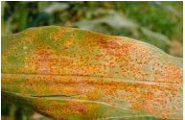

Figure 2.2.1‑1 Corn leaf infected by Common Rust (Mishra et al., 2020)

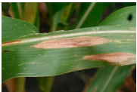

Figure 2.2.1‑2 Corn leaf infected by Northern Blight (Mishra et al., 2020)

Other than those, there is also another common disease named Gray Leaf Spot which is one of the main determinants of the drop in yield production in the northern United States and Ontario based on (Mueller et al., 2020).

These diseases if not detected in the early stage, might have the chance of spreading the pathogen to other healthy plants, resulting in a drop in both quality and quantity of yield production, snowballing to various disastrous damages such as potential harm to food security and also economical effect to the local farmer. In relation to SDG 15 about Life on Land, one of the goals of the SDG is to maintain and protect the ecosystem while also halt the biodiversity loss. It is equally important to mitigate any crop disease in the early stage before it can spread to the whole field as corn field have its own ecosystem where pollinating insects such as bee have mutualistic bond with corn where it can also benefit by feeding from the corn nectars (Siregar & Hutagaol, 2023). Moreover, infected crop can have a bad root that might eventually degrade the soil further exposing terrestrial and environmental damage to the earth and land (Sinha & Shekhawat, 2020).

### Technological Solution on Detecting Corn Disease

As discussed in the previous chapter about importance of early detection of corn disease, several attempt to detect corn disease has shifted towards the use of technological solutions. This is because the traditional methods which include manual detection on the crop field is considered ineffective and time consuming (Barbedo, 2018)**.** Mohammed & Yusoff at 2023 also mentioned about how the manual detection method is not accurate. Therefore a technological solution which can automate the detection process and provide accurate prediction to farmers can assist them through early detection and intervention of diseases.

### Image-based Method of Maize Diseases Detection

Throughout the years, with the improvement in technology, especially machine learning and computer vision, methods of corn disease detection, prediction, and classification have revolved around the use of images. Unlike humans, computers read images differently, computers can transform an image into an array of pixels to be further analyzed (Nixon & Aguado, 2019). Several researchers have utilized this ability to perform detections and classifications on not only plant disease, but also in many other domains as well.

(Mishra et al., 2020) on their research on the use of Deep Convolutional Neural Networks (Deep CNN) on a real-time detection system deployed onto Raspberry Pi 3 which is a stand-alone device that is used in disease recognition. In this paper, the authors seek to classify three labels of images which are *Common Rust, Northern Blight,* and *Healthy.*

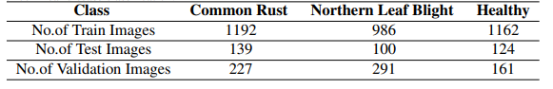

Figure 2.2.3‑1 Dataset of corn disease classification (Mishra et al., 2020)

As seen from the figure above, the dataset is split into 70-10-20 for train, test, and validation respectively. The model that utilizes Deep CNN managed to show an average accuracy of 98.40%.

The use of Deep Learning algorithm can also be seen in the work of other authors such as (Barbedo, 2018) which mentions how Deep learning has become one of the go-to techniques for image classification. The author also mentions the downside of using this algorithm which can happen while working with a small set of images, especially a lack of variety in the train image. In his/her work on identifying plant disease, the author managed to gain accuracies no less than 75 even though taking into account 10 diseases (10 class labels) further proofing the effectiveness of Deep Learning for disease detection.

Another journal also utilizes the concept of neural networks with slightly different alterations to it. (Waheed et al., 2020) exhibit a dense convolutional neural network architecture (DenseNet) classifying on the same dataset and labels of *Common Rust, Gray Leaf Spot,* and *Blight* which manage to produce an accuracy of 98.06%. The author does point out important notes regarding the use of neural networks as it is one of the most popular architectures for image recognition further supporting the notion from the other papers.

On a high-level view, the process flow of Image Classification is similar to any process of data mining task.

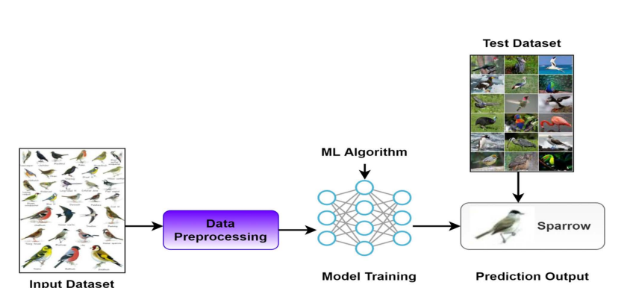

Figure 2.2.3‑2 Process Flow of Supervised Learning for Image Data (Mahadevkar et al., 2022)

This process flow also indirectly shows that a data mining methodology can also be applied in this project such as CRISP-DM (Cross-industry Standard Process for Data Mining). Further details on the methodology will be explained in Chapter 3.

### Computer Vision: Further Options for Corn Disease

In the chapter above, we have discussed one of the common ways of detecting diseases in corn which is through Image Classification. Image Classification itself is a part of computer vision technology and there are still other options available that are equally as good at detecting and predicting diseases through images. The picture below greatly represents some of the common types of Computer Vision.

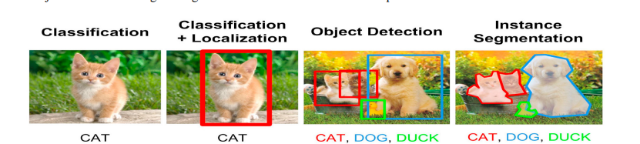

Figure 2.2.4‑1 Types of Computer Vision (Khan & Al-Habsi, 2020)

#### Image Classification

Image Classification is a technique of Computer Vision which focuses on labeling an image and classifying it based on the class label. It merely predicts the presence of the targeted object inside the image. (Mahadevkar et al., 2022).

#### Object Detection

Object Detection involves a deeper and more complex task to the image by not only classifying what the objects are in the image but also exactly where are those objects located in the image (Zou et al., 2023). This is particularly effective in the case of disease detection as it will not only be able to predict what the disease is but also clearly show the damaged area on the leaf surface. Object Detection generally utilizes bounding boxes with different colors for each label as seen from Figure 2.2-5. The box contains the object itself so the user can identify and see where exactly the object is.

#### Image Segmentation

Image Segmentation is the most detailed and complex task out of the 2 that have been explained above. Not only does Image Segmentation involve classifying and detecting the location of the object, but it also highlights the object at the pixel level by outlining the boundaries (Minaee et al., 2022). In the context of corn disease, the use of image segmentation will be on masking the disease area precisely and by creating threshold boundaries.   
One important thing that can be done from Image Segmentation is being able to perform Feature Extraction, a task of identifying and analyzing attributes of the image that contribute to the process of prediction and classification. This concept will be discussed further in the next section – Chapter 2.2.7

### Challenges in Computer Vision

One of the most important steps in the image prediction workflow is on image annotation / labeling. In a large dataset, image annotation will surely come as a problem in our workflow (Mahadevkar et al., 2022). Image annotation is a part of the image prediction flow where the user prepares the data by manually labelling the raw image with different techniques based on the chosen computer vision method. For Object Detection, users will be applying bounding box manually to the target area within the image and label them with the class label. This way, the model will be able to learn from the annotated image and classify it.

Other than that, the quality of the available data (image) can become crucial in determining the performance of the model (Kaur et al., 2019). A common problem in low-quality images is that they can contain noise and distortion which will affect how the model will be able to read the image especially since pixels and texture majorly contribute to how the model can identify the image.

In a journal by (Mahony et al., 2019), the authors touch on the issue of the long processing time of a deep learning model. Especially since some projects require a large number of training data, often millions, training can take from hours to days. They also support the previous notion of how important the resolution of the image is, especially to be able to detect object in a distance.

Finally, the problem of lack of training data is always a problem that occurs in a lot of data mining tasks. On image data, however, the problem of limited data can be solved by performing data augmentation. Data augmentation is a preprocessing method of rotating, shifting, grayscaling (making it into black and white) existing images to increase the number of training data (Mahony et al., 2019).

### Bounding Boxes: Effect on Quality of Data

Based on a paper by (Kuznetsova et al., 2020), a perfect bounding box is the smallest possible box that can capture all aspects of the object to be targeted. This is important in setting up the quality of the annotated image as it also, along with other factors discussed in the subchapter above, affects the final output of the model.

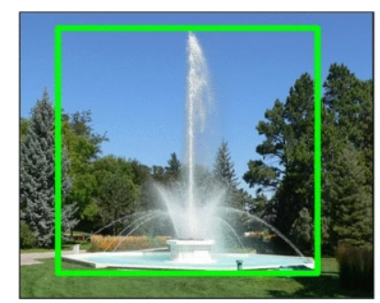

Figure 2.2.6‑1 Example of a good, annotated image (Kuznetsova et al., 2020)

As seen from the figure above, the water fountain is the target object and is annotated as tight as possible to capture all the attributes or part of the water fountain inside the bounding box. Tools that can be used to annotate an image are also available in Python such as Labellmg.

### Feature Extractions: An Analytical Approach for Image

In order to utilize the full capabilities of machine learning algorithms, many researchers on not only corn disease but also plant disease detection in general utilize feature extraction to extract the feature of an image such as shape, color, and even texture into a format that can be acceptable for a machine learning model as an input to train and predict (Salau & Jain, 2019).

#### Color Feature

In image and video data, color is one of the most common feature that is extracted. In feature extraction, color comes in different format such as RGB (Red Green Blue), HSV (Hue Saturation Value). This different color features are called color spaces (Salau & Jain, 2019). In relation to the corn disease project, many past researchers have utilized color to predict the model such as the use of Hue and Saturation Value done in determining the severity of corn disease based on image segmentation found in journal by (Sibiya & Sumbwanyambe, 2019). The color intensity and color ratio of each class label can be further analyzed after the color feature is extracted from the image.

#### Texture Feature

A step up from color feature, Texture Feature take into account a group of pixels in order to used in order to obtain the texture feature such as:

##### Gray Level Co-occurrence Matrix (GLCM)

Gray Level Co-occurrence Matrix is a technique which adopt statistical approach which to measure the texture properties of the image. GLCM as it name implies, work on a gray-scaled image where the intensity of the pixels are ranging between 0-255 (black to white) (Aouat et al., 2021). GLCM is able to characterize the contrast of each pixels meaning the variations of the pixel intensity, spatial relationship between pixels to measure the closeness and also the randomness of pixel distribution (Oghaz et al., 2019). The GLCM comes in pairs of pixels with the frequency of when the 2 pixels occur together (Humeau-Heurtier, 2019).

##### Haralick Feature

After the GLCM is conducted, Haralick Feature can be derived as a set of statistical measures after normalization on the GLCM is done. This process is typically done by dividing each element in the GLCM with the total number of pixel pairs. Once it is computed, Haralick Features such as Contrast, Correlation, Energy, and Entropy can be extracted.

* Contrast: variations within the image
* Correlation: linear dependencies within pixels
* Energy: describe the homogeneity of pixel intensifies which will show a higher value for pairs that are rather different and lower for the opposite
* Entropy: measures the randomness of the pixel pairs distribution (Humeau-Heurtier, 2019).

##### Gabor Feature

Gabor Feature which is extracted based on Gabor Filter is a widely used texture analysis technique where it specialized in spatial and frequency domain. Spatial method means that the technique will be able to capture the data with data from different size or orientation while retaining the original information (Salau & Jain, 2019). In relation to the corn disease data, gabor features can be extracted to find any spots or discoloration on the corn leaves image which can determine and classify which disease it is.

### Machine Learning Algorithms for Prediction

After the feature extraction is done, several machine learning algorithms that are usually applicable for classification task can be applied. These algorithms will be discussed further below.

#### K-Nearest Neighbor

K-Nearest Neighbor (KNN) is a machine learning algorithm that is widely used for classification and regression problems. As its name implies, the algorithm relies on finding tdahe nearest neighbor by calculating the distance matrix between the test sample and the sample of the category that is the closest (Xing & Bei, 2020).

In optimizing KNN, researchers usually focus on finding the optimal K values for each dataset which is a hyperparameter of the algorithm that refers to the number of nearest neighbors to be considered when making a prediction as it can directly affect the result of the model (Yuan & Yang, 2019). The authors do address some of the method to determine the optimal K-values and one of them is the elbow method. Based on the graph shown below, we can see the inflection point that is the most obvious at 2 which means that K=2 is the optimal values of K.

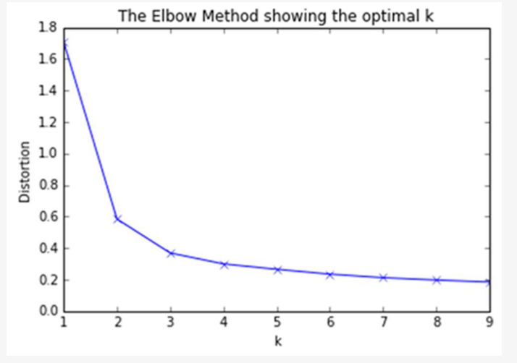

Figure 2.2.8‑1 Elbow Method to determine K values (Yuan & Yang, 2019)

KNN algorithm has been used in model building for image classification task such as one research by (Xing & Bei, 2020) on medical big data.

#### Support Vector Machine

SVM or Support Vector Machine is another popular supervised learning algorithm that is commonly used for classification and regression task. The main goal of using SVM is to find the best hyperplane that can best differentiate the class.

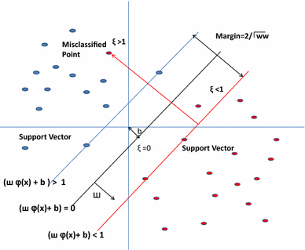

Figure 2.2.8‑2 A graph of SVM (Chandra & Bedi, 2021)

Quoted from (Chandra & Bedi, 2021), SVM is able to classify a class by creating a hyper-plane that is also refer as a decision plane – which is a line that differentiate one group of data from another. In the same journal, the authors have

#### Random Forest

Random Forest is an ensemble machine learning algorithm which similar to SVM, works on classification and regression task. Ensemble models are models that are created based on the combination of multiple machine learning models into one single model which in some cases are able to boost the accuracy of the model. As its name implies, random forest consist of multiple decision trees which are created from subset of training data (Sheykhmousa et al., 20202).

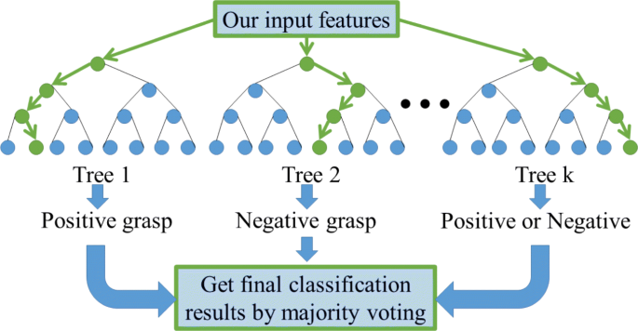

Figure 2.2.8‑3 Random Forest Architecture (Zhang et al., 2020)

#### Convolutional Neural Network

Neural Network especially CNN (Convolutional Neural Network) has been popular in use for image data and has been said to dominate the field of computer vision in the recent years (Hussain et al., 2019). It involves multiple convolutional layers which are known as kernels which can be further applied to image data to extract features from it. Many of the feature extraction tasks also utilize CNN as one of the methods.

In the journal by (Hussain et al., 2019), the authors introduce the other function of CNN which is on Transfer Learning. Transfer Learning is a concept where a pre-trained models trained on large datasets are further tuned and adapted to a related task. This can result to a faster training convergence as it has already learned and trained for data related to the task.

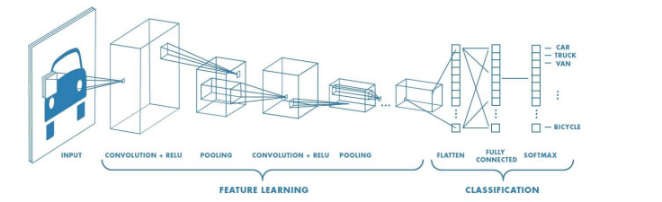

Figure 2.2.8‑4 Layer of CNN by (Hussain et al., 2019),

Based on the figure above, we can see that CNN consists of several layers, each representing and functioning differently (Wang et al., 2021).

* Input Layer: This layer receives the raw data which can be images or sequence of data.
* Convolution Layer: This layer functions in extracting features from the image such as color, edges, texture, etc. It is responsible in producing a feature map or activation map which contains all the features that has been extracted from the data.
* RELU (Rectified Linear Unit) Activation Function: This layer involves finding relationships of each data introducing non-lineratity to the data. This layer also normalize the output of neurons. An example of this is an activation function called Softmax which function in normalizing the values.
* Pooling: This layer downsamples the data and reduce the number of parameters that are created from the past layers in order to decrease the chance of overfitting to the model.
* Classification and Output Layer: This layer is tasked with doing the classification or regression task and channel it to the output layer with the final prediction and output of the network

### Object Detection Models in TensorFlow

#### Faster R-CNN

Faster R-CNN which stands for Faster Region-based Convolutional Neural Network is an improvement of its predecessor R-CNN and Fast R-CNN. It is a deep learning model which is mostly used for object detection task. It utilizes neural network to generate Region Proposal Network (RPN) which is essentially introducing candidate of objects in an image by finding the Region of Interests (ROI) (Cao et al., 2019). ROI Pooling is one of the layer introduced in R-CNN which received the feature map created from the convolutional layer. ROI Pooling layer will produce a fixes size feature map which capture essential spatial information of the object and also coordinate of it represented in a bounding box (Cao et al., 2019).

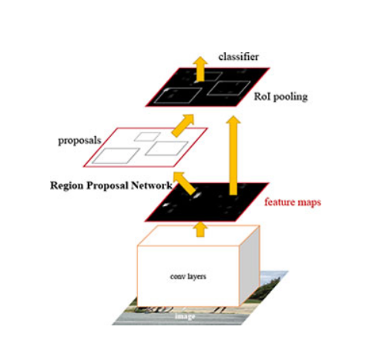

Figure 2.2.9‑1 R-CNN Architecture (Ren et al., 2017)

#### SSD (Single Shot MultiBox Detector)

Single Shot MultiBox Detector or SSD is another object detection algorithm that is popular for its speed and accuracy, As it name implies, the algorithm uses the concept of Single Shot which means that the process of localization and classification is done once only through the network. SSD utilizes a base convolutional network where similar to R-CNN, produce a feature map in multiple scales. The multibox concept comes when SSD generates multiple default bounding boxes on each feature map cell to cover spatial area of the image. This box is called a MultiBox or anchor box. In each anchor box 2 predictions are done which are on the bounding box offset and also the class probabilities (Kumar et al., Object detection in real time based on improved single shot multi-box detector algorithm, 2020). However in a journal by (Kumar & Srivastava, Object Detection System Based on Convolution Neural Networks Using Single Shot Multi-Box Detector, 2020), the authors mentioned about the limitation of SSD. SSD is not suitable in detecting a tiny object since it does not take into account the information outside of the bounding boxes.

#### YOLO (You Only Look Once)

You Only Look Once (YOLO) is another object detection algorithm that is popular for its speed and accuracy. It is more famous for its staggering speed in predicting and detecting an object (Mittal et al., 2019). YOLO works in using a grid-based prediction where the input image is divided into a grid of cells which are then responsible for predicting a number of bounding boxes based on their location.

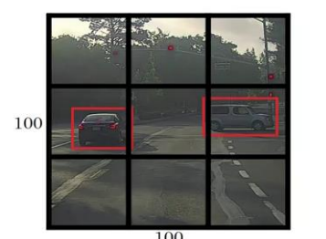

Figure 2.2.9‑2 Example of the Grid-image done by YOLO (Mittal et al., 2019)

Existing research has compared the performance between YOLO and the other algorithms such as Faster R-CNN and Fast R-CNN. YOLO manages to outperform both algorithms as seen from the figure below (Deshpande et al., 2020).

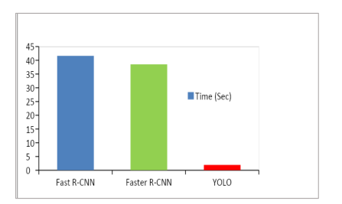

Figure 2.2.9‑3 Performance between Fast R-CNN, Faster R-CNN, and YOLO (Deshpande et al., 2020)

### Model Evaluation Method

#### Confusion Matrix

Confusion Matrix is one of the most popular measure for machine learning models that focuses on classification tasks. It is represented in a square structure described as the actual and predicted result.

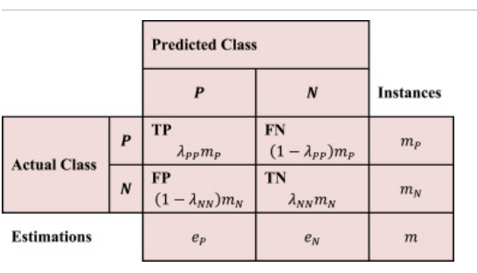

Figure 2.2.10‑1 Sample of Confusion Matrix (Luque et al., 2019)

The Confusion Matrix as seen from the sample figure above, consists of 4 cells which are True Positive, False Negative, False Positive, and True Negative.

* True Positive (TP): The model is able to correctly predict the positive value
* True Negative (TN): The model is able to correctly predict the negative value
* False Positive (FP): The model incorrectly predicted the positive class when the actual value is negative
* False Negative (FN): The model incorrectly predicted the negative class when the actual value is positive.

As the confusion matrix is generated, several other performance metrix can also be calculated such as:

* Accuracy: Overall accuracy of the model.

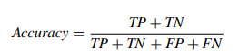

Figure 2.2.10‑2 Formula for Accuracy (Grandini et al., 2020)

* Precision: The number of True positive among all the positive prediction.

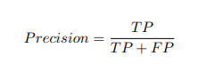

Figure 2.2.10‑3 Formula for Precision (Grandini et al., 2020)

* Recall / Sensitivity/ True Positive Rate: Tendency of the model being able to identify positive class correctly divided by the number of the actual positive cases (True Positive and False Negative)

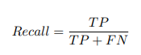

Figure 2.2.10‑4 Formula for Recall (Grandini et al., 2020)

* Specificity / False Negative Rate: Tendency of the model identifying the negative class among all the actual negative cases

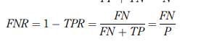

Figure 2.2.10‑5 Formula for Specifitiy / False Negative Rate (Tharwat, 2020)

* F1 Score:

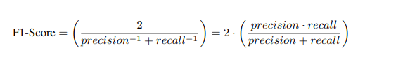

Figure 2.2.10‑6 Formula for F1 Score (Grandini et al., 2020)

#### ROC Graph

Receiver Operating Characteristics (ROC) curve is one of a widely used evaluation metrics that are consist of the True Positive Rate (TPR) or Sensitivity in the y-axis and False Positive Rate or 1-Specificity in the x-axis.

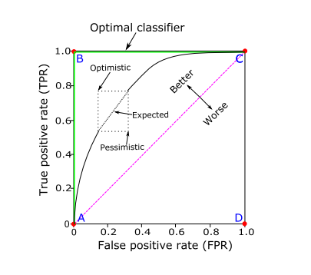

Figure 2.2.10‑7 Sample of ROC (Tharwat, 2020)

In order to compare the performance of one model with the others, AUC (Area Under Curve) is calculated which is based on the area under the ROC curve (Tharwat, 2020).

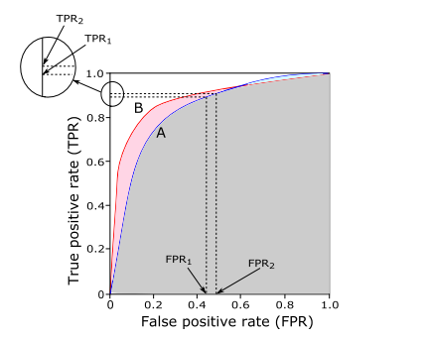

Figure 2.2.10‑8 Sample of AUC for 2 different models (Tharwat, 2020)

The larger the AUC (the area), the better the model performance as it has a higher True Positive Rate meaning that it is able to better distinguish the positive and negative class.

## Similar Systems/Work

|  |  |  |  |  |  |  |  |
| --- | --- | --- | --- | --- | --- | --- | --- |
| Research Topic | Author(s) | Description | Dataset Used | Analysis Technique | Evaluation Techniques | Result/Outcomes | Limitations |
| An optimized dense convolutional neural network model for disease recognition and classification in corn leaf | (Waheed et al., 2020) | The authors aim to build a corn leaf disease recognition and classification using optimized dense convolutional neural network architecture (DenseNet) | Leaf image dataset consists of 4 classes: Common Rust (3816),  Healthy (3720), Cercospora Leaf Spot Gray Leaf Spot (1644). This dataset is splitted in a 90-10 format for training and testing. | Optimized Dense Convolutional Neural Network (CNN) Architecture (DenseNet) | * Training and Validation loss and accuracy on each epoch which is each pass through the training dataset * Confusion matrix * Classification Report showing the accuracy, Precision, Recall, F1-Score, Support. | The optimized DenseNet model produce an accuracy of 98.06% while using a much lesser parameter and requires much less computing time compared to CNN architectures such as EfficientNet, VGG19Net, NASNet, and XceptionNet. | This study focuses on only CNN based algorithm and does not discuss further on other algorithm such as Random Forest, SVM, etc. |
| Deep Convolutional Neural Network based Detection System for Real-time Corn Plant Disease Recognition | (Mishra et al., 2020) | This study proposed the use of Deep Convolution Neural Network that can detect disease in real time by applying the model built into smart devices like NCS, raspberry-pi or even smartphones and drone. | Include 3 classes of leaf image data such as Common Rust (1558), Northern Leaf Blight (1377), Healthy Leaves (1447). This data is splitted into 70-10-20 format for Training, Test, and Validation respectively. | Real time Deep Convolutional Neural Network | * Visual result of each convolution layer * Model accuracy and loss curve for each epoch | The Deep CNN model is able to produce an average accuracy of 98.40%. However the model that is deploy in the NCS device and tested using live images from smartphones camera is able to obtain accuracy of 88.66%. | The accuracy that is achieved on NCS device can be further improved and tuned. The author mention on using data augmentation to train the model and improve the hyper parameter while also increase the variation of the pooling operation. |
| Corn Leaf Diseases Diagnosis Based on K-Means  Clustering and Deep Learning | (Yu et al., 2021) | Similar to the research above, the authors investigate several neural network models such as VCG-16, ResNet18, Inception V3, and VGG-19 alongside a proposed deep learning model. The aim of this study is to also research on the impact of various k-values which are used in the image processing process using k-means clustering. In this study the concept of transfer learning is introduce which is essentially using pre-trained models that are fine-tuned. The knowledge of the pre-trained models from one domain is then transferred to this domain of the deep learning model. | Crop Disease Recognition dataset. Three types of corn leaves are selected which include Gray Spot, Rust, and Leaf Spot. | VGG-19, Inception v3, ResNet18, VGG-16, Proposed Deep Learning model.  K-means clustering is used on the image processing part where it is used in investigating the apparent color difference in the image between the background, leaves, and disease area. | * Confusion matrix to calculate Accuracy, Precision, Recall, and F1 Score * Training and validation loss and accuracy curve for each epoch. * ROC Curve for each class. | Compared to the other neural network models that are tested in this study, the proposed deep learning model achieve a higher performance of 89.24% and also require less parameter making it more simple to operate. | Small sample data and simple background of the image are few of the limitations that are mentioned in the study. The lack of variety of environmental conditions unable the model to work in extreme weather condition which are common if it is to be used in real life situations. |
| Maize Leaf Disease Detection  and Classification Using Machine  Learning Algorithms | (Panigrahi et al., 2020) | Maize or corn leave disease detection using several machine learning algorithms other than the neural network models that are more commonly used in a few study above. | Image of the corn leaves in a total of 3823 images consisted of 4 classes which are Common Rust, Gray Leaf Spot, Northern Leaf Blight, and Healthy Leaves. The dataset is splitted in 90-10 format for traing and testing | Support Vector Machine, Naïve Bayes, K-Nearest Neighbors, Decision Tree, Random Forest | Accuracy, Precison, Recall, and F-Measure. | The supervised machine learning algorithms managed to all receive accuracy under 80% with the highest by Random Forest at 79.23%. | Low performance of the model compared to projects utilizing CNN based models as the difference in the accuracy is apparent. |
| Image segmentation of Leaf Spot Diseases on Maize using multi-stage Cauchy-enabled grey wolf algorithm | (Yu et al., 2022) | Maize leaf disease recognition using image segmentation technique which can not only predict the disease, but also highlight the damage area. This paper utilize Grey Wolf Optimizer as the algorithm and improved it further into a Multi-stage Grey Wolf Optimizer. | Leaf Spot Diseases image. Details about the size of the dataset is not shared by the authors | Multi-stage Grey Wolf Optimizer | PNSR: index to measure the quality of the image segmentation  SSIM: Similarity index between the original and segmented image. The more similar both image, the closer the value of SSIM to 1, proving the effectiveness of the image segmentation.  FSIM: value between 0 and 1 which utilize feature similarity to evaluate the image segmentation. The closer the value to 1, the better the performance. | MGWO is proven to be an effective optimizer for multi-threshold image segmentation. Compared to the original GWO, MGWO has better balance and can produce a more accurate result. | The MGWO model requires more iteration in order to have a better performance which can result to a higher running time. The rising time complexity remains an issue for this model . Future studies is require to reduce the time complexity while maintaining the model performance. |
| A Novel Object Detection Model Based on Faster R-CNN for Spodoptera frugiperda According to Feeding Trace of Corn Leaves | (Du et al., 2022) | As the common method for corn damage detection is time consuming especially on insect detection. The author propose the use of object detection method on the trail of the insect which feeds on the leaves. The researches propose a model called Pest Region-CNN or Pest R-CNN which is based on Faster R-CNN and will be compared in this study. | maize S. frugiperda dataset which contained 585 images that are annoteated with 3150 anchors (bounding boxes) showing the damage or feeding area | Pest R-CNN, Faster R-CNN, Yolo V5 | Mean Average precision (mAP),  Precision, Recall. | The pest R-CNN model is able to achieve a higher mAP compared to both faster R-CNN and YOLO v5 by a large scale at 12% and 19% difference respectively. The mAP for the pest R-CNN model is at 43.6% on the test dataset. This is the first step of applying object detection model on the insect feeding trace. | Limited data especially images from different geography zones. The image is also limited to one type of insect and should be improved in future study. |
|  |  |  |  |  |  |  |  |

Table 2 Similar system for corn disease and damage detection and recognition

## Technical Research

### Python Programming Language

Python is a programming language that has been popular for the past few years. Python has been around since 1990 and is created by Guido van Rossum. Not only are they simple for beginners, it can also support high-level task. In the field of data analytics, Python is often compared to another language, R programming language which is focused on data analysis task. Python also provides several data analytics tools and libraries such as Panda, NumPy, etc. Not only that Python is also able to perform many other tasks such as web development, software and game development, GUI, and many scientific task (Hao & Ho, 2019).

In this study, Python is exce ptionally suitable as it provides many tools and libraries that support not only data analytics but also image processing and image recognition features. Moreover, Python contains many libraries that can be useful for the task that will be done for corn disease recognition (Raschka & Mirjaili, Python machine learning: Machine learning and deep learning with Python, scikit-learn, and TensorFlow 2). This includes TensorFlow libraries which is a machine learning framework that is popular for deep learning task. These libraries will be discussed in further detail in the next chapter.

### Jupyter Notebook in Visual Studio Code

For this study, Visual Studio Code is chosen as the IDE. Visual Studio Code is a free IDE (Integrated Development Environment) which can work as a source code editor, compiler, and also debugger with an in-built terminal making it one of the most popular IDE for not only beginner but also expert programmer (GfG, 2023). Other than that VS Code also provide a marketplace where developers and community can share the plug-in of tools, language, and many other extensions that can be used by programmer. Language extension such as Python, C/C++, Rust, are also available in the marketplace for free to be used inside VS Code.

For data analyst task, many prefer to use Jupyter Notebook compared to the usual Python interface. Jupyter is an open source web application that acts as a text editor while also being able to act as a document that can provide visual, live code, and explanation or description of the notebook. Unlike the usual python interface, Jupyter provide the option for users to execute a chunk of code that is suited for data analytics task such as Exploratory Data Analysis and any task that requires plotting a graph (Wang et al., 2020).

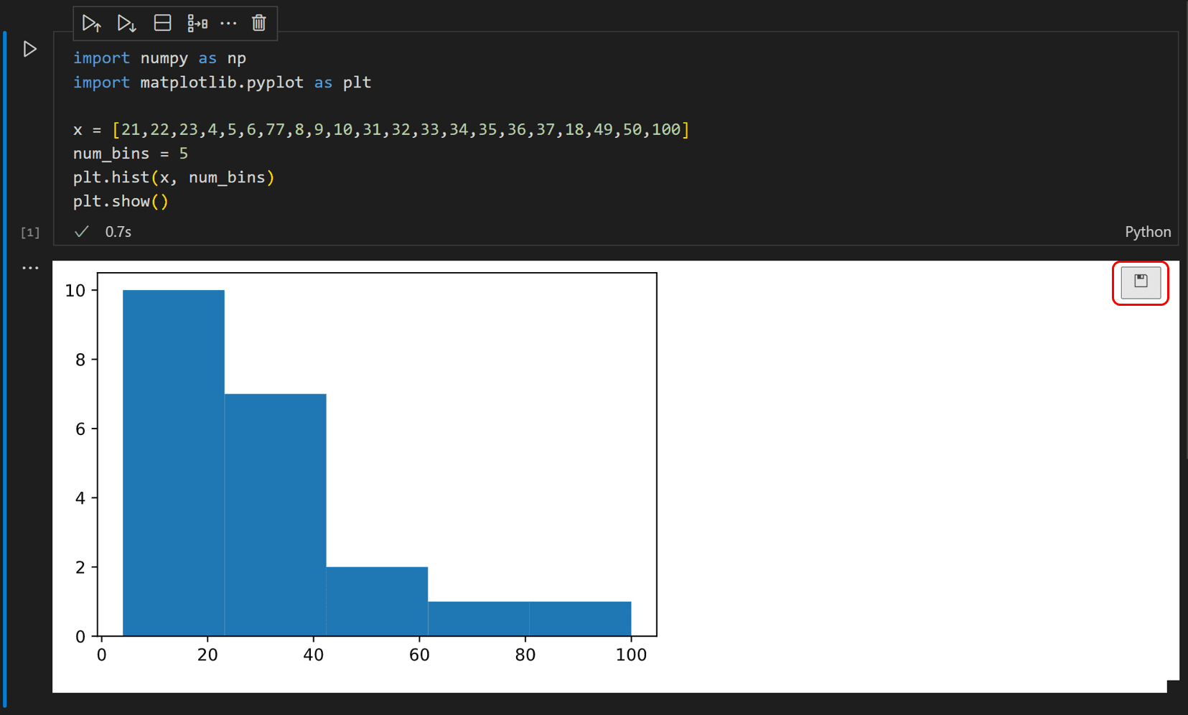

Figure 2.4.2‑1 Sample of Jupyter Notebook in Visual Studio Code plotting a graph using numpy and matplotlib from Python (Working With Jupyter Notebooks in Visual Studio Code, 2021)

### Pandas, NumPy, matplotlib: Tools for data analytics

As mentioned in the chapter about Python, Python include many libraries that can assist in data analysis and data manipulation task.

#### NumPy

NumPy stands for Numerical Python and is commonly used for computing especially for data analysis task. Starting from arithmetic operations to array manipulation, NumPy has proved to perform well.

#### Pandas

Pandas is another data analysis library that is built on top of NumPy which support a lot more data analysis function such as managing tabular and dataframe information.

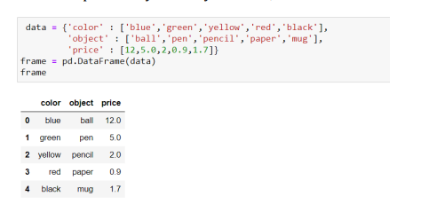

Figure 2.4.3‑1 Pandas dataframe (Sapre & Vartak, 2020)

Other than that, Pandas also support data import and export function, preprocessing function such as data merging, sorting, filtering, and also imputing missing value.

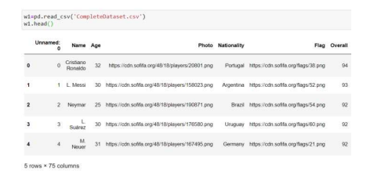

Figure 2.4.3‑2 Pandas reading csv file (Sapre & Vartak, 2020)

#### Matplotlib

In addition to the 2 libraries discussed above, Matlotlib is a library in Python that function in creating and plotting interactive and non-interactive visualization plot within a few lines of code easing data analysis task.

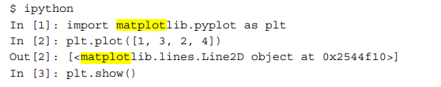

Figure 2.4.3‑3 Code snippet to plot a simple line plot using matplotlib (Tosi, 2009)

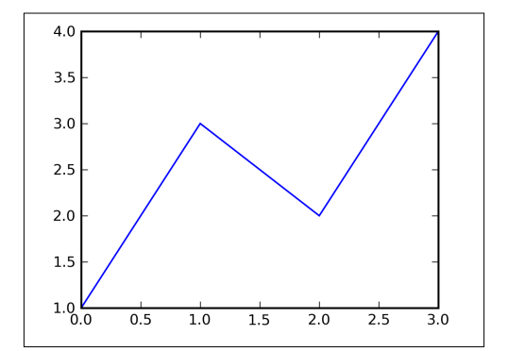

Figure 2.4.3‑4 Line plot result using matplotlib (Tosi, 2009)

### Scikit-learn

Scikit-learn is a popular machine learning library in Python. As an open-source library, Scikit-learn provides tons of predictive machine learning models such as classification, regression, clustering, feature extraction, and also model selection or evaluation functions (Hao & Ho, 2019). Popular machine learning models such as regression, decision trees, random forest and also clustering function such as k means algorithm are all available in the package of Scikit-learn making it the go to for many programmers who are doing predictive data analysis. To further increase the advantage of Scikit-learn it also provide the option of ensemble models such as Gradient Boosting and also combining predictors.

For this study, Scikit-learn is especially useful in the model building phase as the data extracted from image can be classified and predicted using the classification model available in the library. Scikit-learn also provide feature for data pre-processing such as imputing missing values, feature extraction pipeline, image denoising pipeline, and even image segmentation tools which can also be applied in highlighting the leaf damage area.

### Tensorflow and Keras

As the increase of technology in Machine Learning and Artificial Intelligence, programming frameworks have been developed to assist in developing applications, systems and also solve problems. Frameworks generally are a set of tools and libraries that allow users to access prebuilt modules that act as a pipeline in building a machine learning algorithm meaning that users are not required to build the algorithm from scratch (Hari, 2023).

In the field of computer vision, several deep learning frameworks have been developed and implemented in research and projects such as TensorFlow, PyTorch, etc.

TensorFlow is one of the most popular open-source machine learning frameworks developed by Google. It is able to perform any neural network task which is essential for Computer Vision and Natural Language Processing (NLP) (Pang et al., 2019) and also allows computing via CPU or GPU which can affect the processing time. TensorFlow is generally Python-based and also includes an API (Application Programming Interface), Keras which provides a clear and simple high-level interface emphasizing its user-friendly ability and modular. Keras is integrated as the official API for TensorFlow and can be used as a front end in building a neural network project which in this case allows many implementations on image classification, feature extraction on the corn disease images, and even integrated object detection API (Panja et al., 2021).

TensorFlow also comes with a variety of pre-trained models with different purposes that are available in the TensorFlow Hub which is a repository of all the pre-trained models available in kaggle.com which are ready to be deployed and fine-tuned (Models &Amp; Datasets, n.d.).

These include ResNet, Inception that are used in artificial vision; Faster R-CNN (Region-based CNN), SSD (Single Shot Detector), and YOLO (You Only Look Once) which specializes in Object Recognition and Object Detection (Sanchez et al., 2020).

## Summary

In this chapter, Literature Review has been conducted starting from the domain research of a more general topic such as discussion about corn disease, the impact, effect, and how is it usually identify. This serves as a basis on how the past researchers have built a model for the disease prediction. In classifying and predicting corn disease, most researchers have gone through the option of image recognition such as image classification, image segmentation, and even object detection. Image classification, just like the classification task that is done on a tabular dataset, is a task to predict the disease based on the image data. In order to perform classification, model needs information from the image to be extracted. This process is called feature extraction where information such as color, texture of the image is extracted as the input for the model.

In the Literature Review, we have discussed some of the classification model such as Random Forest, Convolutional Neural Network, Support Vector Machine, and also K-Nearest Neighbor (KNN). This chapter also cover information about object detection concept such as bounding boxes which are performed during the image annotation process which is essentially labelling raw image with bounding boxes / anchor boxes that contain the target object inside. Several object detection models such as R-CNN, YOLO, and also SSD is also discuss in the literature review.

Finally, the literature review is wrapped up with a discussion about the technical part. This includes research about Python Programming language which will be used in this study as it is versatile and very effective for data analysis task and machine learning. The advantage of Jupyter Notebook and why data analyst prefer using it compared to the normal Python is also discussed. The IDE used for the code is also explained which is Visual Studio Code, a popular and open-source IDE which include a marketplace feature where user can install extension that they need. This include programming languages, tool to code easier, etc. Several libraries that are essential for data analysis task in Python namely Pandas, NumPy, and Matplotlib are also explained thoroughly . For machine learning, Scikit-learn is an open-source libraries that include many prediction models starting from classification , regression, and even ensemble model. It also include many pipeline that can be useful for this study including pipeline for image segmentation.

In order to use Neural Network model, Tensorflow is one of the most popular framework which provide several pre-trained neural network model in its architecture. It is also highly preferred for deep-learning task. Moreover, object detection task can also be made easier with this framework as it provides tools and even pre-trained model that can also be fine-tuned or trained with our custom data (transfer learning).

Based on the Literature Review, the researcher has decided to incorporate both image classification techniques and also object detection in the final output of the models. Image processing and feature extraction techniques will also be applied in order to have a proper input data which include color feature, Gabor Filter, and Haralick Feature Moreover, the machine learning algorithm chosen will be CNN due to the high accuracy it received on some of the similar systems, however the other algorithms such as Random Forest and SVM will also be tested out to be compared. Moreover, for the object detection model, YOLO and SSD will be chosen due to the high performance and faster processing time which enhance the performance of the model if it is applied in real-time.

# Methodology

## Introduction

The third chapter introduces the methodology that will be chosen for this project, CRISP-DM, a popular data mining methodology. Detail discussion about each step or process that is done within the methodology will be explored further in the Methodology part. Moreover, comparison with other popular data mining methodologies such as SEMMA, KDD, and CRISP-DM is covered in this chapter.

In the next part, data collection from Kaggle will be explored and also the EDA (Exploratory Data Analysis) and Data Pre-processing which will be done through Jupyter Notebook. This subchapter will go through the process of reading the image directory, preprocessing the image, performing feature extraction, EDA before and after the features is extracted (EDA from the image and EDA from the dataframe created from the feature extraction). The process of pre-processing is also done twice, once on the raw image directory including the process of feature extraction and once more on the extracted feature data frame, this is done to ensure there is no error in the extracted feature.

Finally, the essential part of this chapter is concluded and ensuring the output of this project to be ready, cleaned , and transformed for the needs of the model which will be conducted in Part 2 of the Final Year Project.

## Methodology

### Introduction of CRISP-DM

CRISP-DM which stands for Cross Industry Standard Process for Data Mining is one of the most popular methodology used for data mining task. Methodology itself helps provide a structural approach to working on a project. In the case of data mining, CRISP-DM is one of the methodologies that provide a clear phase and step on what to do. CRISP-DM itself consist of 6 crucial steps which are Business Understanding, Data Understanding, Data Preparation, Modelling, Evaluation, Deployment (Schröer et al., 2021). Some of the phase can be iterative, meaning that after getting to the next phase, user can always choose to go back to the previous phase if they miss something.

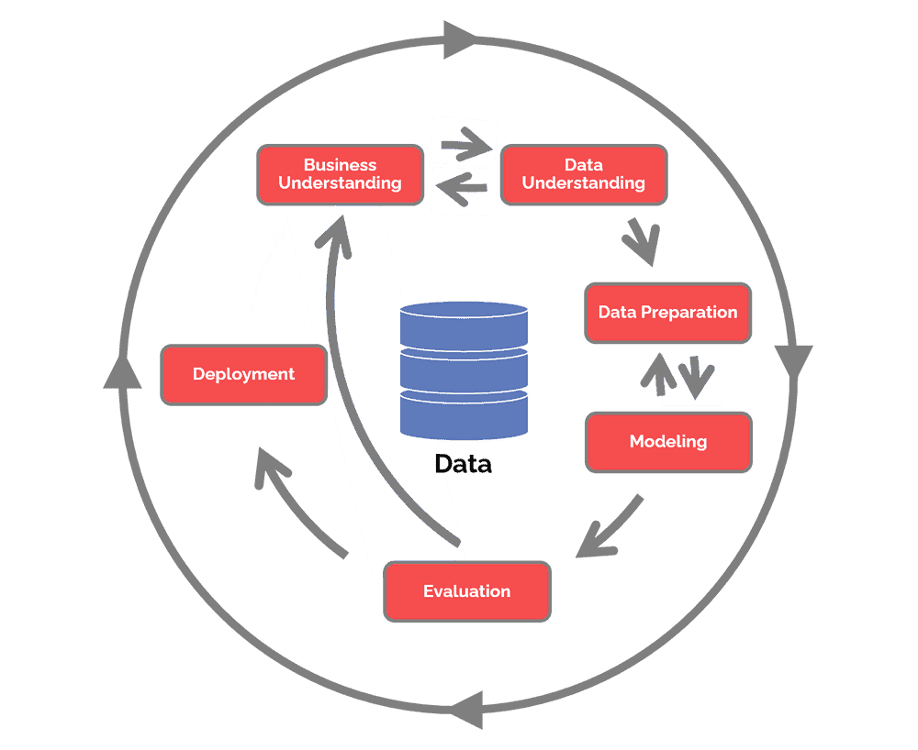

Figure 3.2.1‑1 Flow of CRISP-DM (Hotz, 2023)

### Selected Methodology

Other than CRISP-DM, there are other methodologies such as SEMMA (Sample, Explore, Modify, Model, and Assess) and KDD (Knowledge Discoveries of Databases). In SEMMA, the workflow focuses more on the workflow of building a model and less focus on both the business understanding and deployment part. KDD having similar weakness where it emphasize more on the technical part of the workflow. KDD itself is also the original terms of data mining which is essentially knowledge extracted from data (Martinez-Plumed et al., 2019).

For the corn disease prediction project, thorough research of business understanding needs to be performed. This include identifying the cause of corn disease in order to proceed to the next stage of data understanding. This define a clearer goal or business objective where the study will now focus on corn leaves as discussed in the literature review. Even though in this study no model will be actually deployed, it opens up the window of opportunity for researchers or future study to apply the built model into a hardware device. Therefore CRISP-DM is chosen and not the other methodologies.

### Steps and Phases of CRISP-DM and Relation to Image Processing

As briefly mentioned in Chapter 3.2.1, CRISP-DM consist of 6 steps which include (Schröer et al., 2021):

#### Business Understanding

Business Understanding is the first phase of CRISP-DM where the project goals and objectives are define. In this study, this part would be on Chapter 1 where the problems of the project are defined and the goal and objectives of the study are stated as well. Literature review on corn disease itself can also be included in this part as it helps set the requirements on what are the relevant factors in predicting corn diseases.

#### Data Understanding

In this phase, attempts to collect the data is done. For this study, the data that will be collected is in a form of image data of the corn leaf with 4 labels. This phase also include data exploration or Exploratory Data Analysis (EDA) process. This is done to explore the relationship between each variable, ensuring quality of the data and points out any error if found.

#### Data Preparation

Based on the EDA that is conducted in the previous phase, data processing or data preprocessing is performed in order to fix any error that is previously found. This include missing value which can be fix by imputing the value or dropping the data; imbalanced dataset which means that one or more of the classes have different amount of data; normalization on the value of the data; standardization especially if there is an improper datatype or wrong format. In this study using an image data, this phase also include feature extraction process where the information of the image is extracted into a meaningful data. The extracted feature will then be explored going back to the previous phase of Data Understanding to identify any error and also to analyze the extracted feature. After analyzing, the extracted data will then be preprocessed further. This show the iterative process of CRISP-DM.

#### Modelling

After preparing the dataset and ensuring that it is clean, the dataset can now become the input model training. This phase involves building machine learning models from the dataset. It also involves splitting the dataset into training, test, and validation. There is no true ratio for this split, but in general, the training ratio should be larger than both test and validation. A 70-10-20 split or even 70-30 and 80-20 split without validation are commonly seen in many research. After the model is built, the result of the model can also be tested out in the next.

#### Evaluation

After the models are built, the performance of the models area evaluated based on certain criteria such as accuracy, precision, recall, and F1 Score. This is done to choose which models that will be deploy in the real world. As the iterative nature of CRISP-DM it is also important to revisit the previous step of the phase in order to improve the performance of the model. This can be better preparing the data in the data preprocessing phase or even improving the hyper parameter in the modelling phase.

#### Deployment

The final part of the workflow is deployment. After ensuring that the model has achieved the desire outcome and performance, the model is then ready to be deployed. For an object detection model, it can be applied and deployed on a hardware recording device or even smartphone or a software that will show a livefeed of the predicted object. In this study, the deployment part will only involve the final report of the model without implementation into any system.

## Data Collection

For this project, the data collected is in the form of image datasets from Kaggle.

|  |  |  |  |
| --- | --- | --- | --- |
| Data Source | Number of Images | Number of Class | Classes |
| * [Corn or Maize Leaf Disease Dataset (kaggle.com)](https://www.kaggle.com/datasets/smaranjitghose/corn-or-maize-leaf-disease-dataset/data) | 4188 | 4 | * Blight * Common_Rust * Gray_Leaf_Spot * Healthy |
| * [Corn Disease (kaggle.com)](https://www.kaggle.com/datasets/buffyhridoy/corn-disease) | 3852 | 4 | * Corn_Common_Rust * Corn_Gray_Leaf_Spot * Corn_Healthy * Corn_Northern_Leaf_Blight |

Table 3 Data Source Collection

## Data Understanding

As mentioned in the previous sub chapter, this project utilizes 2 image datasets. In this sub chapter, exploratory data analysis will be performed to find information such as pattern, relation of the data, and even errors within the data.

### Data Import and File Directory

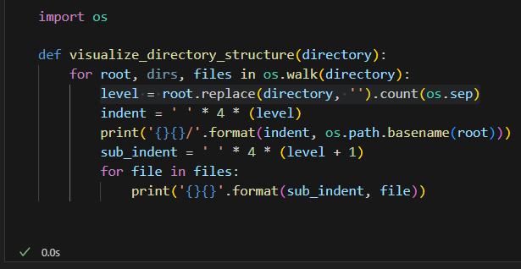

Figure 3.4.1‑1 Function to visualize the directory structure

The figure above shows the way to traverse the file system in order to better show the dataset directories (classes). The function os.walk() is a popular function that can be used to generate the filename by returning root, dirs., and files.

* Root : path of the directory visited
* Dirs.: sub-directory of the root
* Files: list of filenames of the root and dirs. (GfG, 2022) .

#### Directory of dataset 1

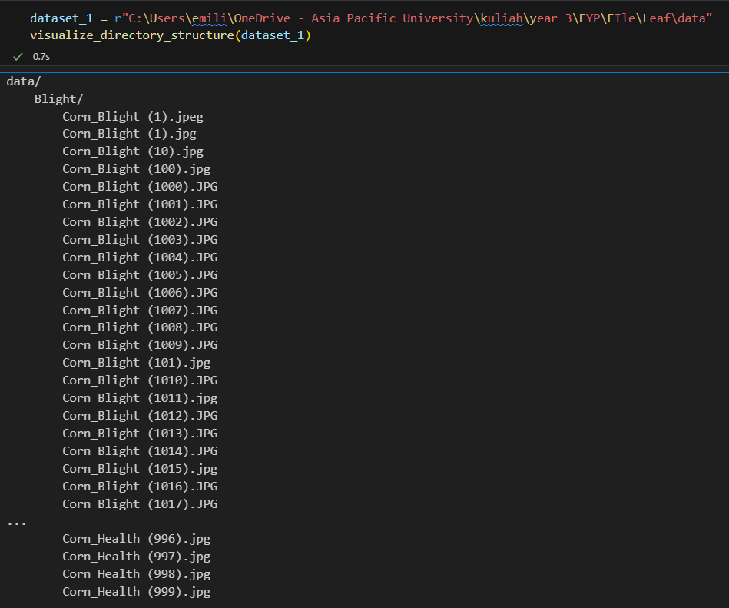

Figure 3.4.1‑2 Part of the directory of dataset1

#### Directory of dataset 2

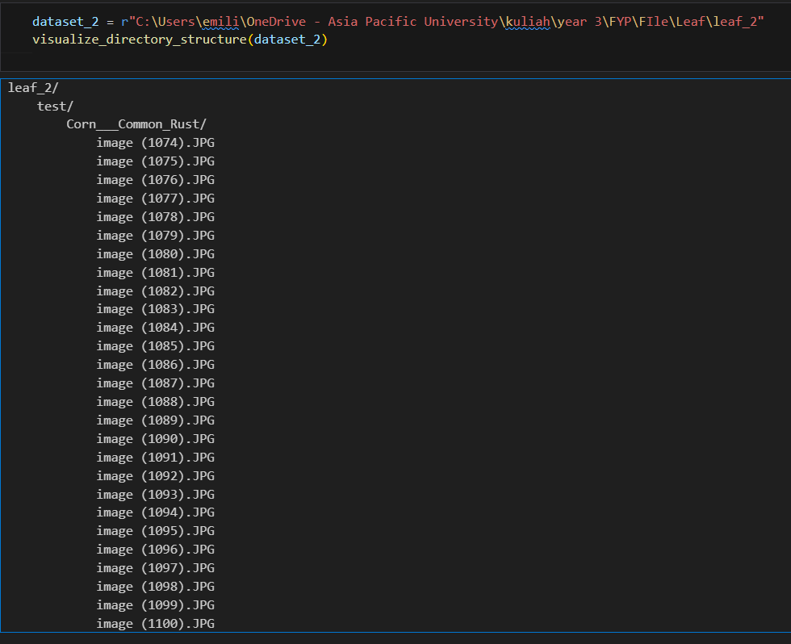

Figure 3.4.1‑3 Part of directory of dataset 2

As seen from both figures above, the first dataset is separated based on the class or image categories. The 2nd dataset has a different approach where the raw dataset is already split into train, test, and validation. Each of those are then further distributed based on the class.

### Image Distribution of both dataset

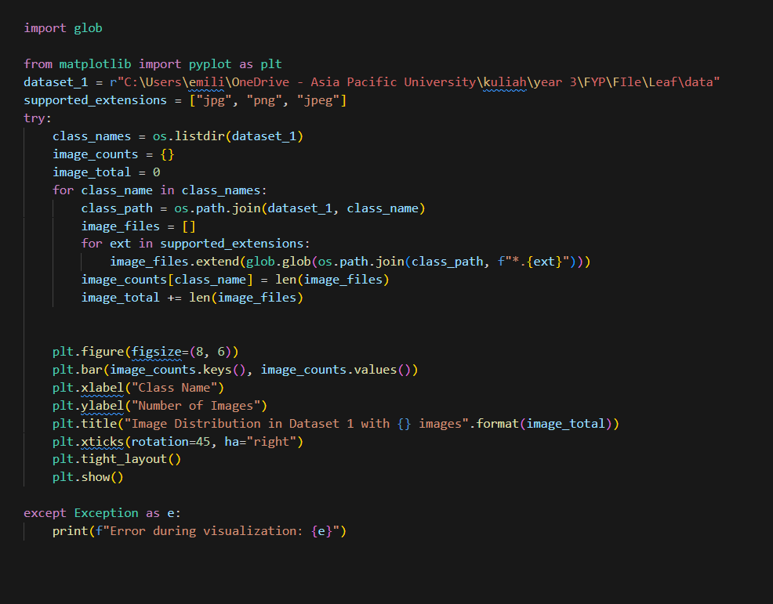

Figure 3.4.2‑1 Code to generate image distribution plot

Using *glob* (GfG, 2020b) to retrieve the pathname, each image from each class in the dataset is counted in order to create the image distribution plot.

Matplotlib is the library chosen to plot the bar graph showing the class distribution.(*Pyplot Tutorial — Matplotlib 3.8.3 Documentation*, n.d.).

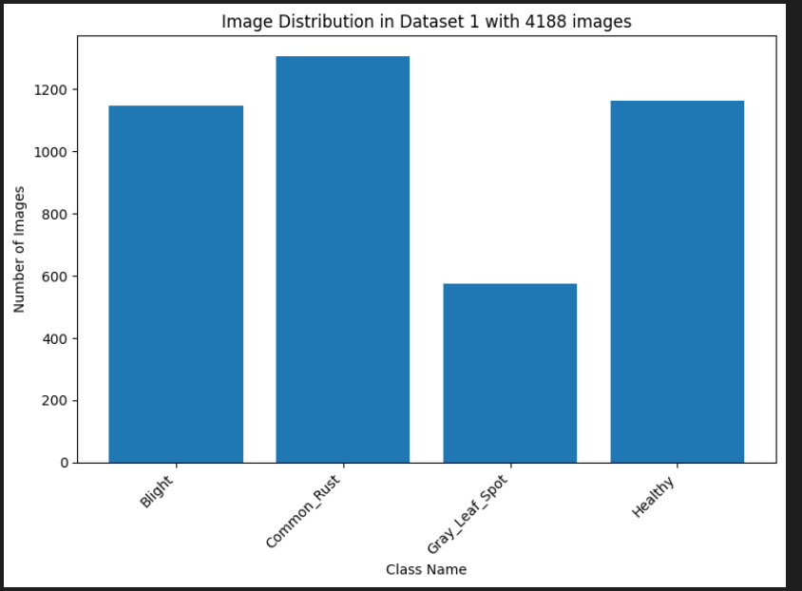

Figure 3.4.2‑2 Image and Class distribution of dataset 1

As seen from the figure above, dataset 1 has quite an imbalanced dataset where the class Gray_Leaf_Spot only has images with less than 600 while the other classes have more than 1100 images.

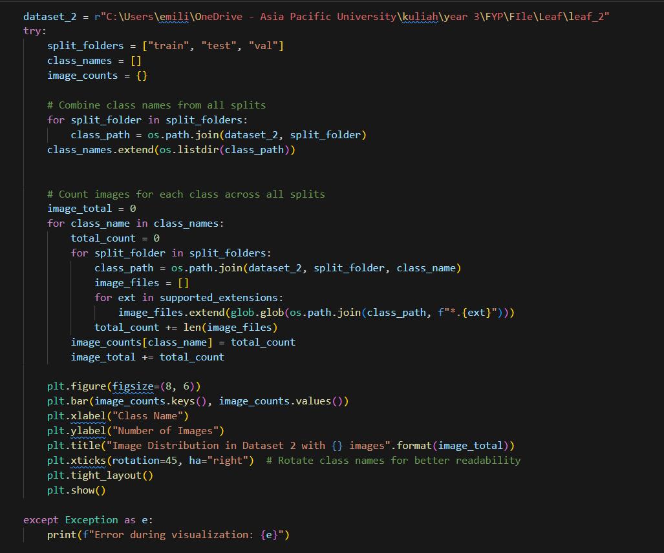

Figure 3.4.2‑3 Code to create image distribution of dataset 2

Using a similar logic, the 2nd dataset also traverse through the train, test, and validation folder to access all the class within those folders. Using os.path.join to generate the class path of the split_folder and the class_name, the image can be accessed through each folder and class category.

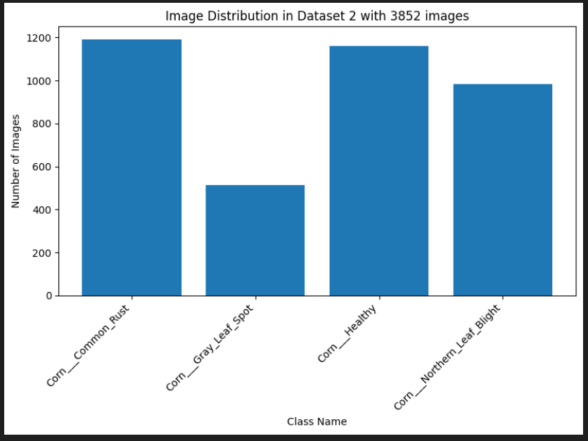

Figure 3.4.2‑4 Image and Class distribution of dataset 2

Similar to the first dataset, the 2nd dataset with a total of 3852 also has a problem of class imbalancy where the Corn_Gray_Leaf_Spot class is only around 500 while the others have more or near to 1000 images.

### Initial Preprocessing: Merging both datasets

After plotting the distribution and also the directories tree of both dataset, they are then merged together into one directory.

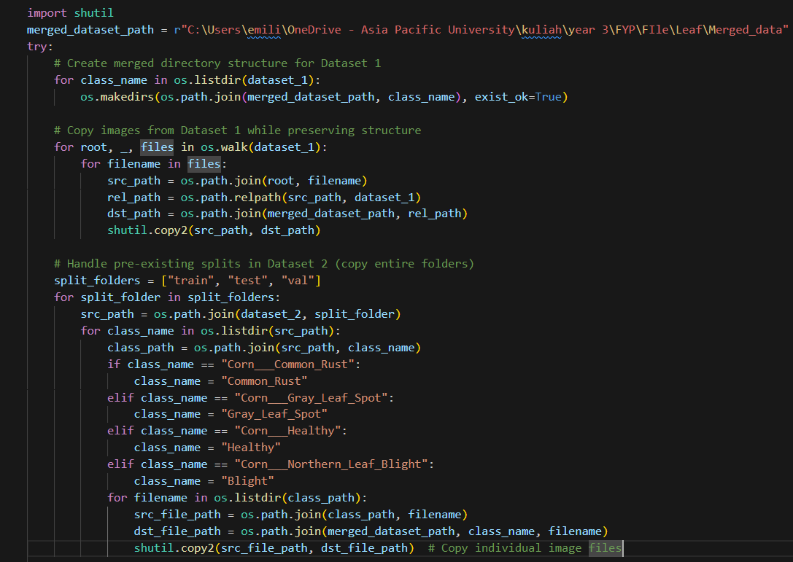

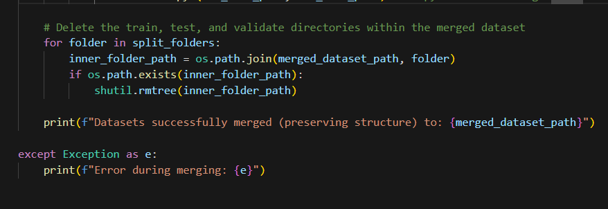

Figure 3.4.3‑1 Code to merged both datasets

First, the function iterate through all the class_name in dataset_1 by listing out the sub-directory of it. It then creates a specific pathname for the merged dataset which also includes each of the classes. The next process is to copy the first dataset into the merged dataset path by utilizing *shutil.copy2()* (GfG, 2022a).

The next process is to copy the directories of dataset 2. Since the class name of dataset 2 and 1 is not the same, a manual editing through file manager to standardize the name is done following the name on dataset 1. Since the train, test, and validation folders are also copied in the merged folders, it can be deleted by utilizing *shutil.rmtree()* function to remove a directory tree.

### Sample Images of all Classes

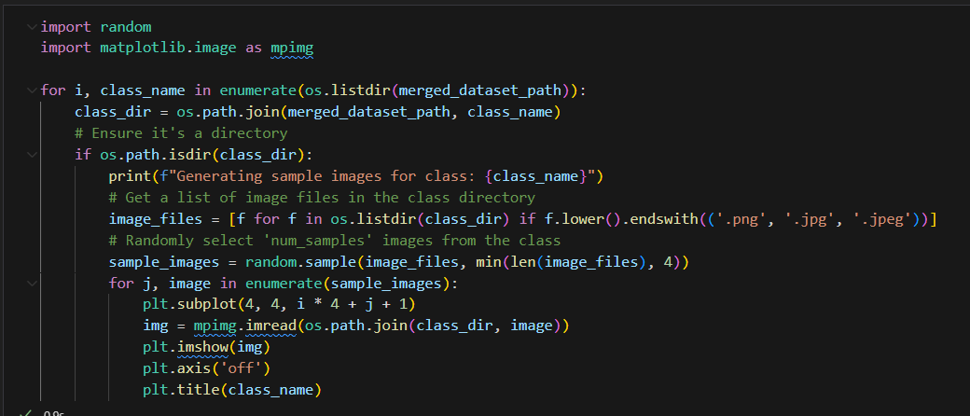

Figure 3.4.4‑1 Code to generate sample images of each class

Using the *random* library, images can be sampled randomly (GfG, 2018).

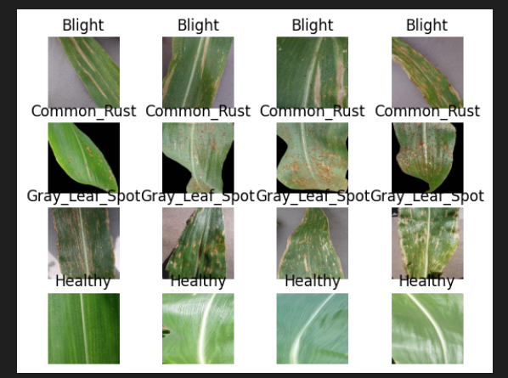

Figure 3.4.4‑2 Sample Images of 4 Classes

As seen from the figure above, there are different aspects of the leaves that can be identified in order to differentiate each disease. The Blight disease generally includes a larger area of the leaves that are damaged with a pale color. Common_Rust has spots over the leaves with red-ish color to it. Gray_Leaf_Spot have leaves with multiple spots with pale color, while Healthy leaves generally has no spot or damage seen.

### Image and Class Distribution for the Merged Dataset

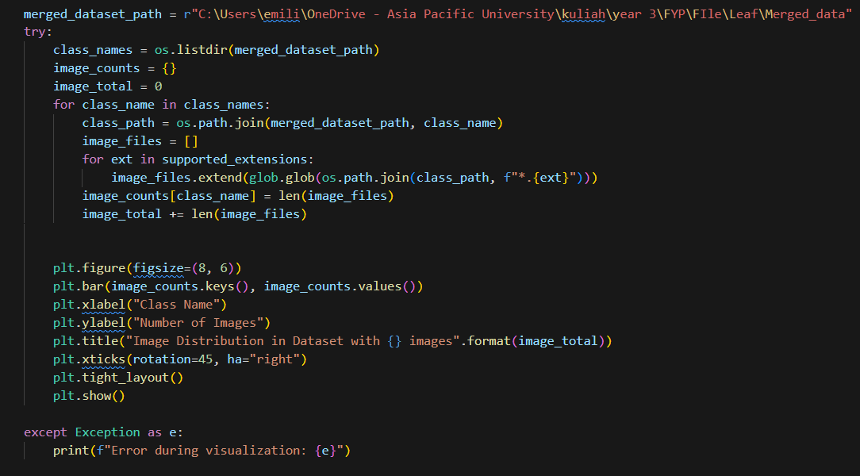

Figure 3.4.5‑1 Code to perform image and class distribution for the merged dataset

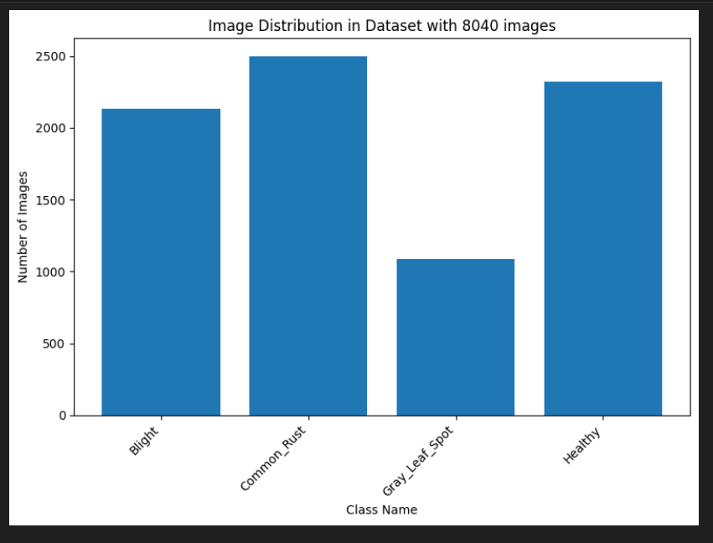

Figure 3.4.5‑2 Image and Class Distribution in the merged dataset

After the merged, the lowest class number, Gray_Leaf_Spot now has a total image of more than 1000, even though the class is still imbalanced. The class imbalance should be fixed later on in the preprocessing section by under sampling the dataset.

### Pixel Intensity of Each Class label

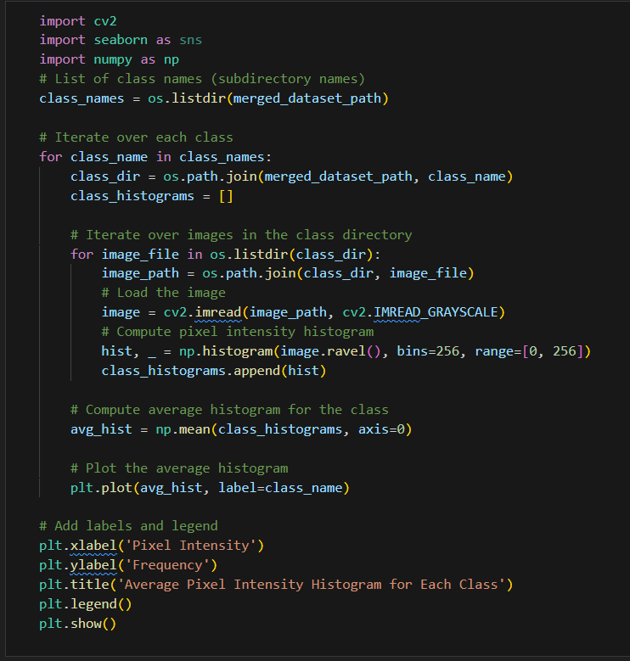

Figure 3.4.6‑1 Code to calculate and plot pixel intensity of the images.

In order to read the image data, *cv2* library is used. The library include function such as *imread()* to read the image. In the figure above, the image is also grayscale using *cv2.IMREAD_GRAYSCALE*. The reason for this is to calculate the intensity of the pixel (GfG, 2023b). The way that computer read an image data is in a form of a 2D NumPy Array where each element represent the pixel intensity ranging form 0-255 (black-white).

*np.histogram* is a function in NumPy which allows user to create a histogram (GfG, 2021). Using *image.ravel()* the 2D NumPy array is flattened into 1D format which is now readable for histogram (GfG, 2022a).The average value of each class is then calculated.

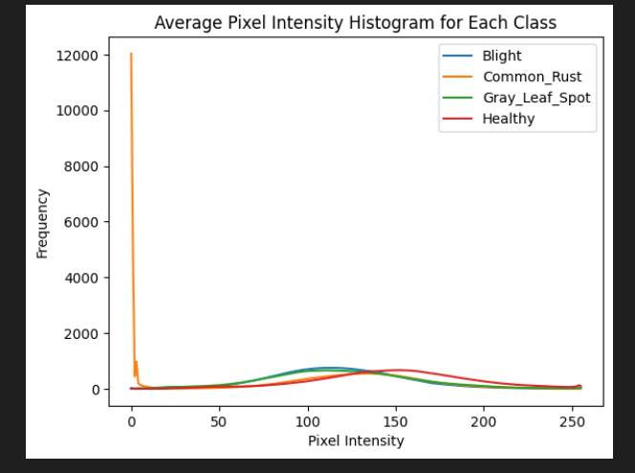

Figure 3.4.6‑2 Average Pixel Intensity Histogram for Each Class

As seen from the figure above, the number of 0 pixel intensity (black) is very high in Common_Rust data. This can be interpreted that the images in the Common_Rust directory have a large portion of dark or black color in it. Other than that, the common pixel range that can be seen are from 50-150 for Blight; 100-200 for Healthy; and 50-150 as well for Gray_Leaf_Spot.

### Color Analysis

. 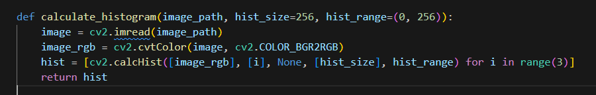

. 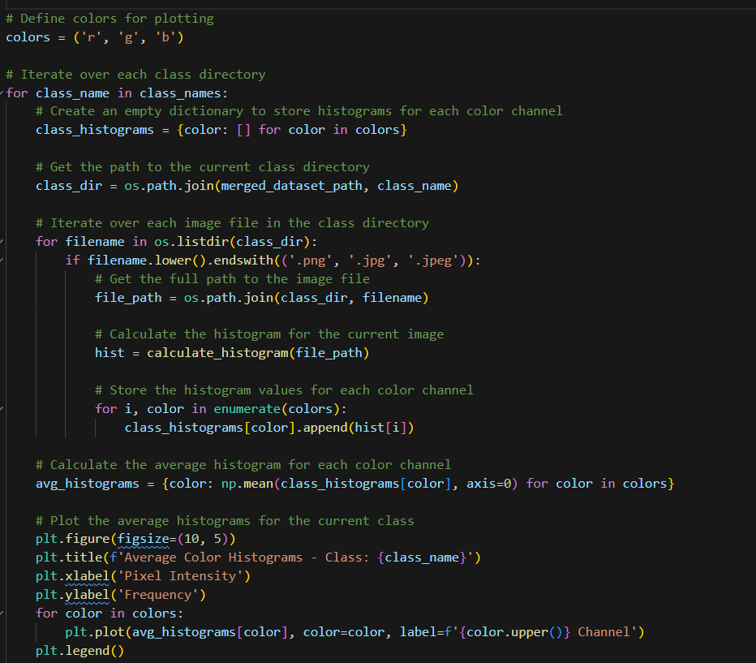

Figure 3.4.7‑1 Code to generate the color histogram for ecah class

In the function calculate_histogram, each image is read using *cv2.imread*(). OpenCV usually read image in BGR format(Blue Green Red), that’s why the image is converted back to RGB format to be readable in the histogram (GfG, 2023a).

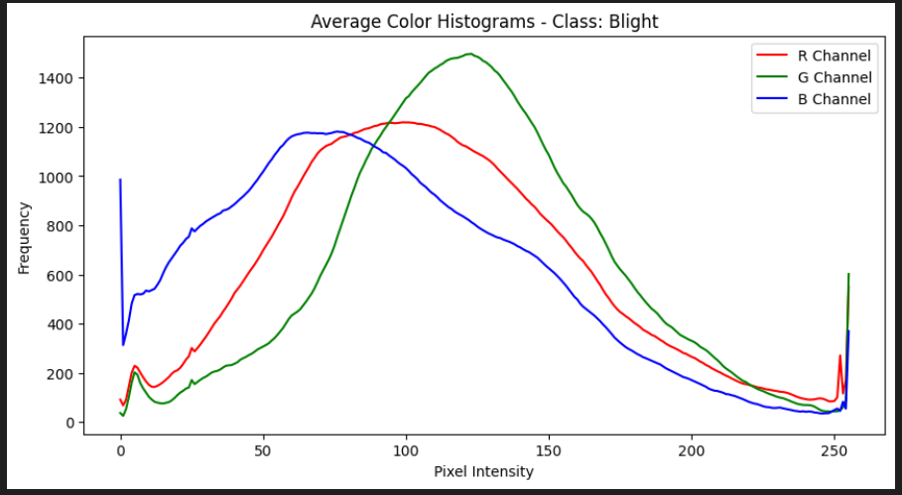

Figure 3.4.7‑2 Average Color Histograms of Blight

Based on the figure, the higher frequency of intensity is on green color around 100-150. Although a spike of a 0 blue value can also be seen reaching almost 1000 frequency which can be interpreted that there are around 1000 pixels in average that does not contain any blue color.

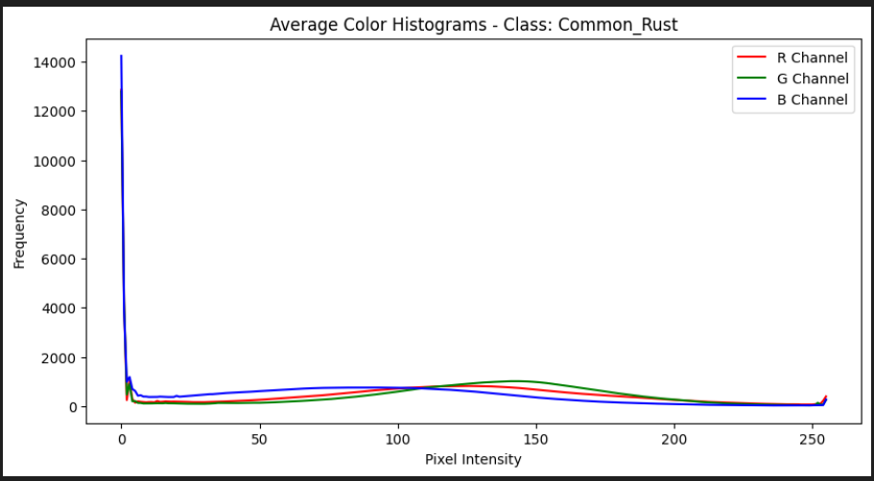

Figure 3.4.7‑3 Average Color Histogram of Common_Rust

The Common_Rust shows an interesting graph where the number of 0 intensity blue channel is more than 14000 pixels. Other than that value, the intensity of green channel at 150 seems to be higher than red and blue, implying the green color aspect of the leaves.

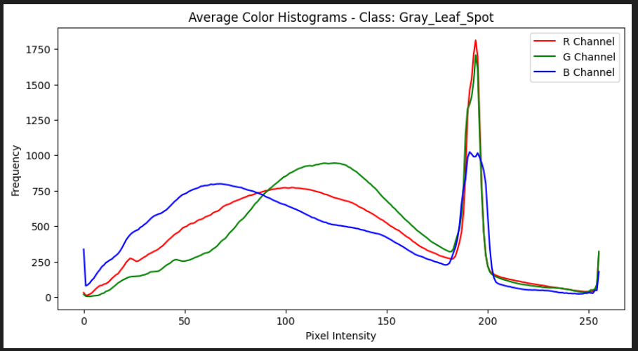

Figure 3.4.7‑4 Average Color Histograms of Gray_Leaf_Spot

Unlike the other classes, the red intensity of almost 200 can be seen with the highest frequency in Gray_Leaaf_Spot. This can be interpreted as a high occurrence of red and green color in the picture.

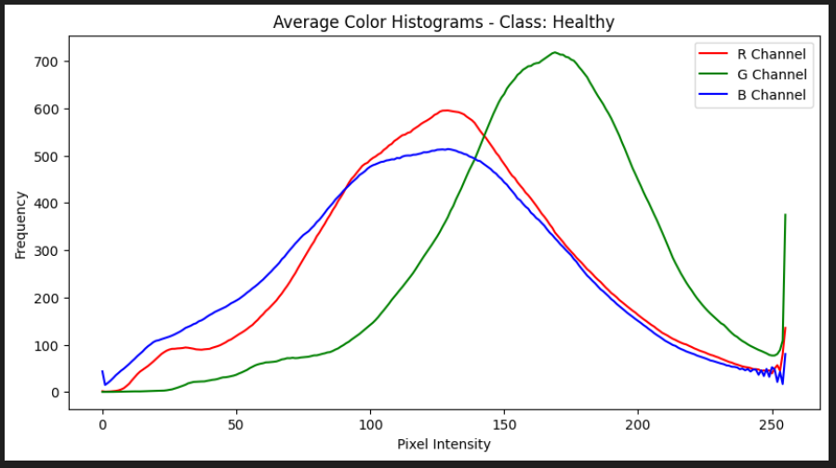

Figure 3.4.7‑5 Average Color Histograms of Healthy

.Finally, the Healthy leaves as hypothesized, the green intensity will be high and will be the most frequent color in the dataset. Followed by Red of 100-150 intensity.

### Image Resolutions

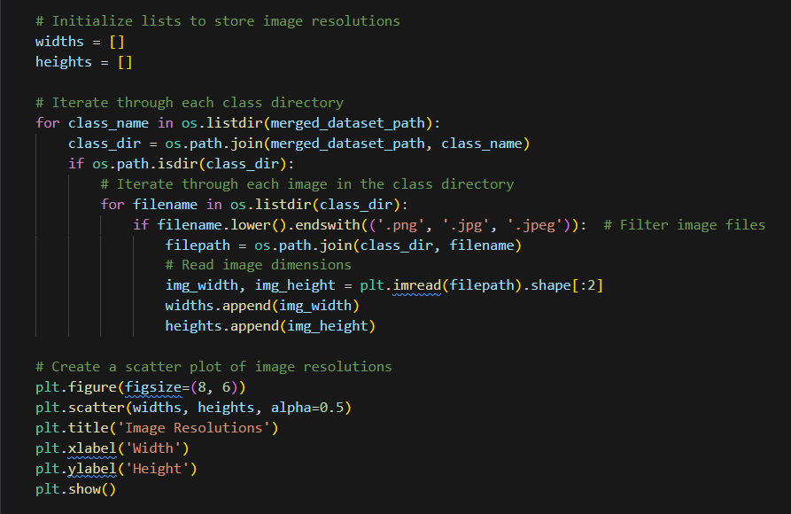

Figure 3.4.8‑1 Code to create scatter plot of width and height of the dataset

Using *plt.scatter()* the scatter plot of width and height of each image in the dataset can be mapped. This is important to check the overall size and dimensions of the dataset.

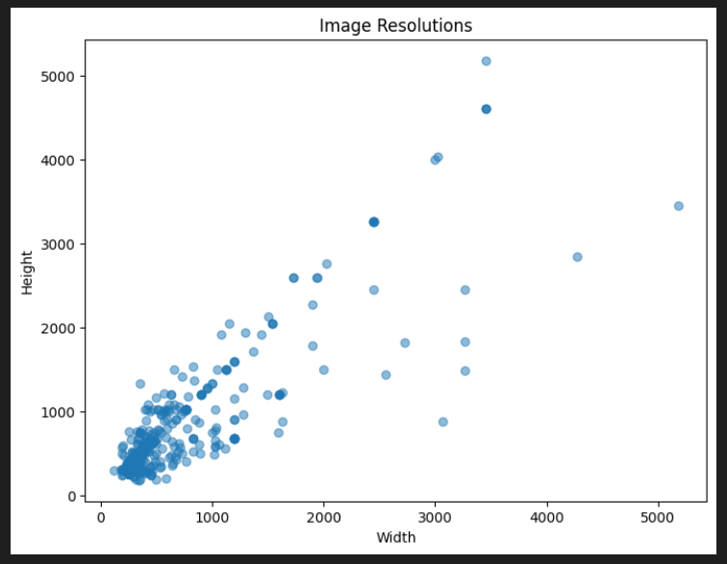

Figure 3.4.8‑2 Image Resolutions scatter plot

As seen from the figure above, majority of the dataset is located within the 1000 x 1000 range. The figure also shows that there is no standard size and dimensions in the dataset. This should be addressed and fixed later on by resizing all of the images into one dimension.

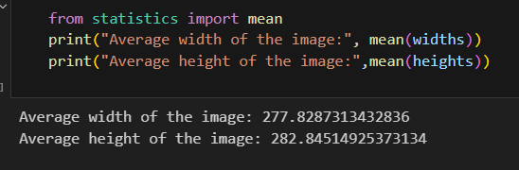

Figure 3.4.8‑3 Average widths and heights of the dataset

By using statistics, the average width and height of each image can be calculated which are 277.82 and 282.84 respectively. This also means that most of the image in the dataset are actually square (having the same width and height). This information shows the researcher that the standardize dimensions of the image should be closed to the average that has been calculated.

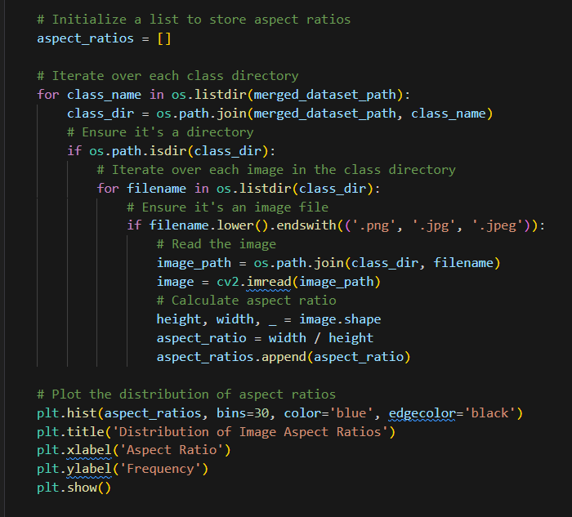

Figure 3.4.8‑4 Code to calculate aspect ratio

In order to support the notion above, the aspect ratio of each image is also plotted and calculated.

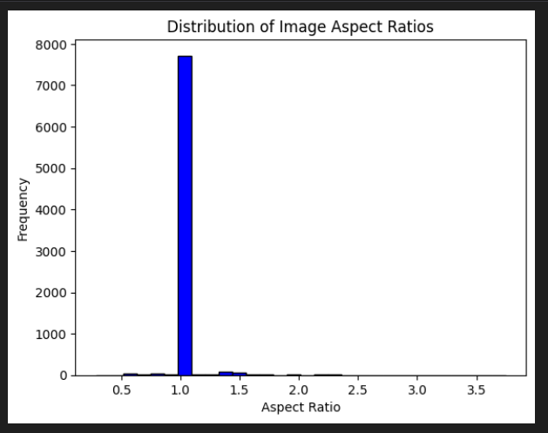

Figure 3.4.8‑5 Distribution of Image Aspect Ratios

The histogram above shows that more than 7500 images have aspect ratio of 1, which means that those are square images while only a few images have different aspect ratio. This also should be addressed by resizing every image into a square format (aspect ratio of 1).

## Data Preprocessing/ Data Preparation

Based on the issues and error that have been addressed in the previous section, the data will be processed and prepared for further analysis and also transformed for model input.

### Image Resizing

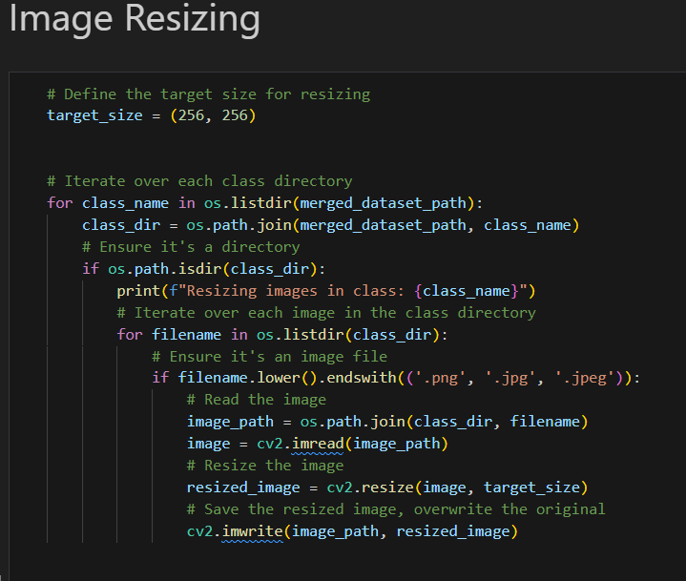

Figure 3.5.1‑1 Code to resize image

One of the problem that has been addressed during the data understanding and exploration phase is the different aspect ratio and dimension of some image within the dataset. The images are the resize into one standard dimension. In this case, 256 x 256 is chosen as the dimension as it is one of the highly used and common dimensions (Chandrasekaran, 2022).

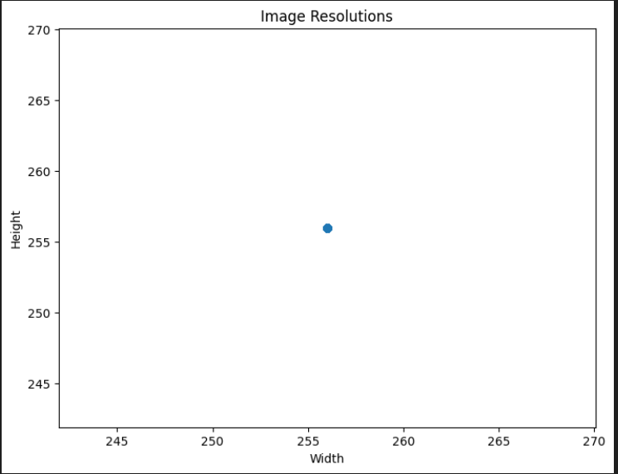

Figure 3.5.1‑2 The resolution of the processed dataset

Using the same code in the EDA process, a scatter plot is generated again, but this time the dimension of all the images have been resized to 256 x 256, fixing the unstandardized issue within the dataset.

## Feature Extraction Process

This section will discuss and explore the features extraction process which is a mixed of data exploration and data preparation where the image can be analyzed but also processed to get the better output.

### Edge detection

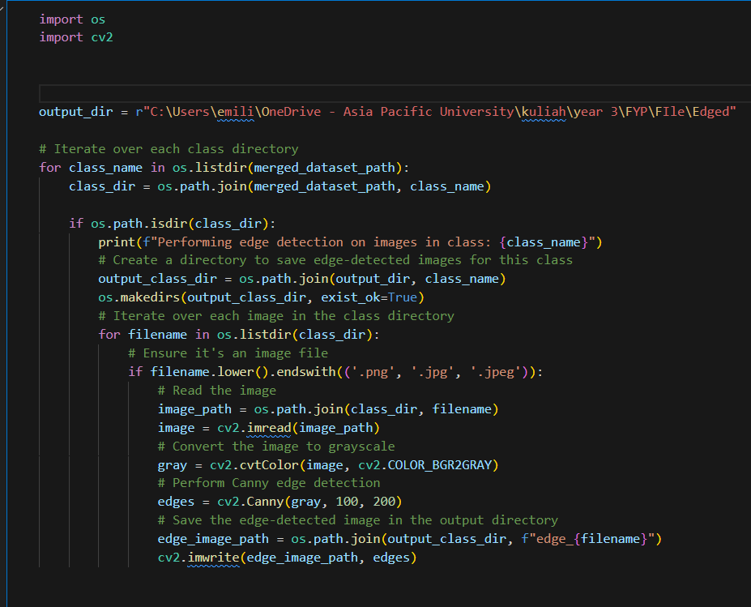

Figure 3.6.1‑1 Code to perform edge detection

In this section, an edge detection process is performed. Edge detection refers to a method in image processing where edge or boundaries of the image is detected and highlighted. The *canny()* function is applied to create the canny edge filter on the image. It is using 100 and 200 as the parameters which refer to the lower and higher threshold of Hysteresis Thresholding (GfG, 2023b).

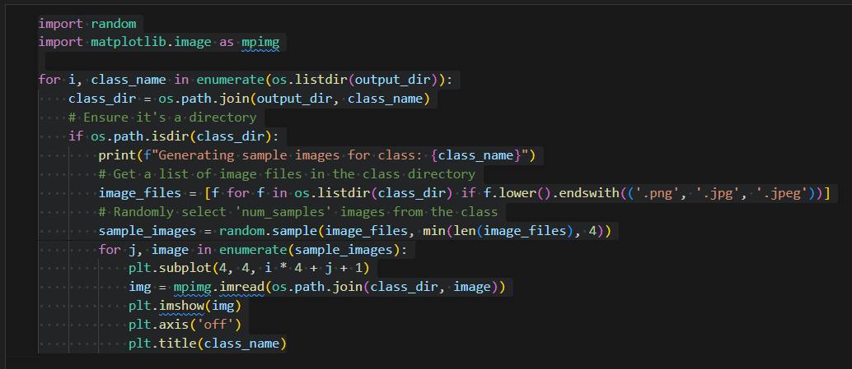

Figure 3.6.1‑2 Code to show the sample edge filtered images

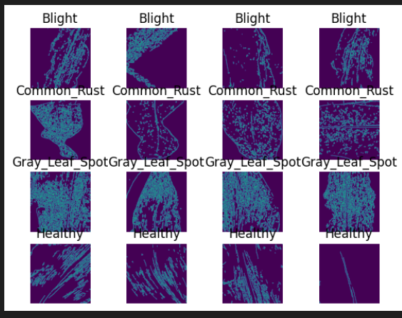

Figure 3.6.1‑3 Edge Filtered Images

As seen from the figure above, the edge filtered images have been created and boundaries of the leaves including the damage area and texture of the leaves can be plotted.

### Contour Feature

Similar to edge detection, contour feature is also a method where the outlines and curves of the object, typically detected from the change of color intensity, are detected. This technique is also specifically important to detect the damage area within the leaves.

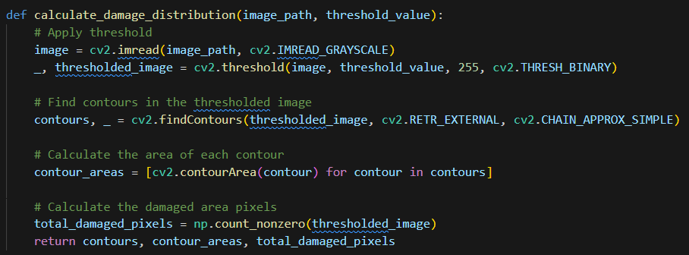

Figure 3.6.2‑1 Function to calculate the damage and contour areas

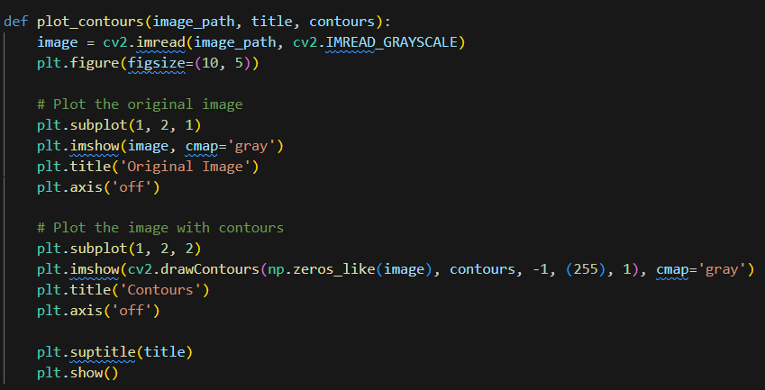

Figure 3.6.2‑2 Function to plot the original and contour image

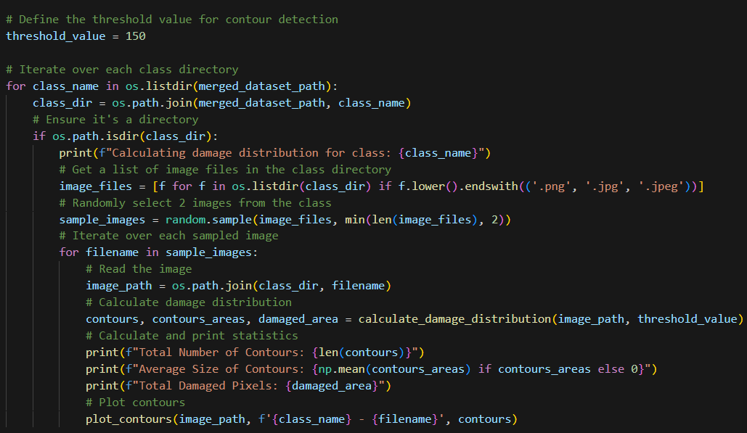

Figure 3.6.2‑3 Code to iterate through sample images

The cv2 library contains several functions to calculate and detect contours of the image. First of all the threshold_value is defined. Each threshold_value can affect how sensitive the function will detect the contour. The image is first converted to gray scale and thresholded into black and white pixels using *cv2.threshold()* (GfG, 2023d). *cv2.findcontours()* function is then used to calculate the contours value that is stored in a NumPy array. Moreover, the *cv2.drawcontours()* function is used to generate the contour images (*OpenCV: Contours : Getting Started*, n.d.) in *plot_contours().* The *calculate_damage_distribution()* function returns the number of contours found, the area of the contours, and also the total number of pixels that are marked or highlighted.

#### Threshold = 150

.

.

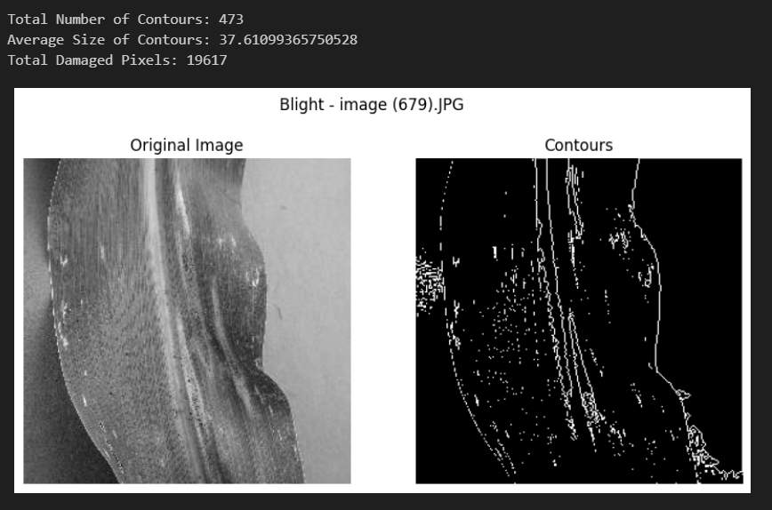

Figure 3.6.2‑4 Contour Result of Blight

Based on the contour result, Blight has a smaller amount of contour but with quite a huge size of it.

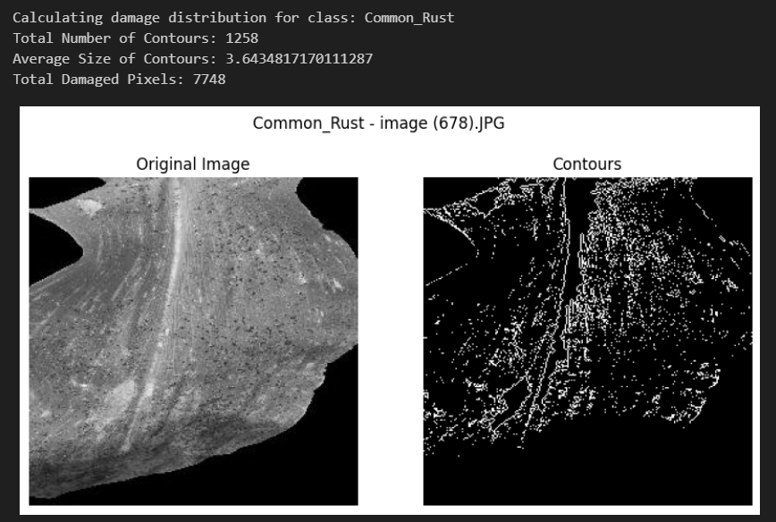

Figure 3.6.2‑5 Contour Result of Common_Rust

Common_Rust on the other hand has a large amount of contour but most of them has an average size of 3.6 which is relatively small compared to Blight.

.

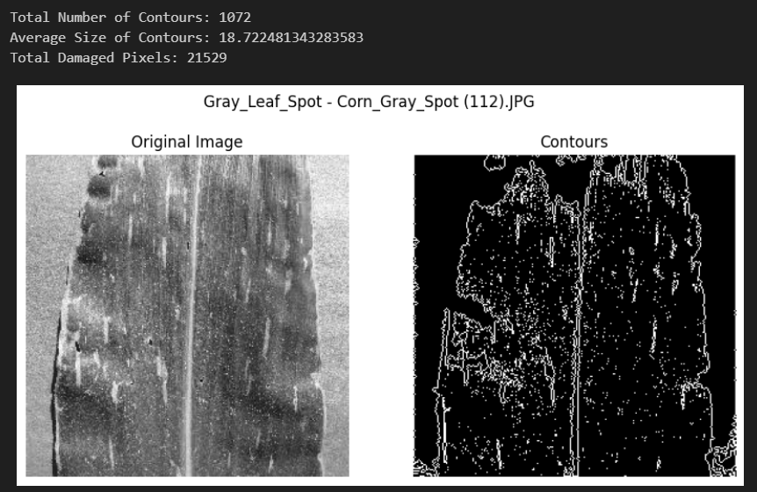

Figure 3.6.2‑6 Contour Result of Gray_Leaf_Spot

Gray_Leaf_Spot has a similar property with Common_Rust where the number of contours are huge but with a slightly smaller contour size.

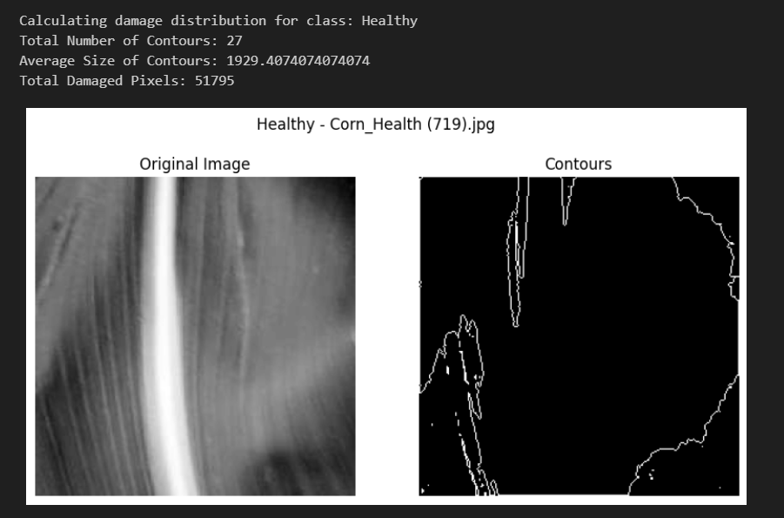

Figure 3.6.2‑7 Contour Result of Healthy

Healthy leaves are supposed to have a small number of contours with the change of color from the root of the leaves. This should result in a huge size of contour itself.

#### Threshold = 100

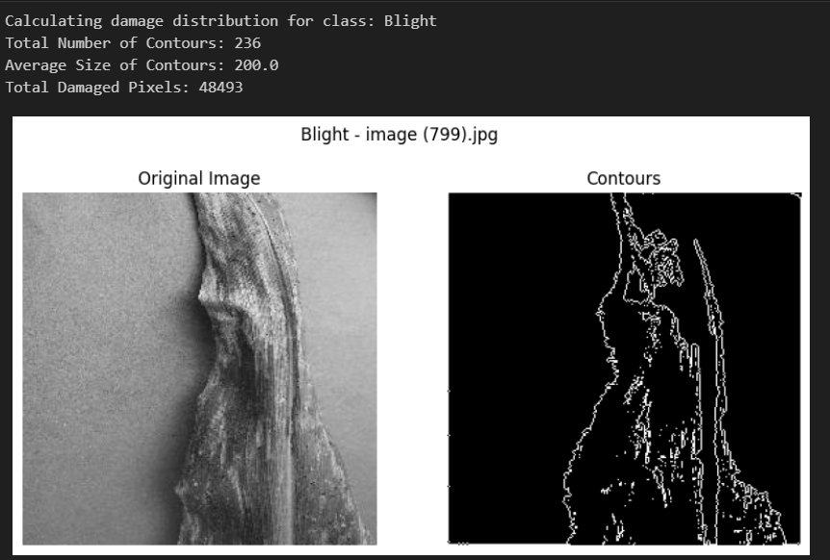

Figure 3.6.2‑8 Contours of Blight

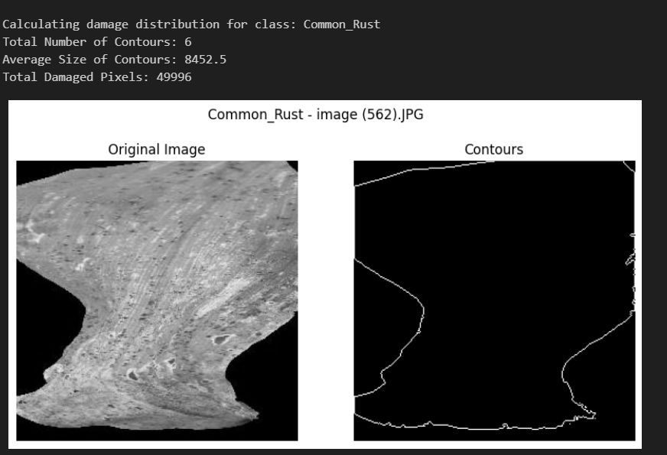

Figure 3.6.2‑9 Contours of Common_Rust

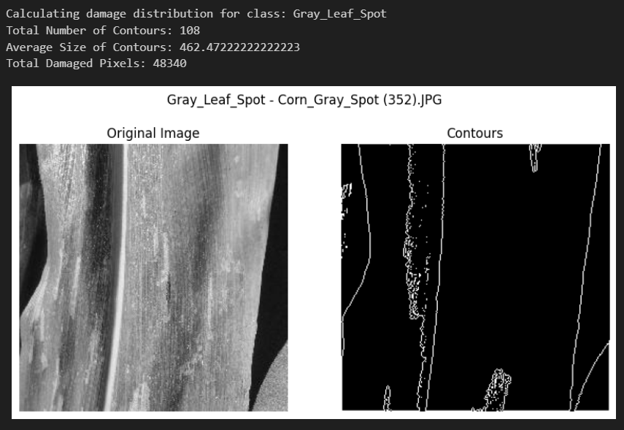

Figure 3.6.2‑10 Contours of Gray_Leaf_Spot

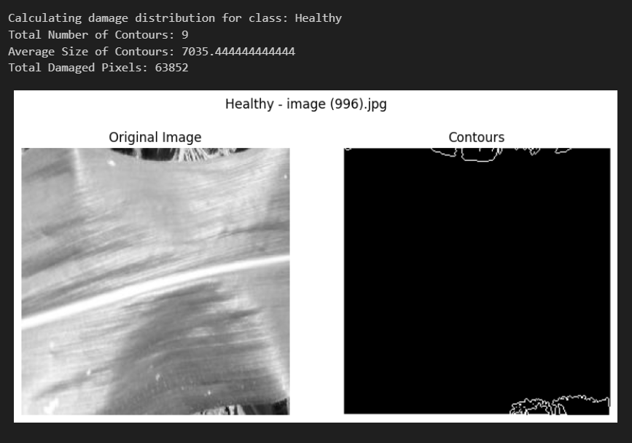

Figure 3.6.2‑11 Contours of Healthy

With a different threshold value, the result achieved from the contours generator can also be different. Generally, with a smaller threshold more pixels and larger region of the object will be included, which also means that the sensitivity of the contour is also increased.

### Gabor Feature

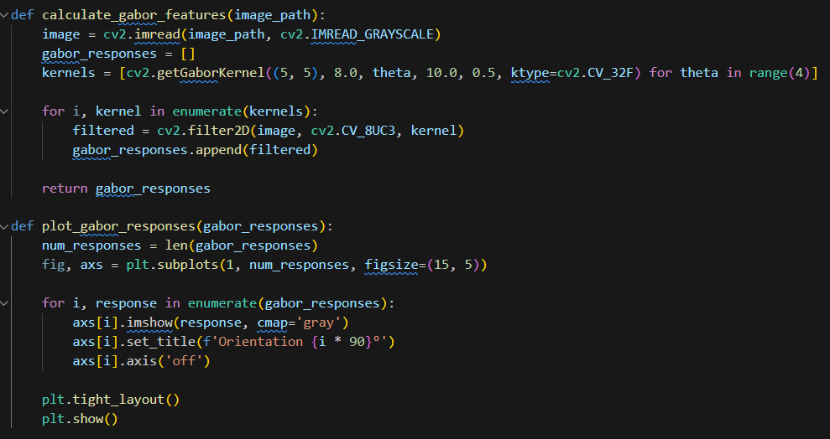

Figure 3.6.3‑1 Function to calculate and plot Gabor feature

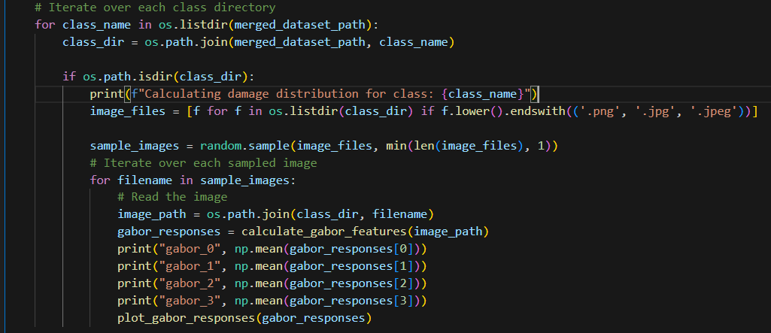

Figure 3.6.3‑2 Iterating through the dataset and calling Gabor function

Cv2 library also includes a function for calculating Gabor responses. *Cv2.getGaborKernel*() is a function that helps perform Gabor filtering by returning the Gabor Kernel or Gabor Responses (GfG, 2023f).



Figure 3.6.3‑3 Parameters of getGaborKernel() from (GfG, 2023f)

Ksize = kernel size 🡪 5,5

Sigma = standard deviation of the Gaussian envelope 🡪 8.0

Theta = Orientation of the Gabor filter 🡪 theta in range (4)

Lambda = wavelength of the sinusoidal factor 🡪 10.0

Gamma = spatial aspect ratio of the filter 🡪0.5

Psi = phase offset of the filter

Ktype = datatype of the kernel. 🡪32 bit floating point.

The kernels are then applied using 2Dfilter function available in cv2 to be applied on the image.

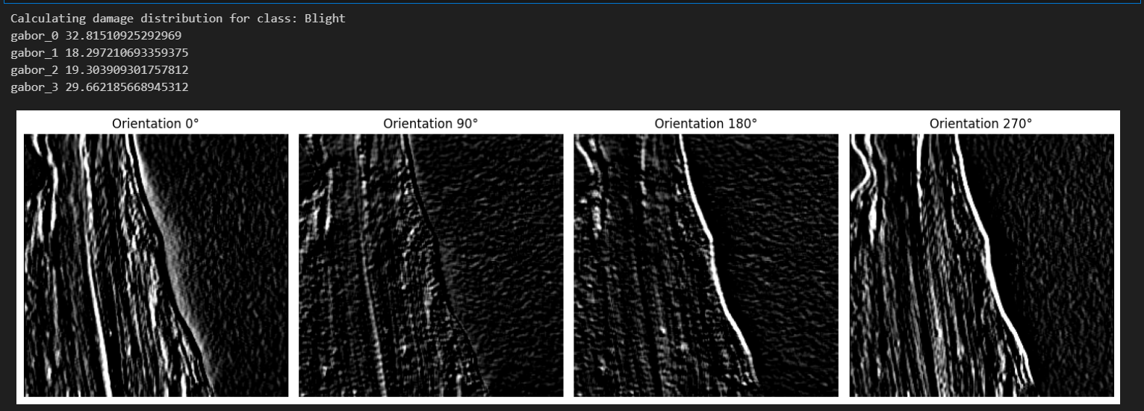

Figure 3.6.3‑4 Gabor Response of Blight

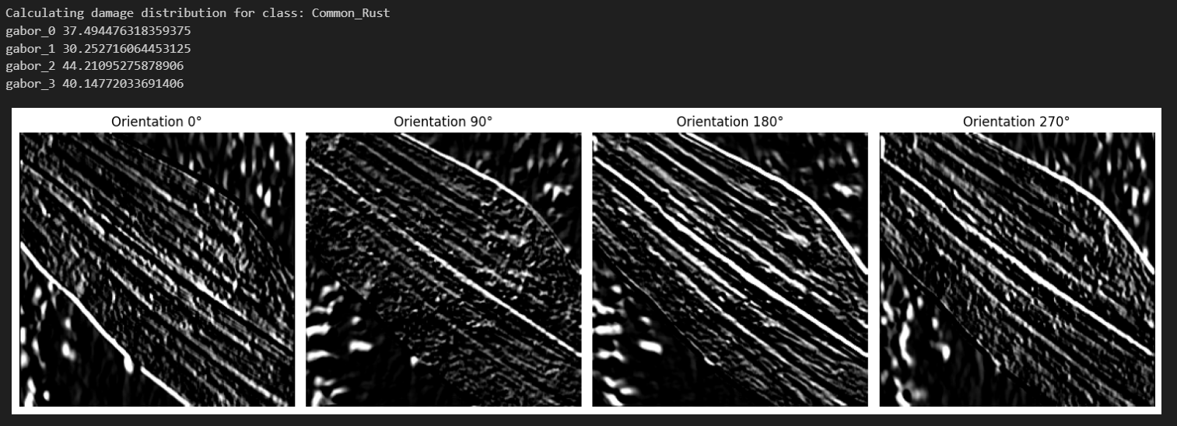

Figure 3.6.3‑5 Gabor Response of Common_Rust

. 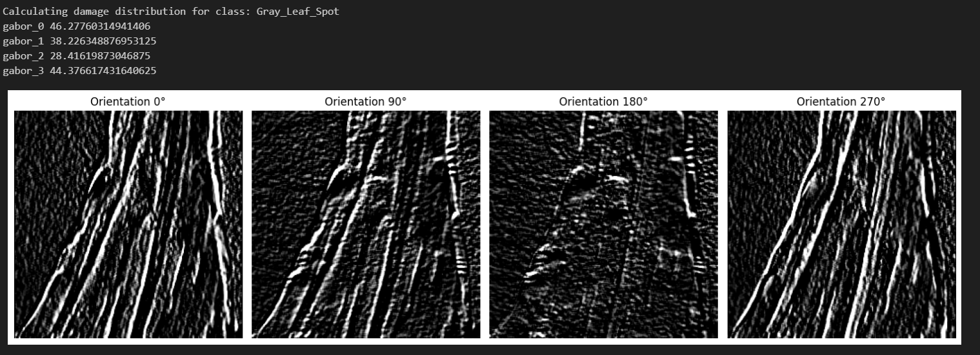

Figure 3.6.3‑6 Gabor Response of Gray_Leaf_Spot

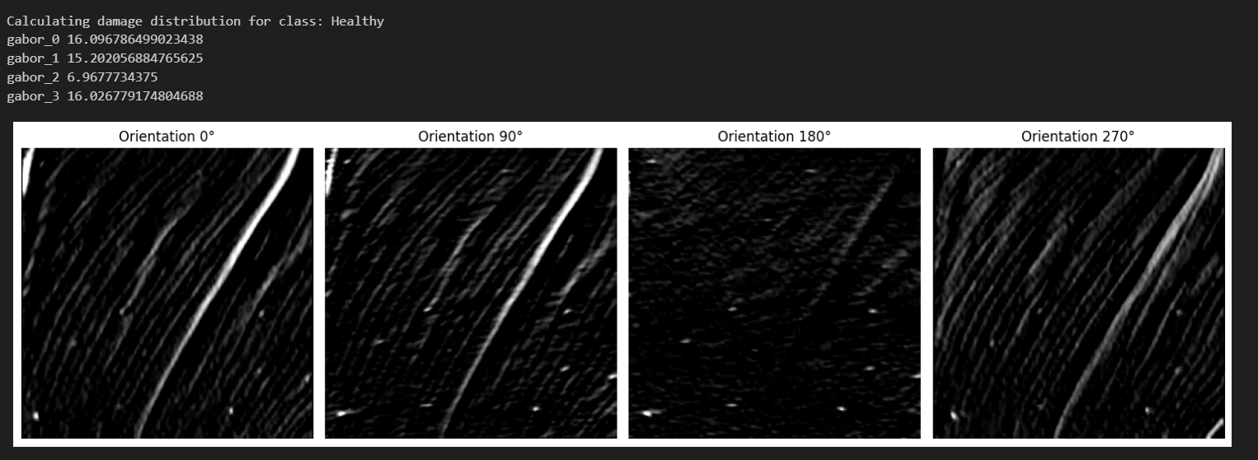

Figure 3.6.3‑7 Gabor Response of Healthy

Each Gabor response represents the value from each orientation. A higher value typically represents a stronger alignment with the orientation and frequency which also result to higher detail. These 4 features can be used as the input for the prediction model.

### Gray Level Cooccurrence and Haralick Feature

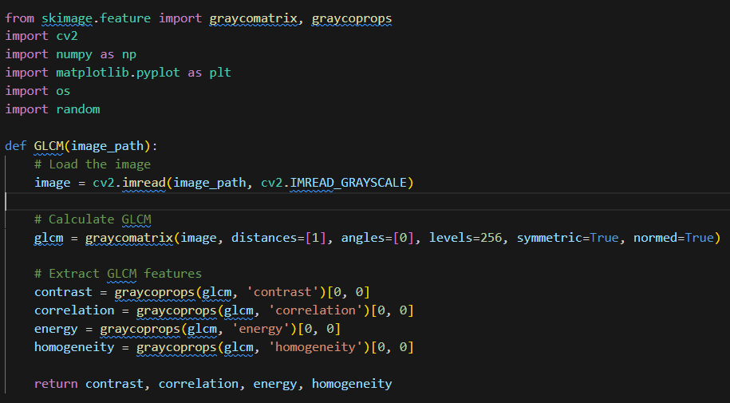

Figure 3.6.4‑1 Function to calculate the gray level coocurence matrix

The graycomatrix function is imported through the skimage.feature library from scikit-image(*Skimage.Feature — Skimage 0.22.0 Documentation*, n.d.). Based on the matrix, the texture feature of the image can be extracted using graycoprops function which can extract contrast, correlation, energy, homogeneity. The definition of these are discussed back in Chapter 2.2.6. These features are then called Haralick feature.

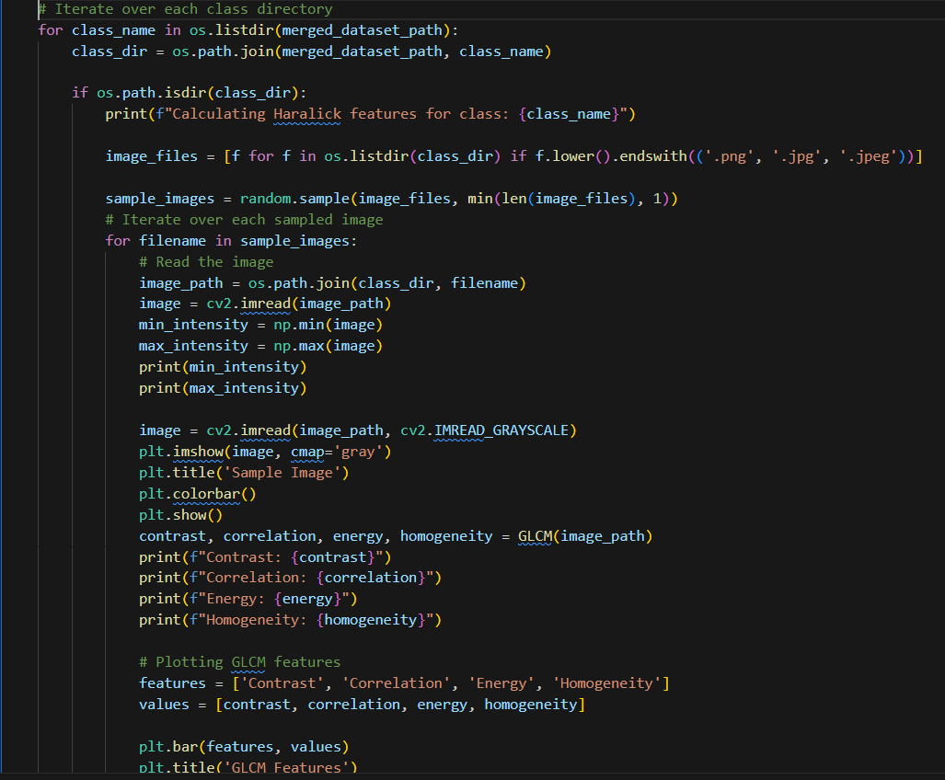

Figure 3.6.4‑2 Code to apply the GLCM and printing out the Haralick feature

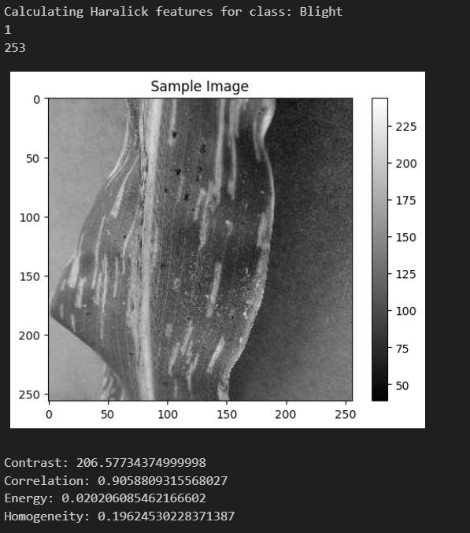

Figure 3.6.4‑3 Sample result of the GLCM and haralick feature

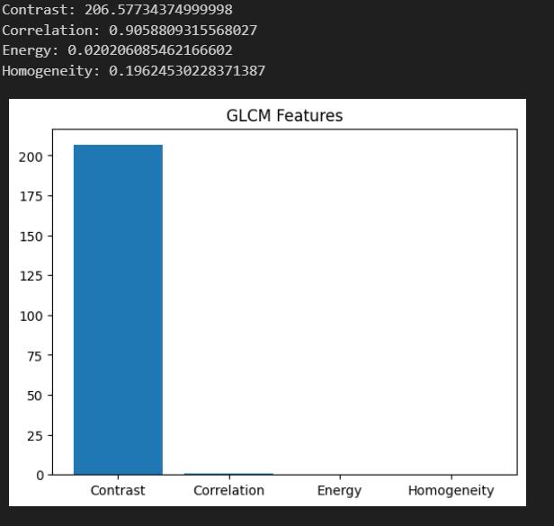

Figure 3.6.4‑4 Bar Graph of the GLCM and haralick feature

The 4 haralick/ GLCM features can also be extracted to be used as inputs in the model building phase.

### Feature Extraction to CSV File

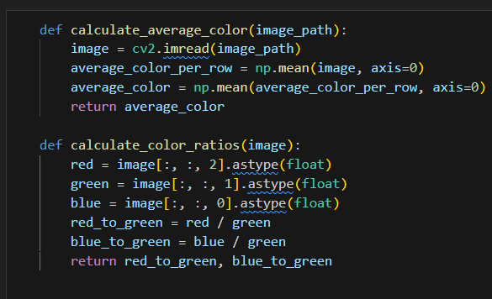

Figure 3.6.5‑1 Function to calculate average color and color ratio

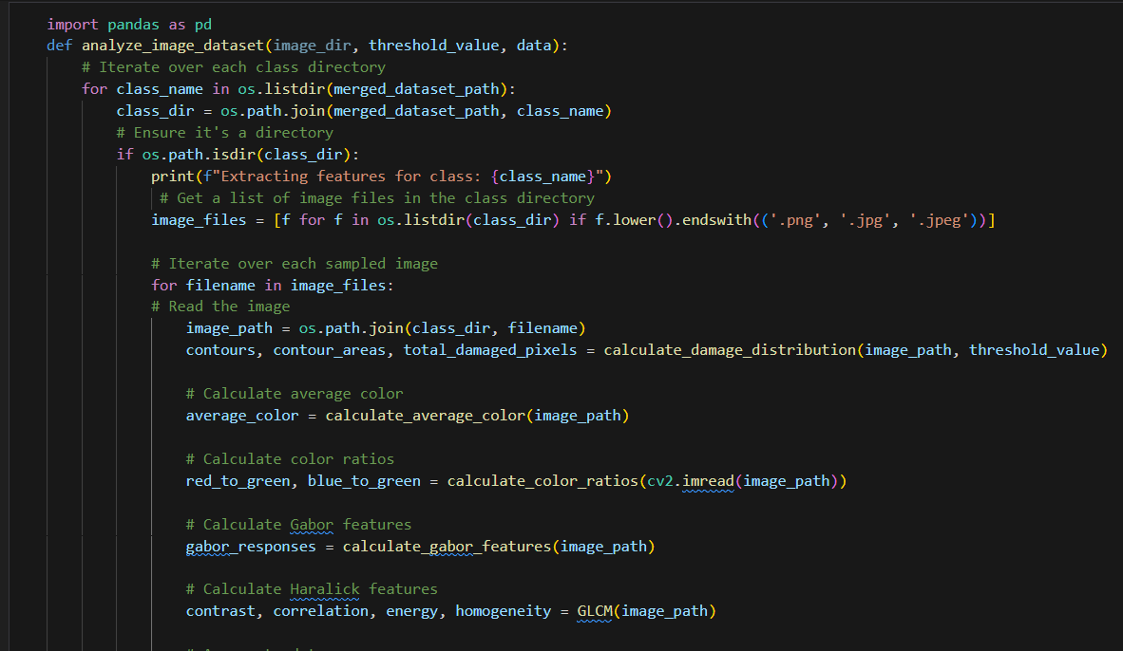

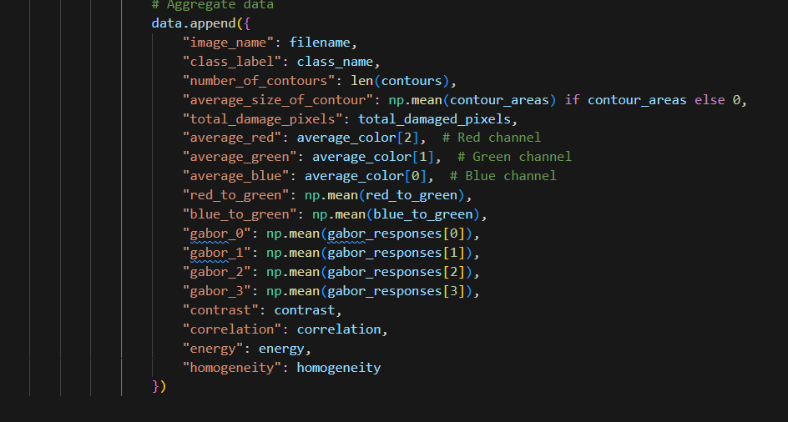

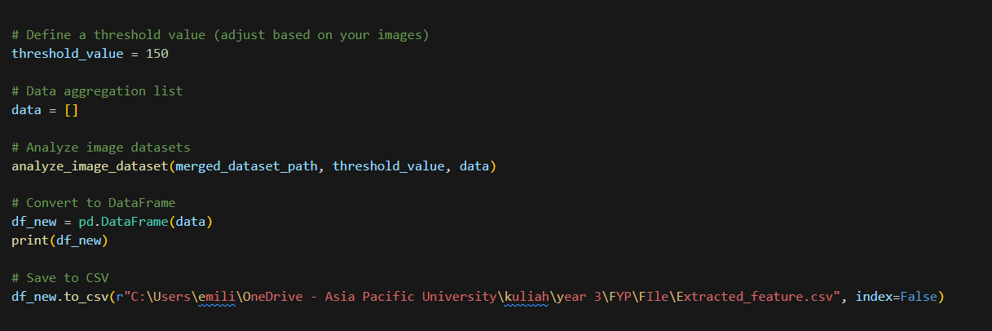

Figure 3.6.5‑2 Code to extract all the features to a csv file

Based on what the researcher has gone through such as contour, gabor feature, haralick/ gray level coocurence matrix features and also color feature, the data is extracted and merged into a dataframe and csv file.

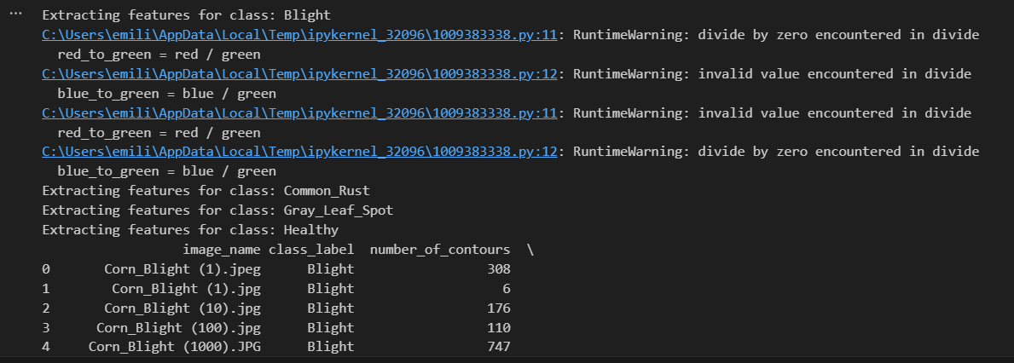

Figure 3.6.5‑3 Warning and errors during the convertion

As seen from the warning message above, there will be an issue such as infinite and missing value due to the calculation of the color ratio. This might occur because of 0 value pixels on some images.

## EDA and Processing for Extracted Feature

### EDA and Overview of the Data Frame

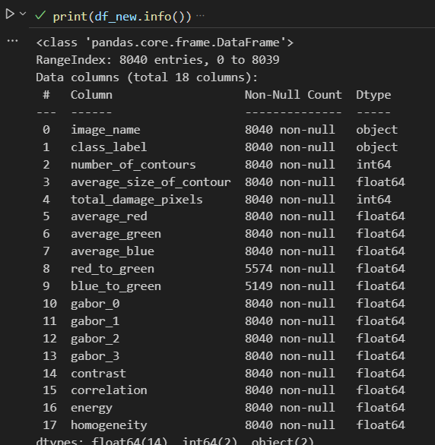

Figure 3.7.1‑1 Information about the extracted feature data frame

There are 18 columns in the dataframe in total for each feature. This includes the file name and also class_label for the image. The class_label will be the target variable for the prediction.

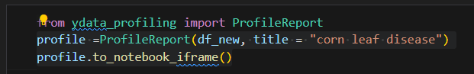

Figure 3.7.1‑2 Profile Report EDA on the dataframe

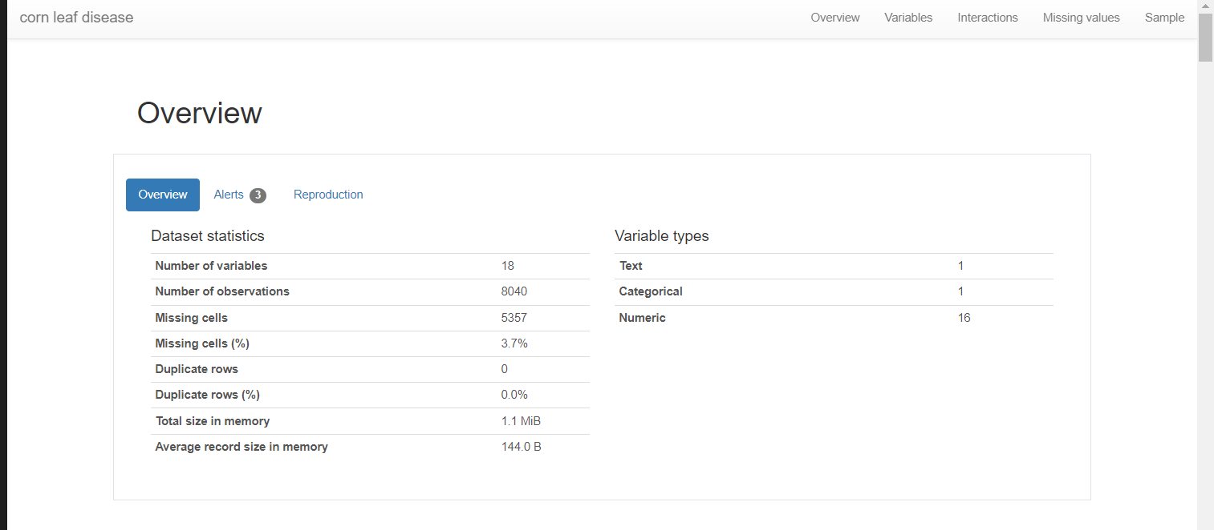

Figure 3.7.1‑3 Overview of the dataframe

As seen in the overview, there are 5367 missing cells that occur during the calculation of the color ratio. This issue should be fixed before undergoing further EDA process as the correlation plot would not be accurate with missing values.

#### Class_label

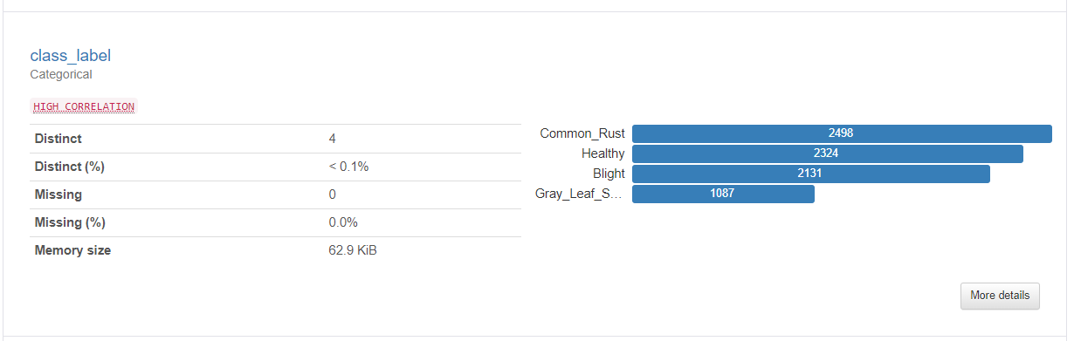

Figure 3.7.1‑4 Overview of class_label

As seen back in Chapter 3.4.5, class imbalance can be seen from the dataset where Common_Rust has the highest amount of data at 2498 images followed by Healthy leaves data at 2324 images. However the Gray_Leaf_Spot class has only 1087 images which cause imbalance issue within the dataset. This is then fixed by undersampling the dataset which is dropping the dataset to follow the lowest class value.

#### Number_of_contours

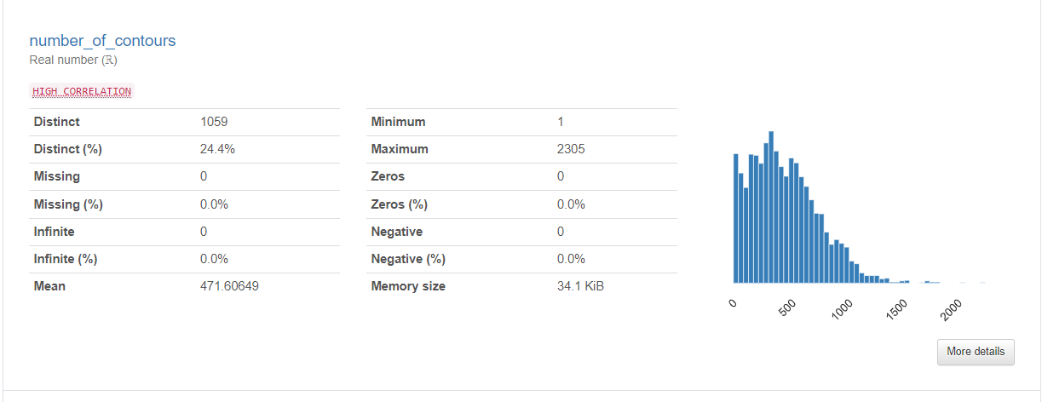

Figure 3.7.1‑5 Overview of number_of_contours

Number_of_contours, as the name implies, contain the number of contours that has been detected in an image. It has an average value of 471.60649. The majority of the contour can be found between 0 to 1000.

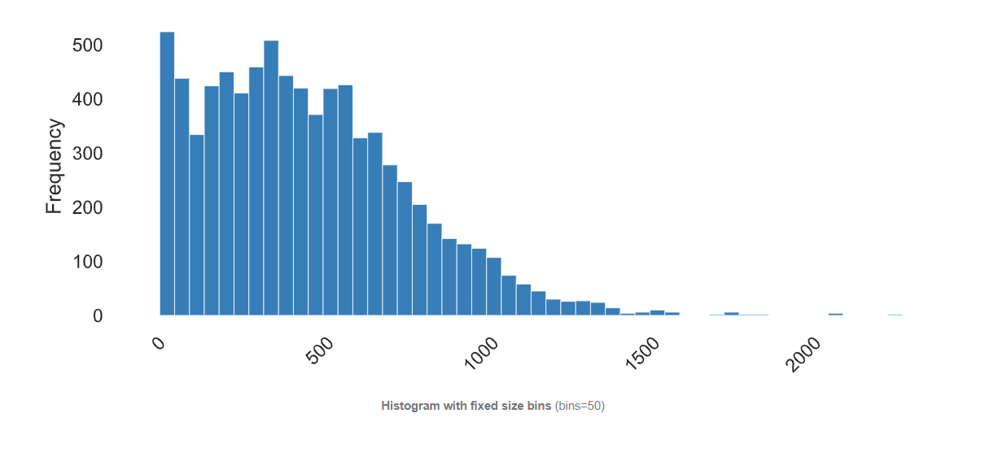

Figure 3.7.1‑6 Detailed histogram of number_of_contours

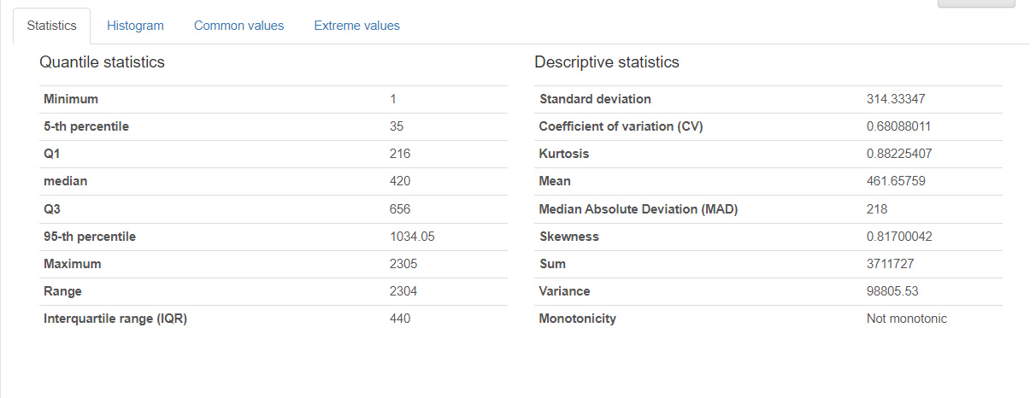

Figure 3.7.1‑7 Detailed statistics of number_of_contour

The detailed statistics provided through ProfileReport include information such as Interquartile Range (IQR) which can be calculated from the first and third quartile (Q1 and Q3) which falls in 25% and 75% of the dataset. The standard deviation of the variable is also quite high at 314.33. Based on this quartile the extreme values within the variable can be identified such as:

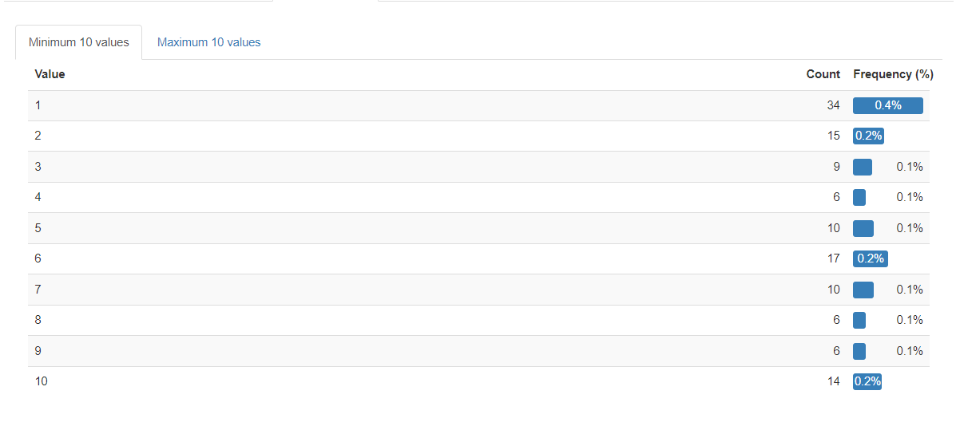

Figure 3.7.1‑8 Minimum Extreme Values in number_of_contours

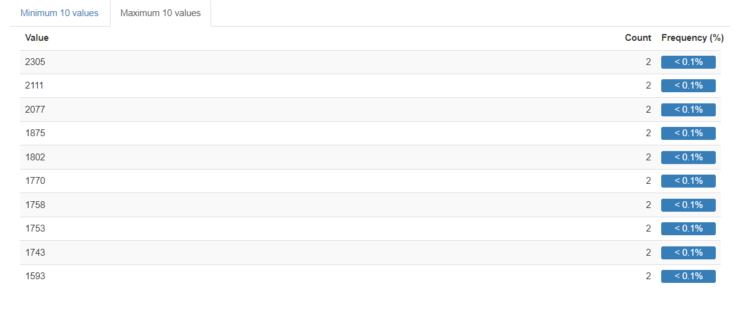

Figure 3.7.1‑9 Maximum extreme values in number_of_contours

#### Average_size_of_contour

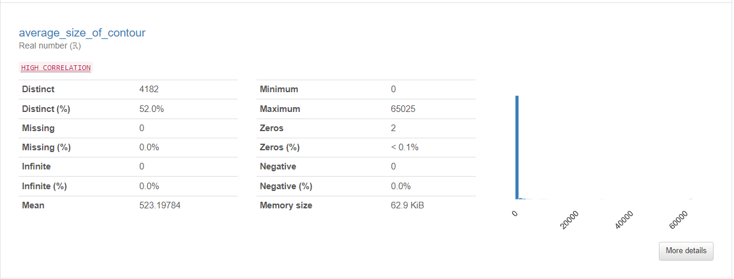

Figure 3.7.1‑10 Overview of average_size_of_contour

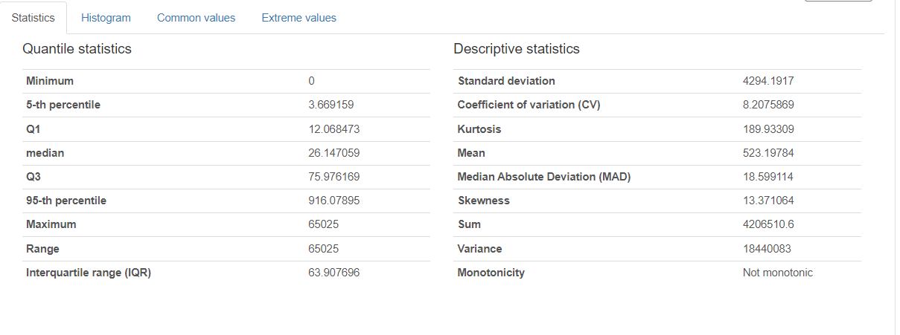

Figure 3.7.1‑11 Detailed Statistics of average_size_of_contour

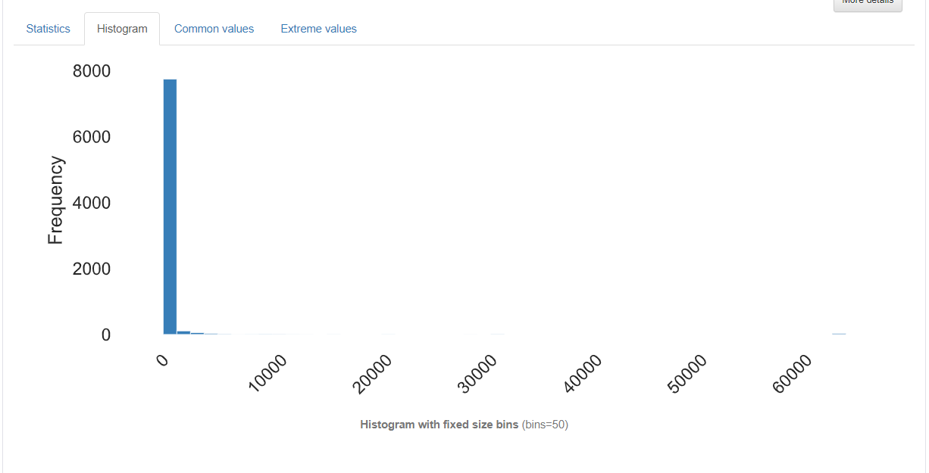

Figure 3.7.1‑12 Histogram of average_size_of_contour

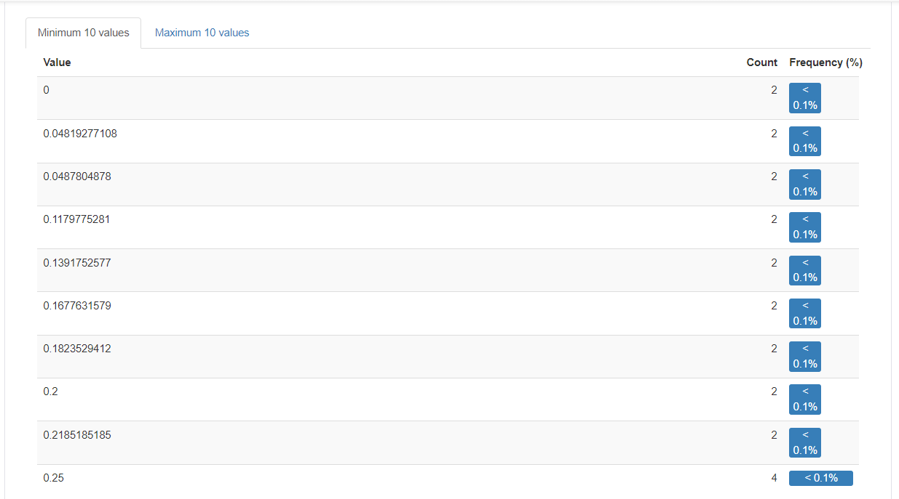

Figure 3.7.1‑13 Minimum Exteme Values of average_size_of_contour

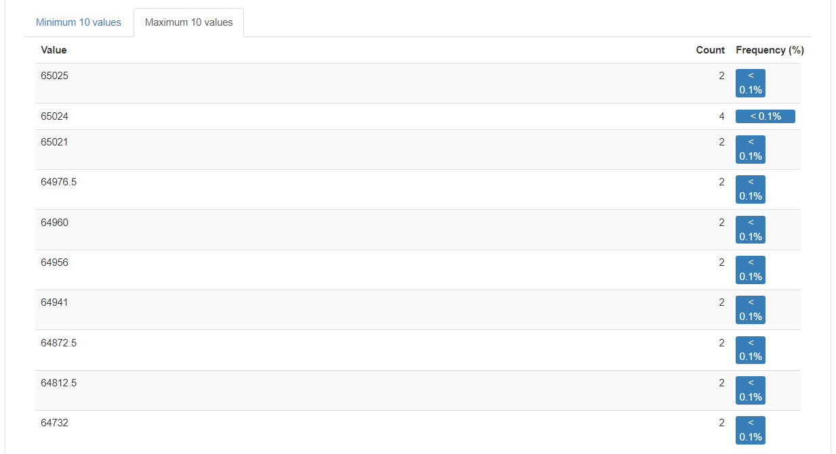

Figure 3.7.1‑14 Maximum extreme values of average_size_of_contour

Based on the histogram shown above, there are a number of maximum extreme values typically above the range of 60000. However the normal range and IQR of the dataset is only from 12 to 75.9 (Q1-Q3), hence the imbalanced distribution on the histogram. This can happen due to bad quality of image, threshold setting that is too sensitive during the contour detection, etc. The average (mean) of the dataset is 523.19 which is the average size of all contours in the dataset. Moreover, the standard deviation of the variable is consider very high at 4294.1917. This means that the data is spread out across the histogram over a wider range compared to the mean. Moreover, the graph also shows a high skewness of 13.37 which exceeded the normal range.

#### Total_damage_pixels

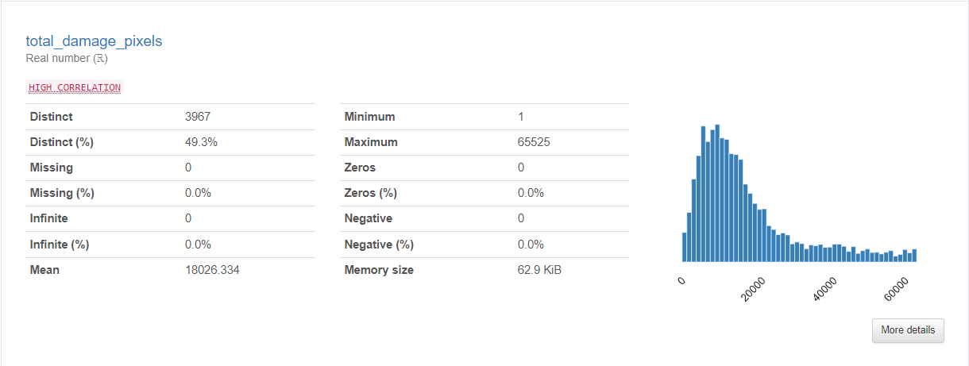

Figure 3.7.1‑15 Overview of total_damage_pixels

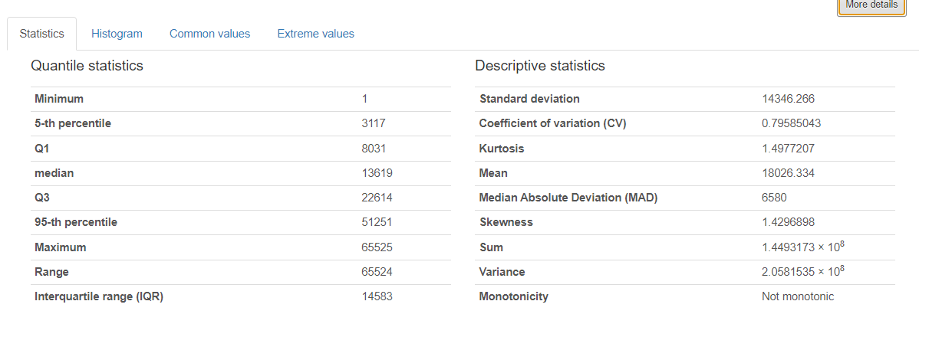

Figure 3.7.1‑16 Detailed Statistics of total_damage_pixels

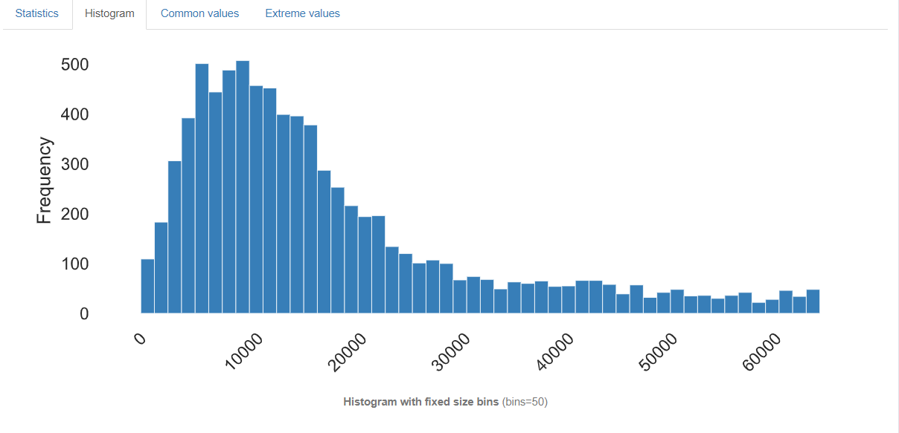

Figure 3.7.1‑17 Histogram of total_damage_pixels

Total_damage_pixels refers to the number of pixels that are highlighted during the contour filter process. The histogram of total_damage_pixels shows a right skewed data where majority of the data can be seen in the left side. The IQR is 8031-22614 with the mean at 18026.334. A standard deviation of 14346.266 can also be seen which is considered high.

#### Average_red

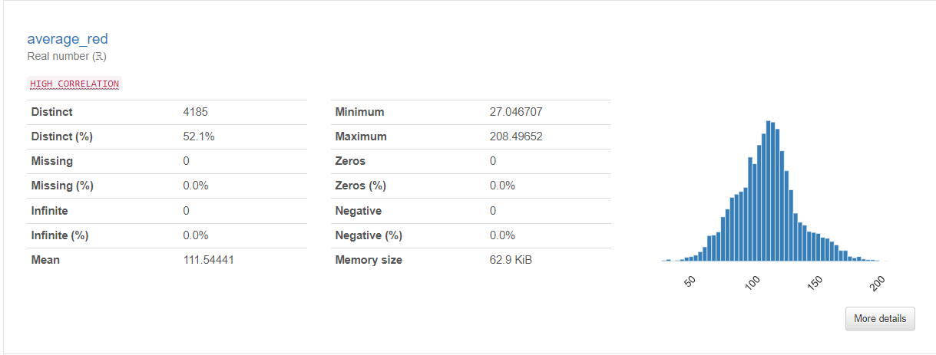

Figure 3.7.1‑18 Overview of average_red

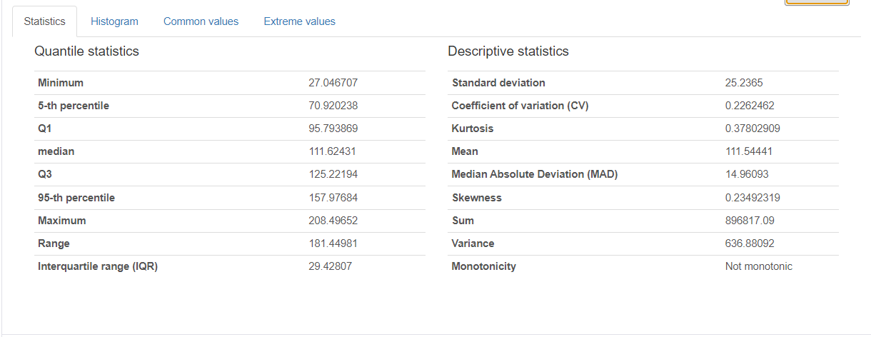

Figure 3.7.1‑19 Detailed Statistics of average_red

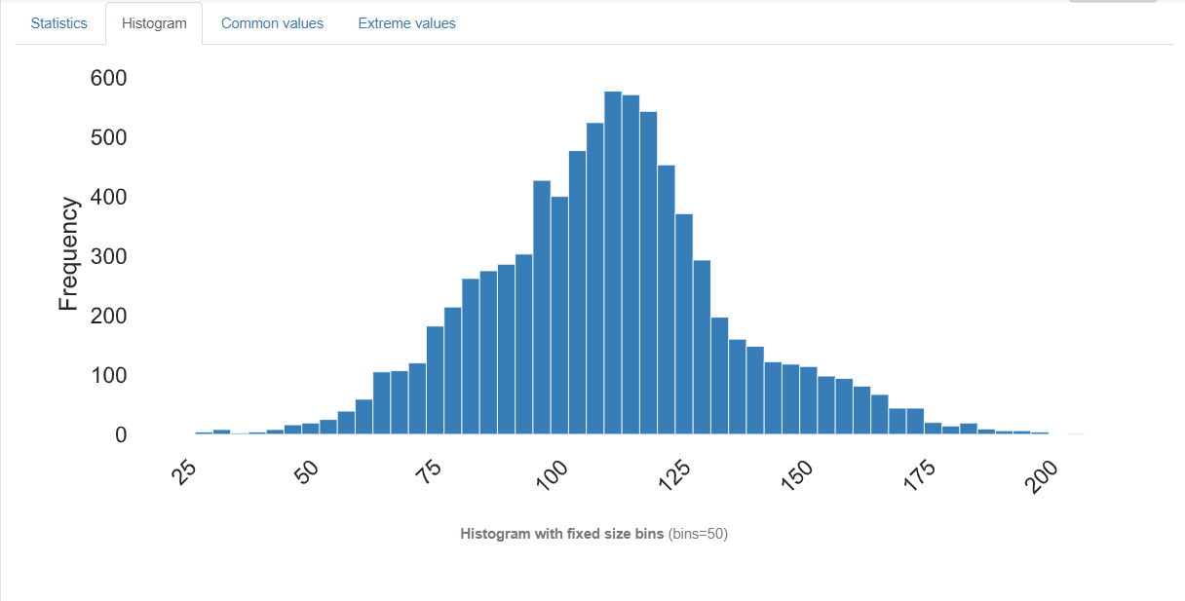

Figure 3.7.1‑20 Histogram of average_red

Average_red has quite symmetric skewness on the histogram of 0.23 which is a close value to 0. The variable has an IQR from 95.79 to 125.22. The min and max value of the color pixel range from 0-255, while the mean of the variable is 111.54.

#### Average_green

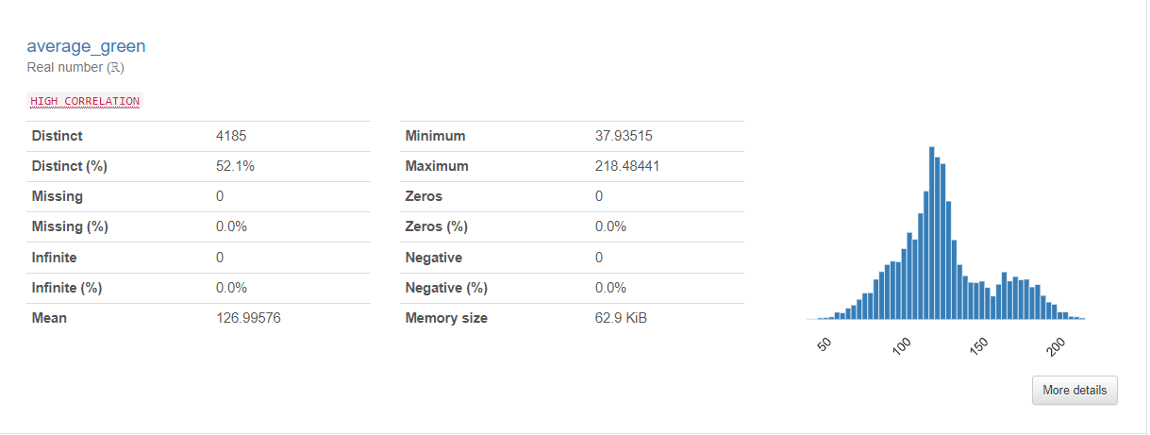

Figure 3.7.1‑21 Overview of average_green

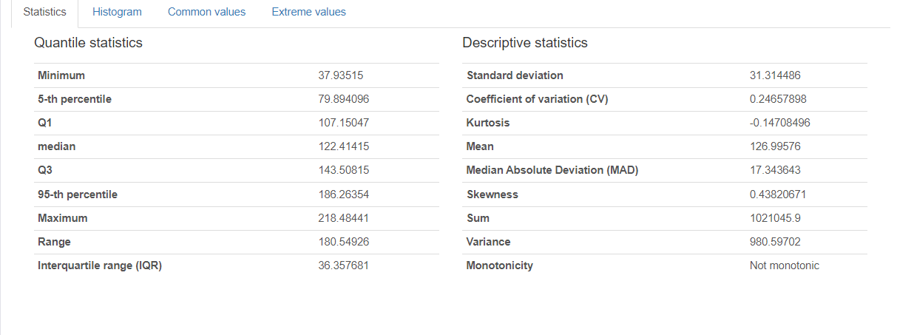

Figure 3.7.1‑22 Detailed Statistics of average_green

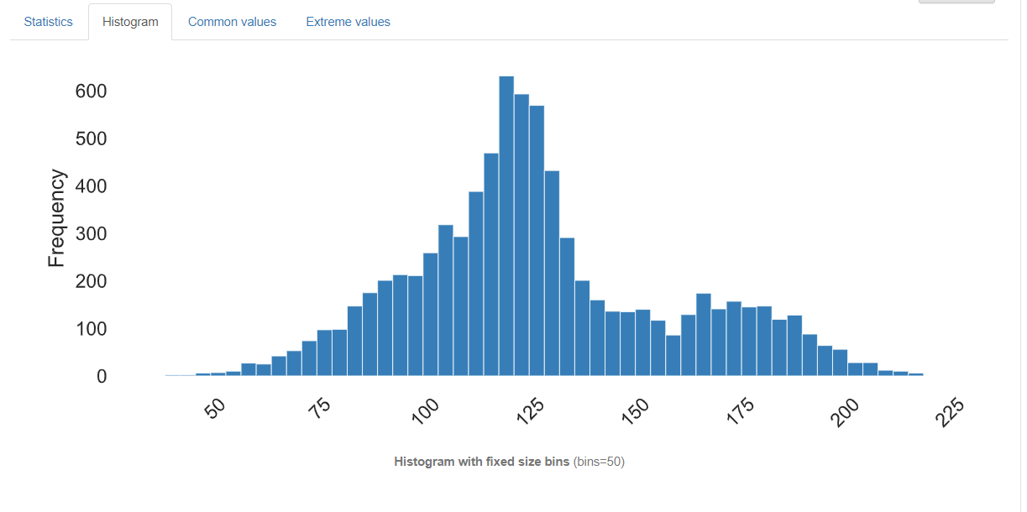

Figure 3.7.1‑23 Histogram of average_green

The average_green column also shows a positive skewness of 0.43 where the IQR is ranging from 107.15047 to 143.50815 with the mean 126.99578. It does possess some extreme values around 50 and less and above 200 close to 225.

#### Average_blue

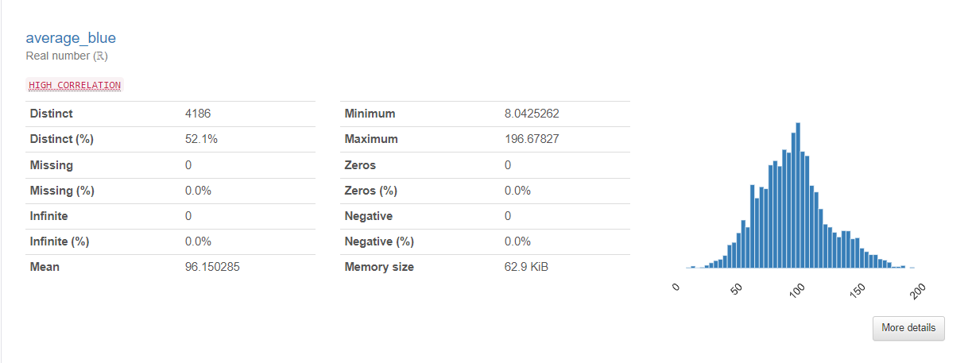

Figure 3.7.1‑24 Overview of average_blue

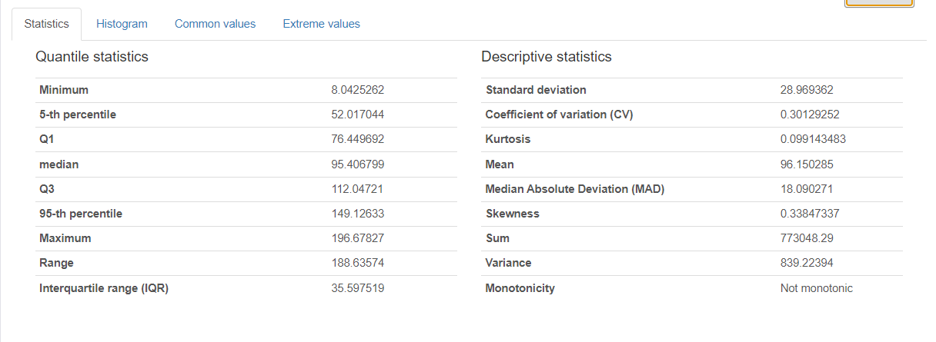

Figure 3.7.1‑25 Detailed Statistics of average_blue

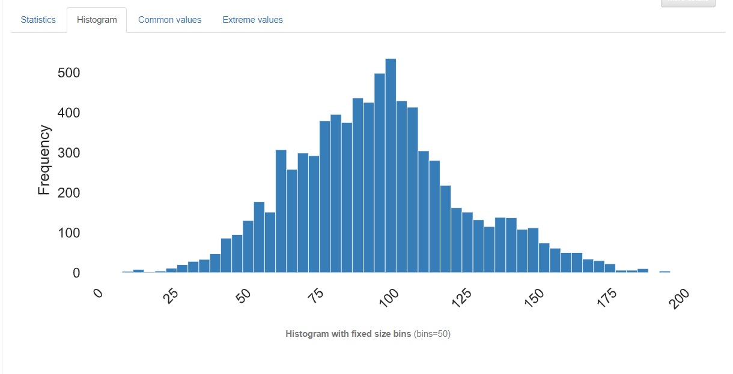

Figure 3.7.1‑26 Histogram of average_blue

Similar to the other color, a balance bell with skewness of 0.3 which is a positive skewness close to 0, can be seen in the histogram where Q1-Q3 is ranging from 76.449692 to 112.04721 and mean of 96.150285. Similarly, the extreme values can be found at values close to 0 and values close to 200 but not above 200.

#### Red_to_green

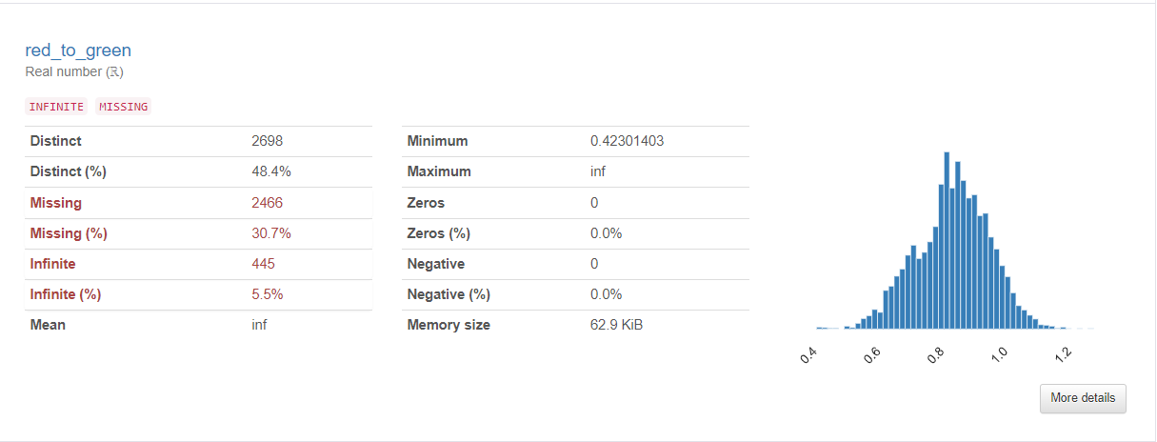

Figure 3.7.1‑27 Invalid Values in red_to_green

As seen from the summary information of red_to_green, there are a total of 2466 missing values which account to 30.7% of the total data. There are also 446 infinite value which is 5.5% of the total data.

#### Blue_to_green

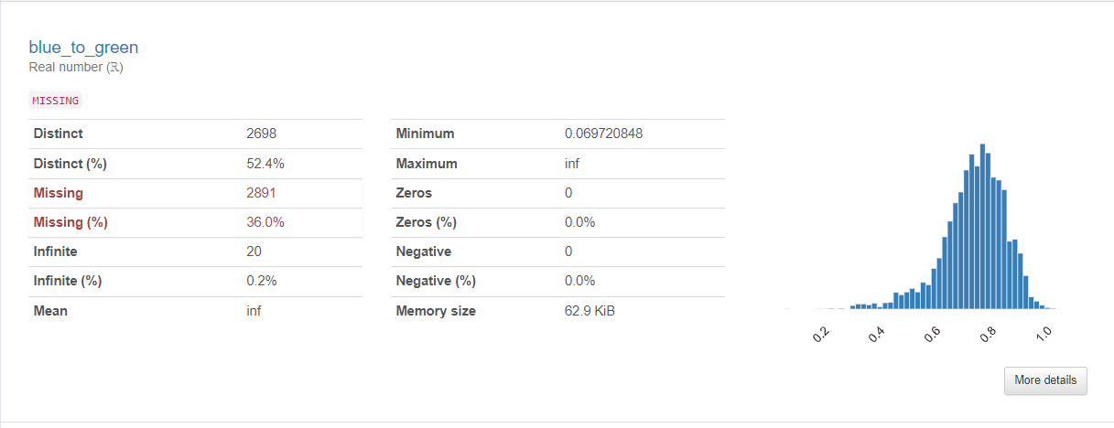

Figure 3.7.1‑28 Invalid Values in blue_to_green

The same issue can be seen in blue_to_green column where there are 2891 missing values at 36.0% There are significantly less infinite value in this column compared to red_to_green at 20 of 0.2% of the total dataset.

#### Gabor_0

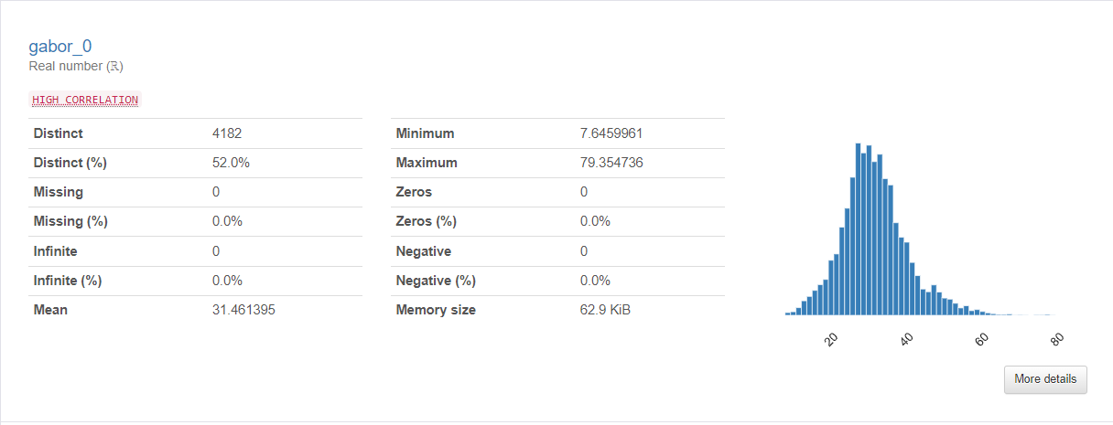

Figure 3.7.1‑29 Overview of gabor_0

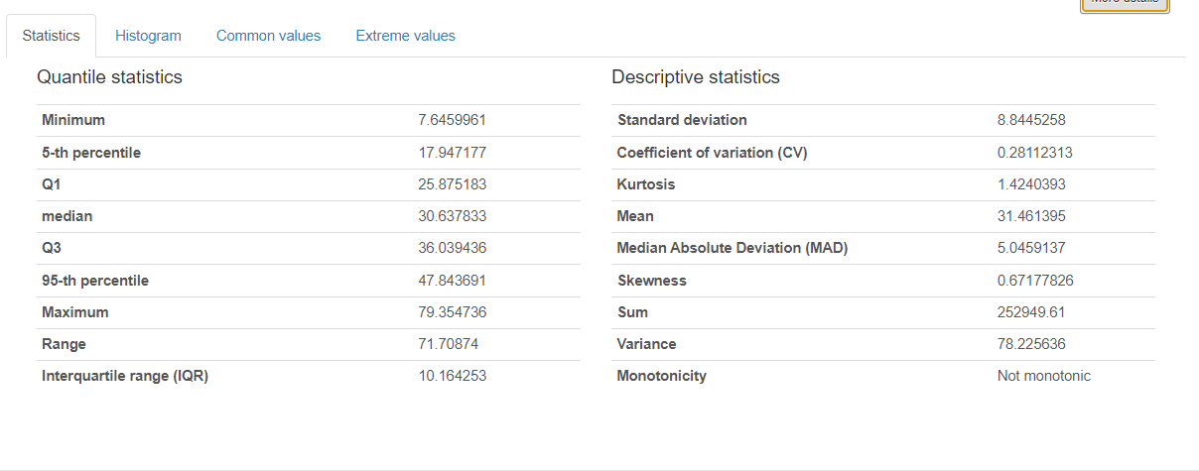

Figure 3.7.1‑30 Detailed Statistics of gabor_0

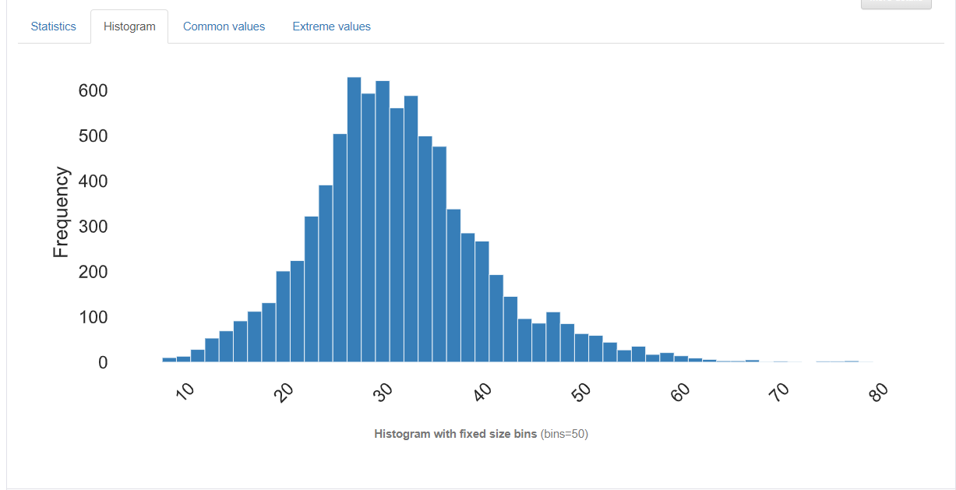

Figure 3.7.1‑31 Histogram of gabor_0

One of the texture features that has been extracted, Gabor Filter, produces 4 outputs of Gabor Features which are gabor_0, gabor_1, gabor_2, gabor_3. Gabor_0 shows a slightly right skewed histogram where the IQR ranges from 25.875183 to 36.039436. It has an average value of 31.461395.

#### Gabor_1

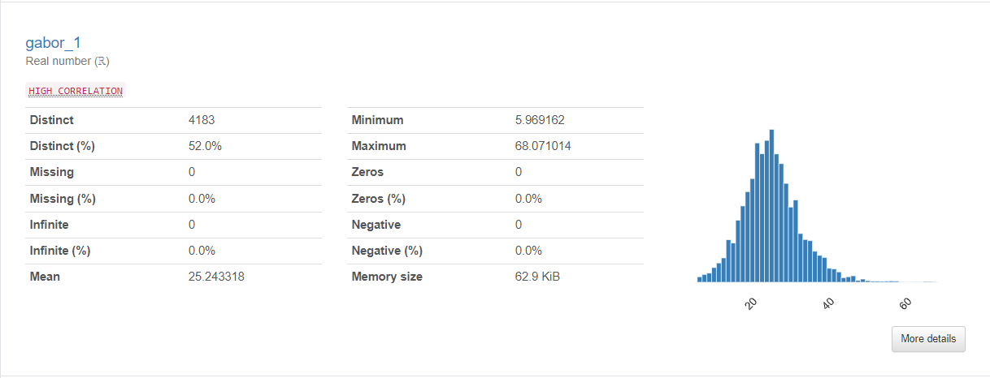

Figure 3.7.1‑32 Overview of gabor_1

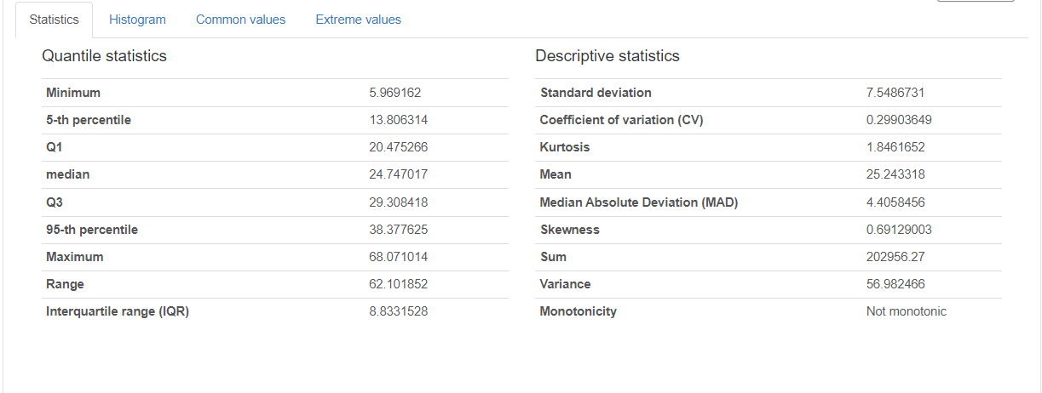

Figure 3.7.1‑33 Detailed Statistics of gabor_1

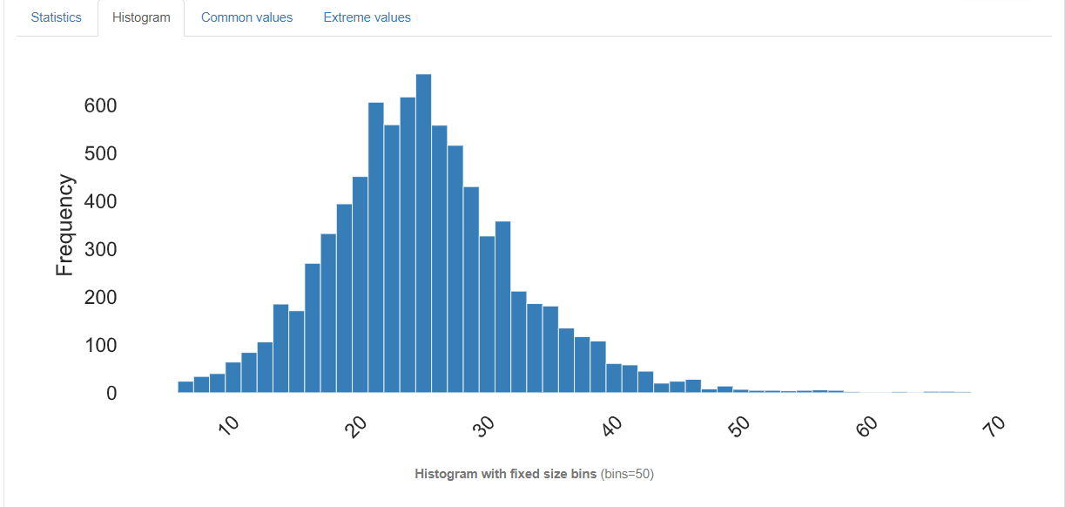

Figure 3.7.1‑34 Histogram of gabor_1

Gabor_1 has a slightly different features and values from the previous orientation, with the IQR ranging from 20.47 to 29.30 slightly lower than gabor_0. It also has a positive skewness of 0.69 indicating a right skewed histogram and also a mean of 25.24

#### Gabor_2

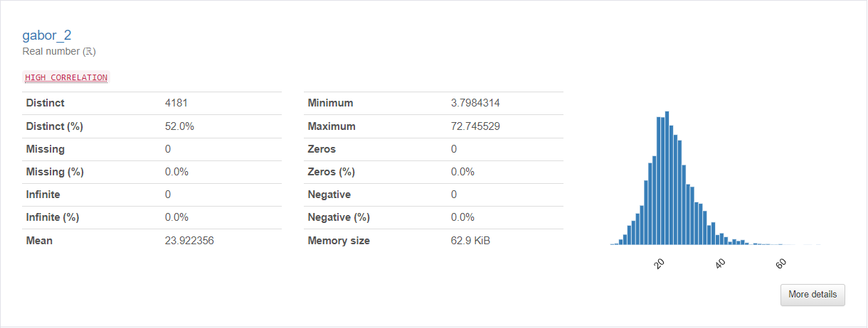

Figure 3.7.1‑35 Overview of gabor_2

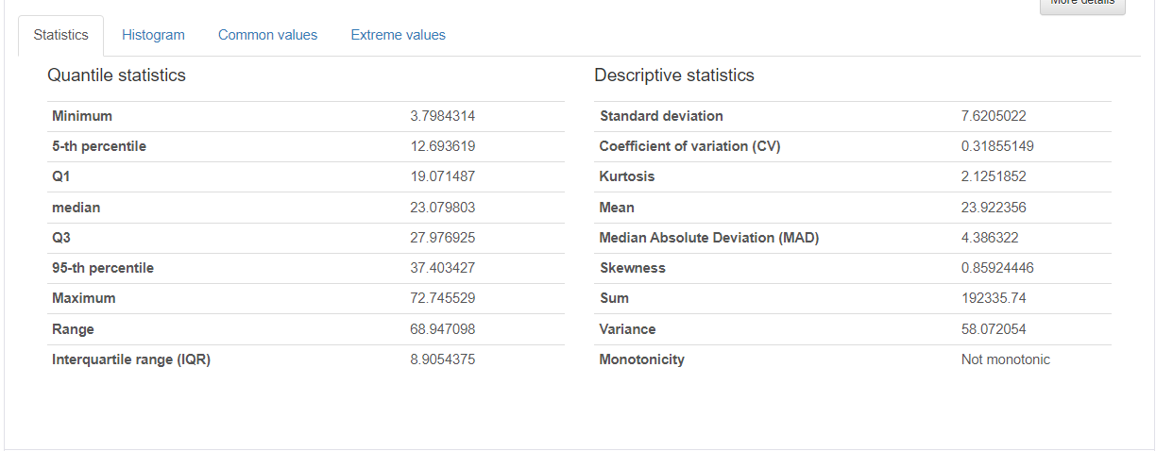

Figure 3.7.1‑36 Detailed Statistics of gabor_2

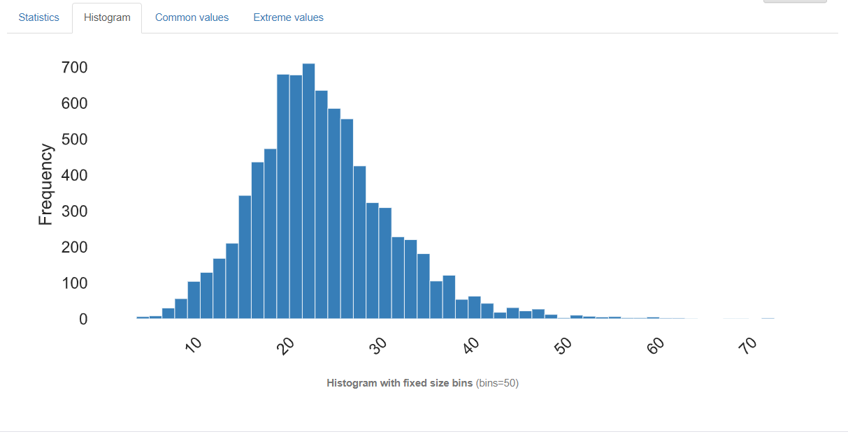

Figure 3.7.1‑37 Histogram of gabor_2

Similar to gabor_1, gabor_2 has IQR ranges from 19.07 to 27.97 and also a positive and right skewed histogram of 0.859 which indicates a high skewness in the variable. It also has an average value of 23.9. Some extreme values above 50 can be seen as well ranges towards the 70 value.

#### Gabor_3

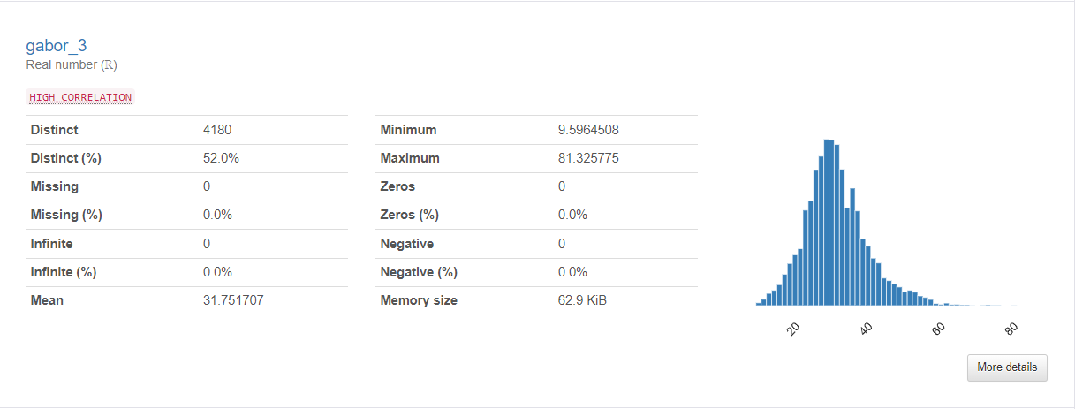

Figure 3.7.1‑38 Overview of gabor_3

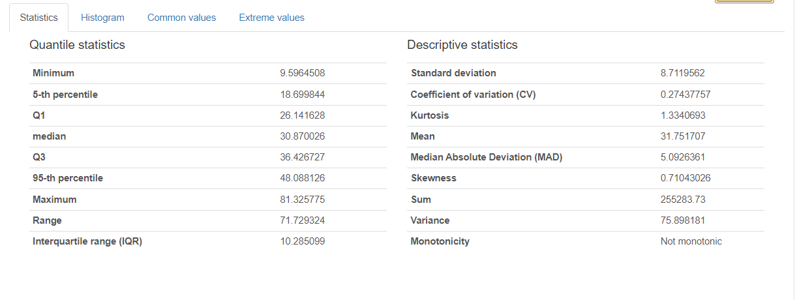

Figure 3.7.1‑39 Detailed Statistics of gabor_3

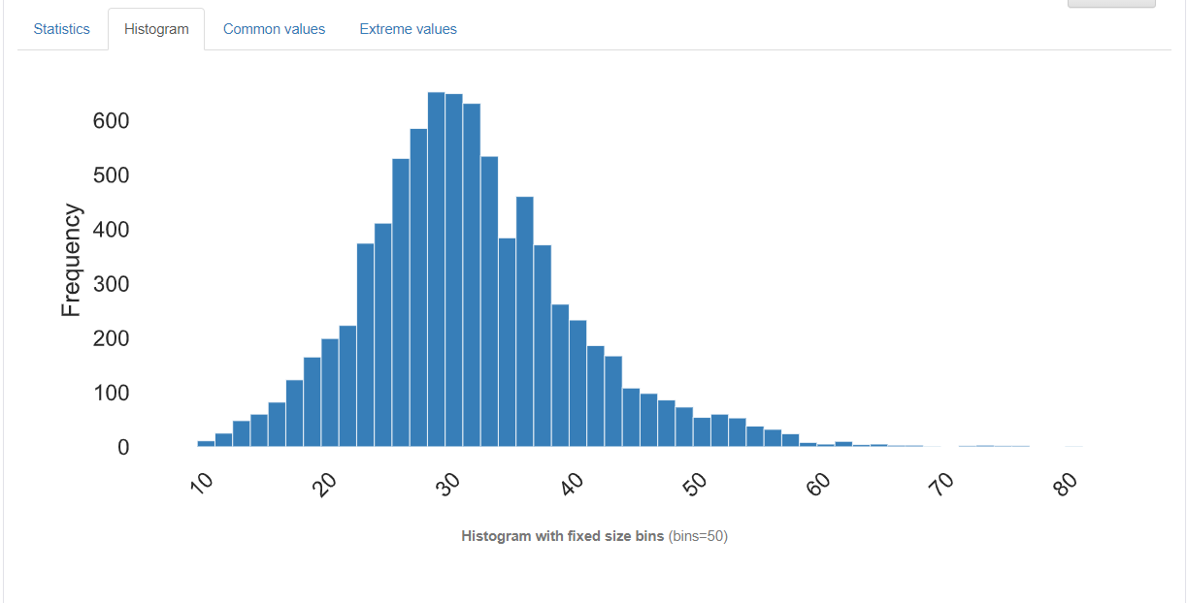

Figure 3.7.1‑40 Histogram of gabor_3

Also having quite, a high skewness of 0.71, gabor_3 has a similar IQR from 26.14 to 36.42. Due to the high skewness, maximum extreme values above 60 which include values that have low frequency can be seen ranges up to 80.

#### Contrast

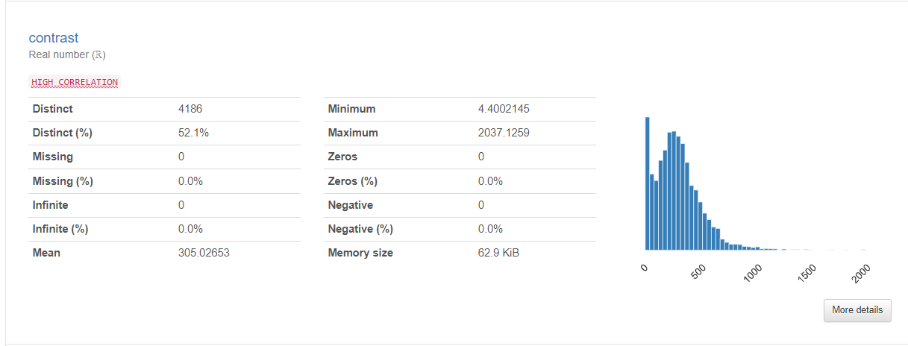

Figure 3.7.1‑41 Overview of contrast

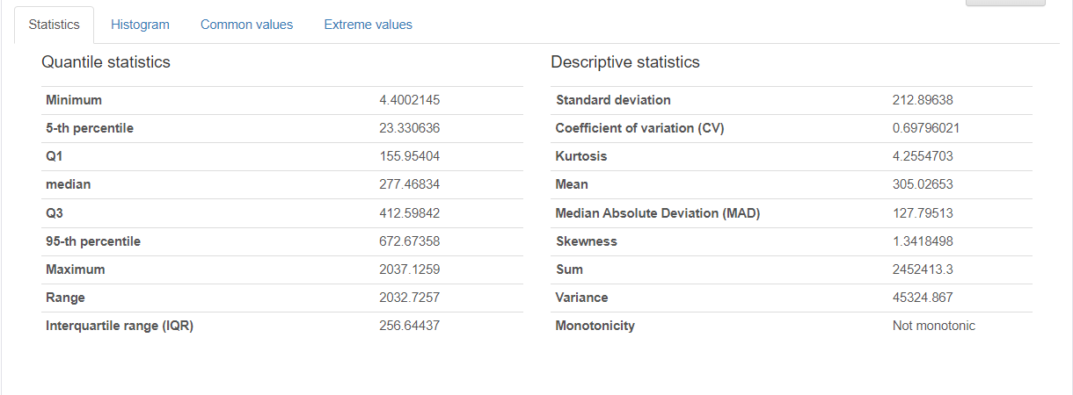

Figure 3.7.1‑42 Detailed Statistics of contrast

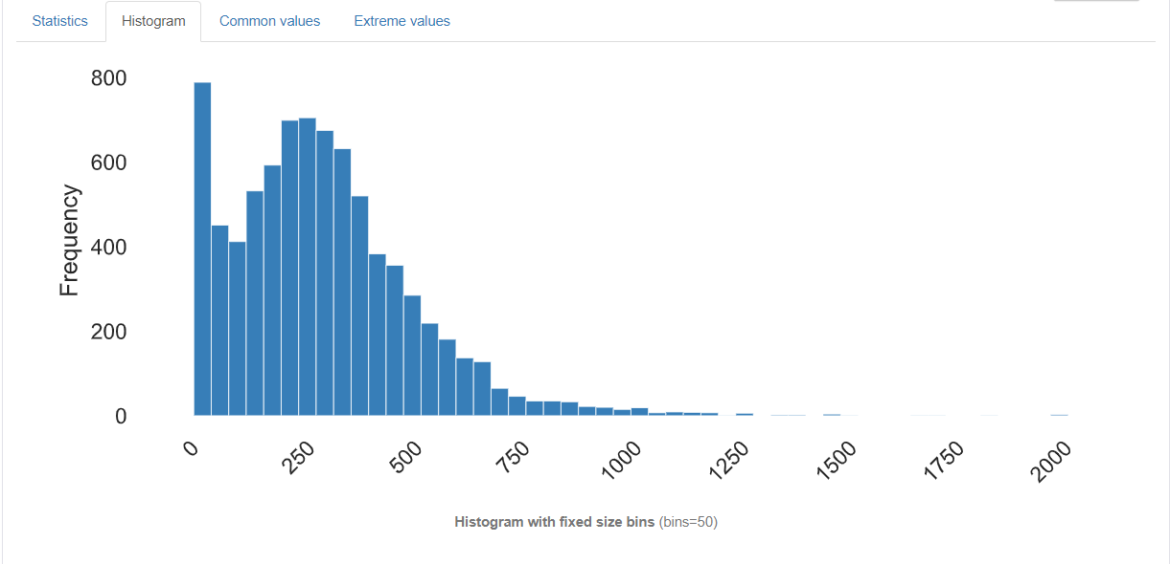

Figure 3.7.1‑43 Histogram of contrast

Moving on to the next texture feature, Contrast is one of the Haralick feature extracted from the gray level cooccurrence matrix. Based on the histogram alone, a right and positive skewness can be seen which has the value of 1.34. The IQR range is from 155.95404 to 412.59842, which if seen from the graph is only reaching up to ¼ of the whole histogram. Extreme values above 1000 to even 2000 can be seen.

#### Correlation

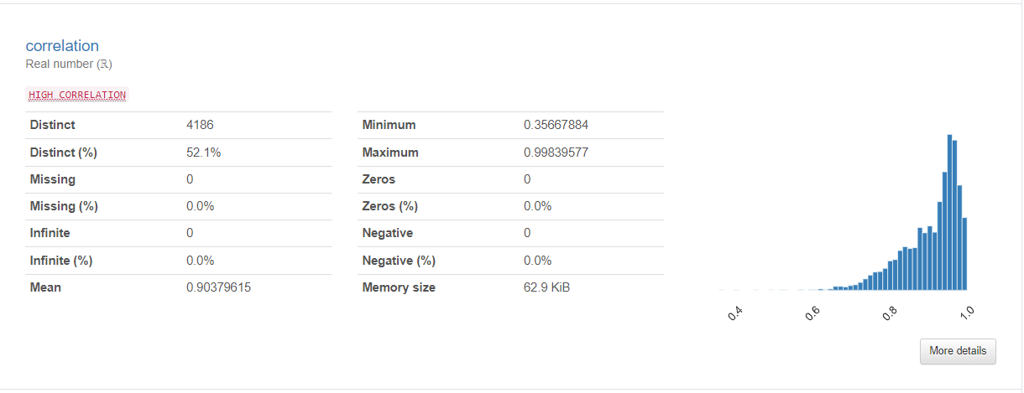

Figure 3.7.1‑44 Overview of correlation

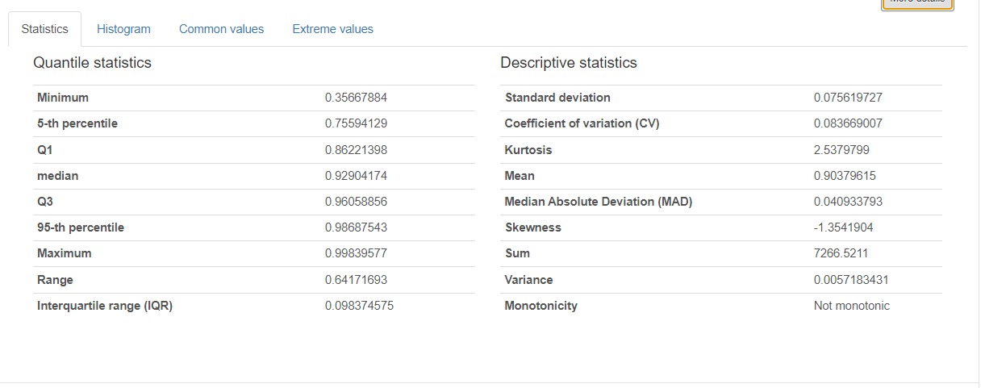

Figure 3.7.1‑45 Detailed Statistics of correlation

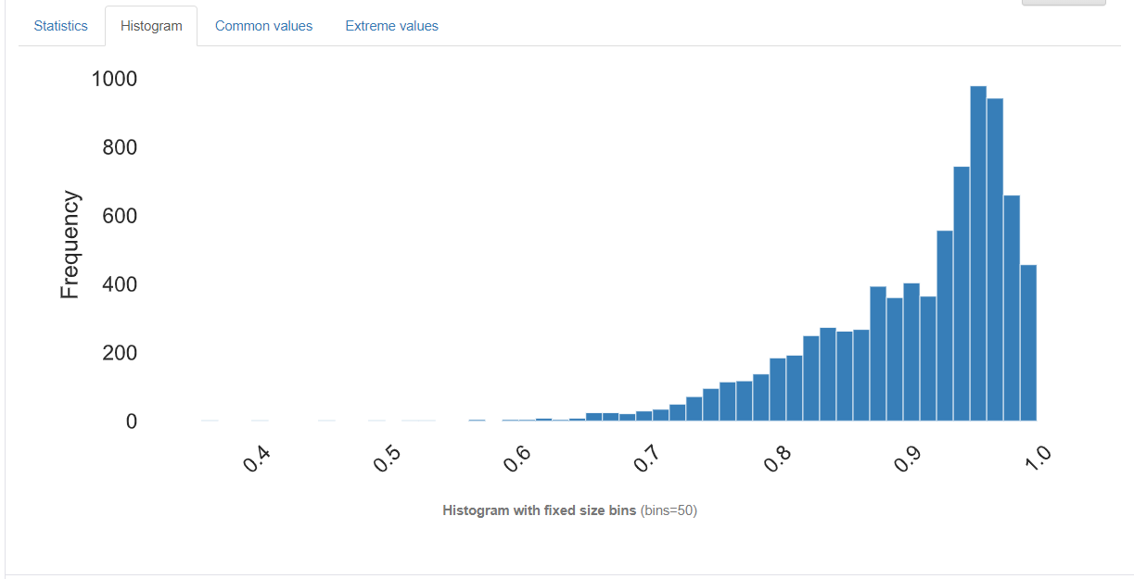

Figure 3.7.1‑46 Histogram of correlation

Unlike Contrast, the 2nd extracted Haralick feature have a left skewness of -1.35. It has IQR ranges from 0.86221398 to 0.96058856. Extreme values can now be seen on the left side of the histogram which can be seen below 0.7 and ranges from 0.35667884 which is the minimum value in the graph. The value however doesn’t go over 1 where a general value of 0-1 can be concluded for the Haralick features except for contrast.

#### Energy

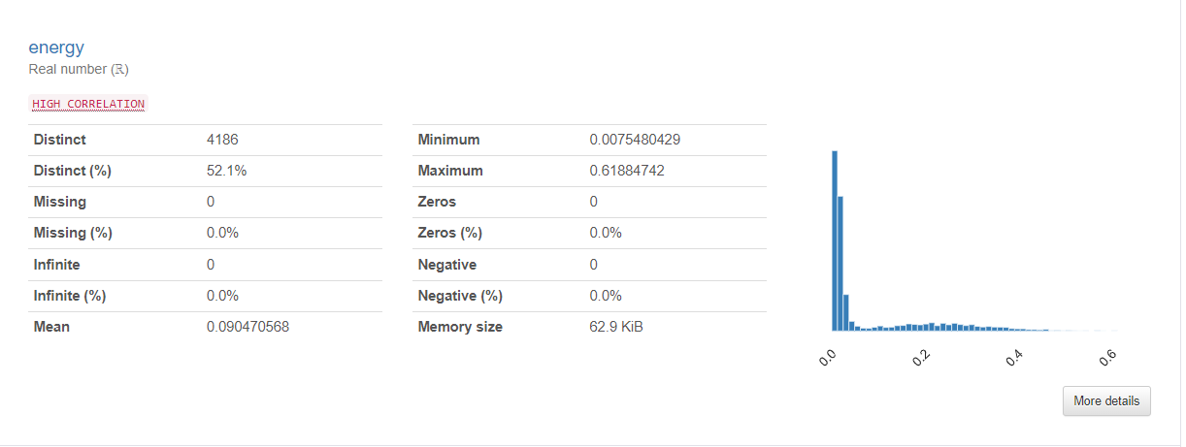

Figure 3.7.1‑47 Overview of energy

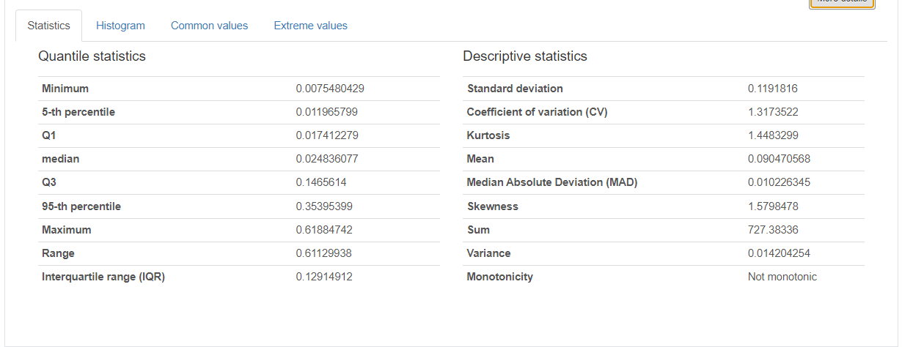

Figure 3.7.1‑48 Detailed Statistics of energy

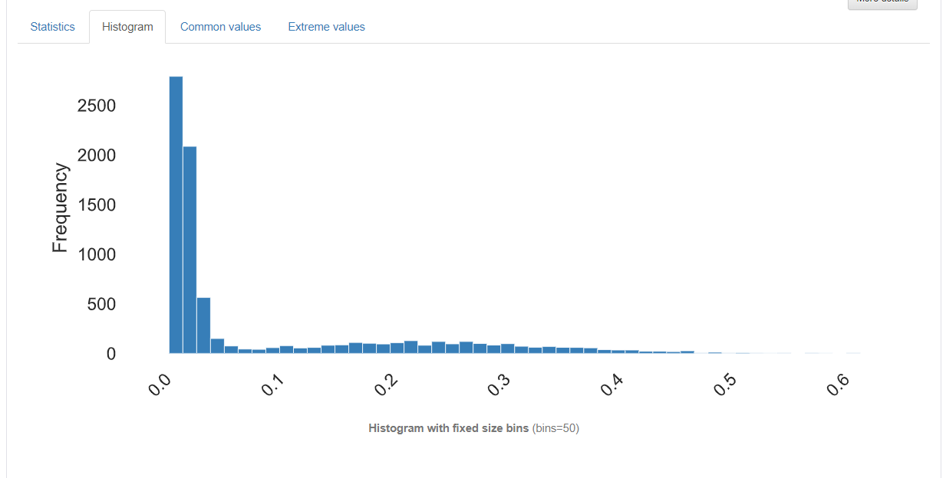

Figure 3.7.1‑49 Histogram of energy

A high positive skewness can be perceived in Energy where majority of the data in IQR only ranges from 0.017412279 to 0.1465614, while the whole column has a maximum value of 0.61884742. Indicating a huge number of extreme values within the variable.

#### Homogeneity

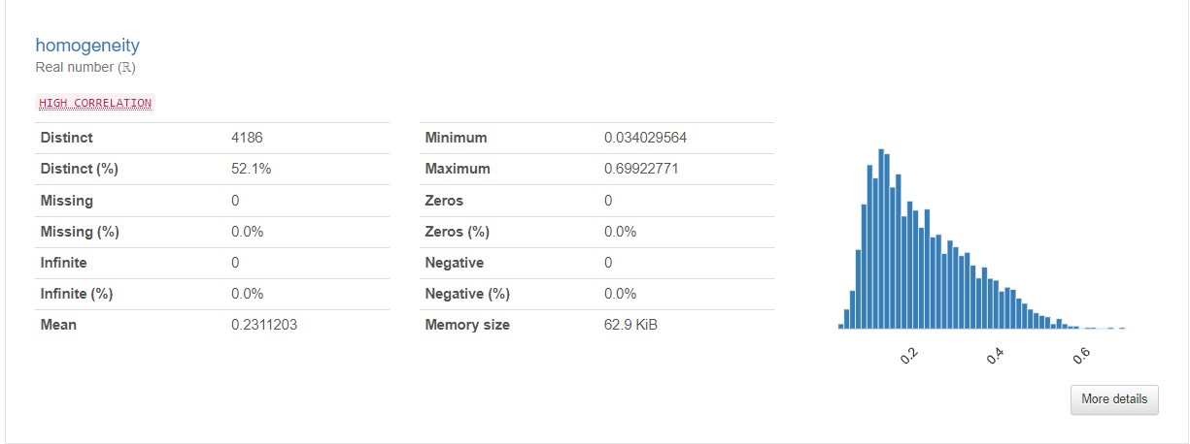

Figure 3.7.1‑50 Overview of homogeneity

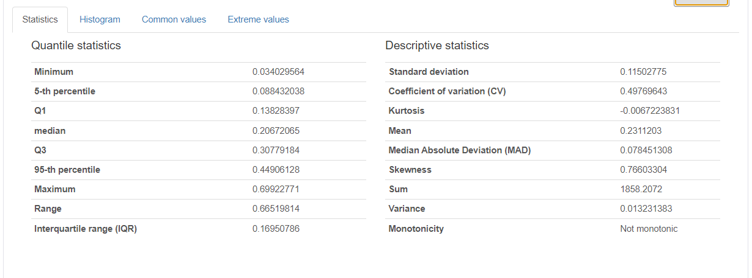

Figure 3.7.1‑51 Detailed Statistics of homogeneity

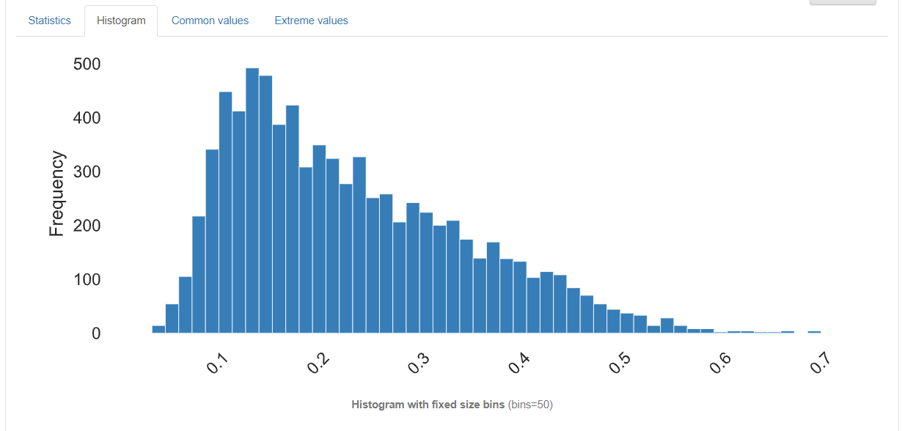

Figure 3.7.1‑52 Histogram of homogeneity

Homogeneity has a low standard deviation of 0.115 with a positive skewness of 0.766 since the data ranges from 0 to 1, which is already normalized. It has an IQR of 0.13828397 to 0.30779184 and mean of 0.23. Extreme values can be seen on the right side of the graph which are above 0.44 as the 95th percentile of the variable.

#### Correlation Plot

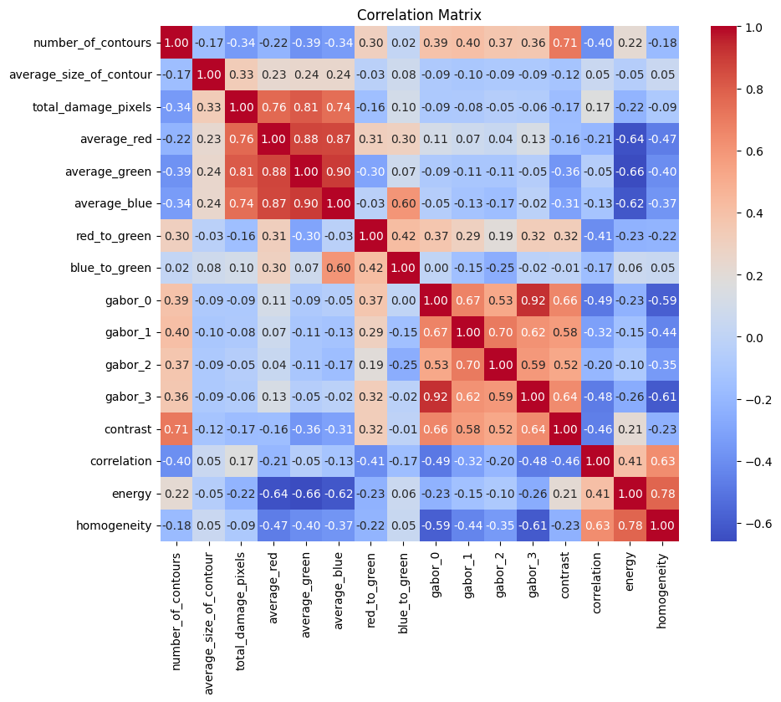

Figure 3.7.1‑53 Correlation Plot of the Extracted Feature

The figure above shows a correlation plot between variables in the Extracted Feature. As seen from the plot, there are some patterns of high correlation between each of the features extracted.

##### Color Feature

Since the color feature is extracted at once, high correlation can be detected between the variables. Moreover, the *total_damage_pixels* which are also taken based on the pixels of the image show a high correlation with *average_red, average_blue,* and *average_green.*  The correlation value ranges from 0.74 to 0.90 with *average_green* and *average_blue* having the highest correlation.

##### Gabor Feature

Gabor extractions show a moderate correlation within each of the features such as *gabor_0, gabor_1, gabor_2,* and *gabor_3* which ranges around 0.52 to 0.7. However a high correlation of 0.92 can be seen between *gabor_0* and *gabor_3.*

##### Haralick Feature

Other than *contrast*, the other Haralick Feature namely, *correlation, energy,* and *homogeneity* all have a moderate correlation with each other ranging from 0.41 to 0.78. The lowest correlation can be found between *energy* and *correlation.* *contrast* however has either low or negative correlation to each of the features.

### Imputing missing and invalid values

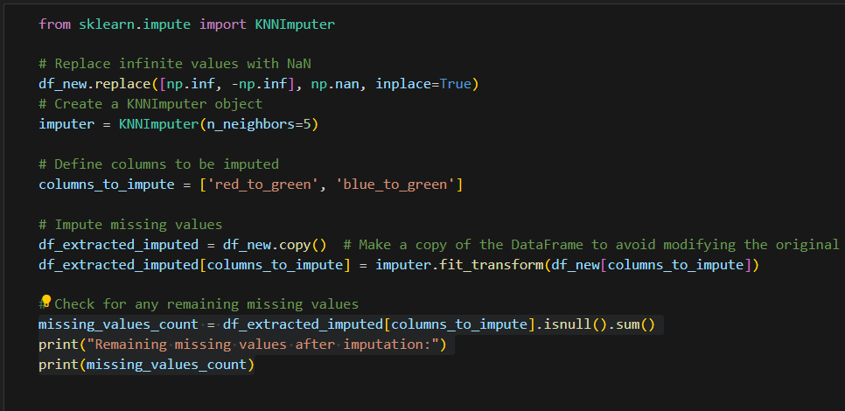

Figure 3.7.2‑1 Code to impute the missing and invalid values

In order to impute the missing values, KNNImputer is applied which is a machine learning algorithm based on K-Nearest Neighbors that are used in imputing missing values (*Sklearn.impute.KNNImputer*, n.d.). The n_neighbors value, which refers to the neighboring sample can be changed for different result, but in general 5 is the default value.

Before imputing, the infinite value within the column is replaced with a nan or missing value.

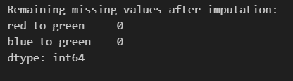

Figure 3.7.2‑2 Result of imputation

After the imputation, no missing result can be seen in the new data frame.

### Normalization of Variables with High Standard Deviation

Based on the EDA, the researcher has pointed out several variables that possess a high standard deviation. In order to suppress the number, normalization can be done towards the variables such as number_of_contours, average_size_of_contour, total_damage_pixels, and contrast.

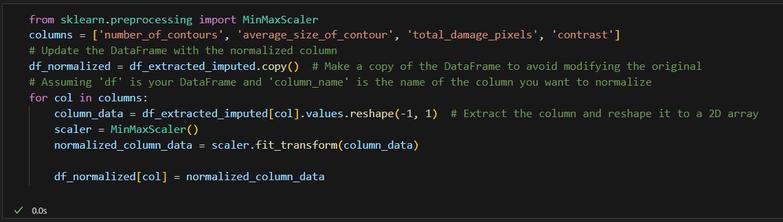

Figure 3.7.3‑1 Code to Normalize the Data

Sklearn library provide preprocessing function such as scaling and normalization with detailed documentation on their website. In this case, the researcher has chosen to use MinMaxScaler which rescale the data into 0-1 range (*Compare the Effect of Different Scalers on Data With Outliers*, n.d.).

### Outliers and Skewness

In a statistical data, outliers can be considered noise or errors within the dataset. In this case, the Extracted Feature are data that are extracted from the image directly. Some of the extreme values found from the EDA process or values outside of the IQR (Interquartile Range) can be considered as True Outliers that are not noise but represent a unique value within the data.

However, if needed, there are also methods to transform the data by cleaning outliers and fixing the skewness into a normal distribution. Quantile Transformers from scikit.learn can be utilized to perform the transformation process (*Sklearn.Preprocessing.QuantileTransformer*, n.d.).

One of the variables within the Extracted Feature that has a high skewness and extreme values is *average_size_of_contour*.

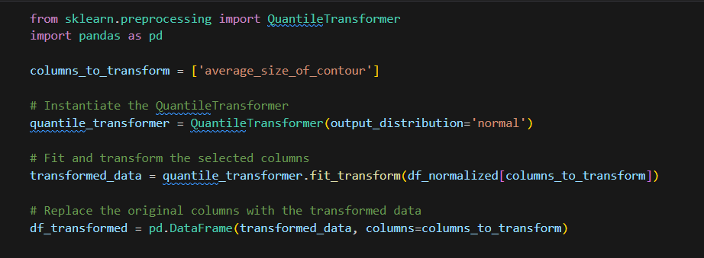

Figure 3.7.4‑1 Code to perform quantile transformers

With this, the data will now be transformed and distributed normally without outliers.

### Undersampling the data

To tackle the class imbalance, the dataset can be undersampled by following the number of the lowest class, Gray_Leaf_Spot.

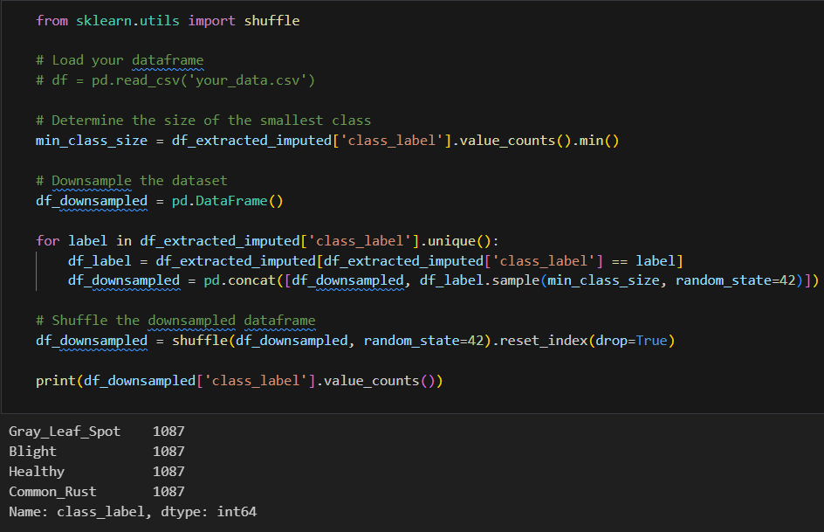

Figure 3.7.5‑1 Code to undersample the dataset

The total rows of data after the undersampled/downsampled process is 4348. This data will then be used for the model building purposes. Using *sample()* the data chosen will be in a random state in order to have a fair and each data has an equal chance to be in the undersampled version of the dataframe.

### Detail Exploration of the Processed Data

In order to cover and analyze the whole dataset, the EDA that is shown in this section is conducted based on the imputed dataset only before the undersampled data.

#### Overview of the data

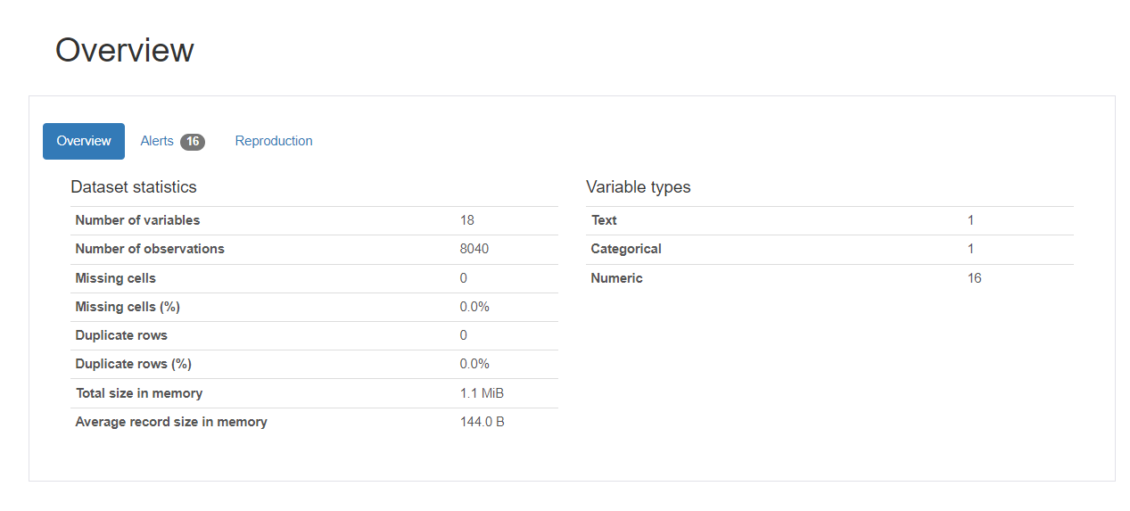

Figure 3.7.6‑1 Overview of the Processed Data

After the invalid values are fixed, no missing cells can be seen in the new dataset resulting to a total of 8040 images. There is a total of 18 columns where 1 is text, 1 is categorical which will be the class label and the target variable of the dataset, and 16 numerical variables.

#### Number_of_contours

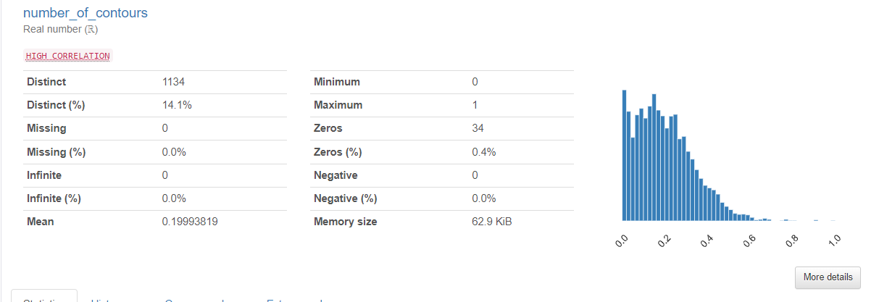

Figure 3.7.6‑2 Overview of new number_of_contours

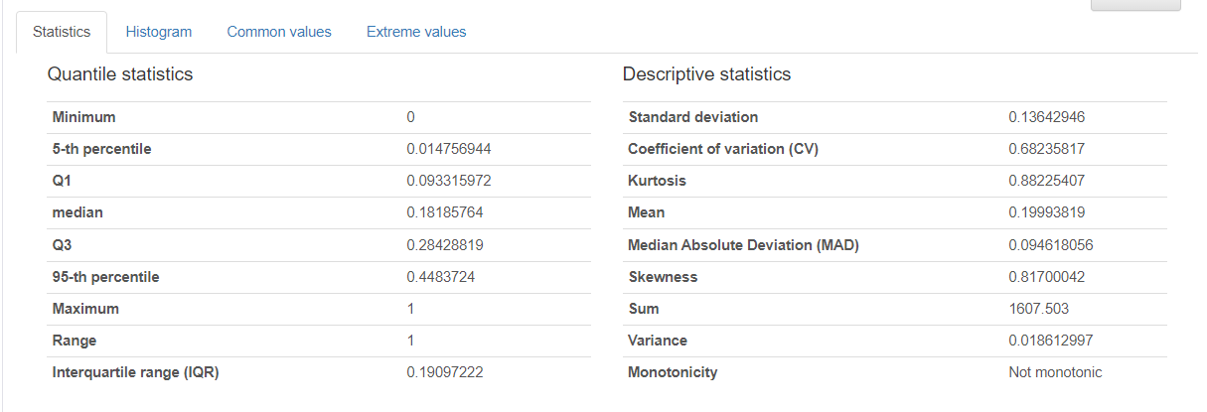

Figure 3.7.6‑3 Detailed Statistics of new number_of_contours

As seen from the figures above, there are no changes noticeable within the histogram since the data is only scaled. The standard deviation which is previously 314.33 falls to 0.136.

#### Average_size_of_contour (Normalized)

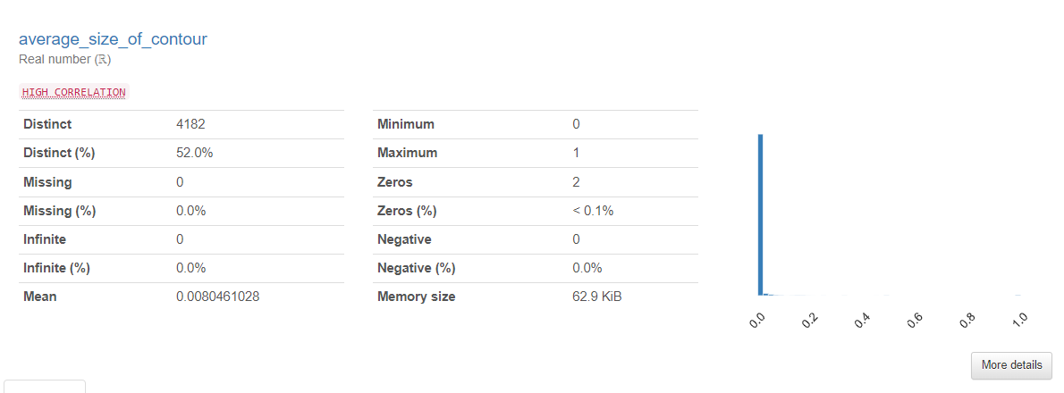

Figure 3.7.6‑4 Overview of new average_size_of_contour

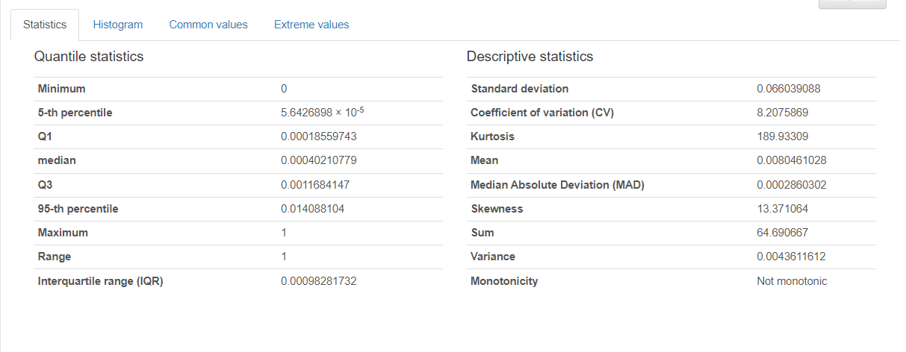

Figure 3.7.6‑5 Detailed Statistics of average_size_of_contour

The same changes can be encountered in average_size_of_contour where the new standard deviation is 0.066 compared to previously 4294.1917.

#### Total_damage_pixels

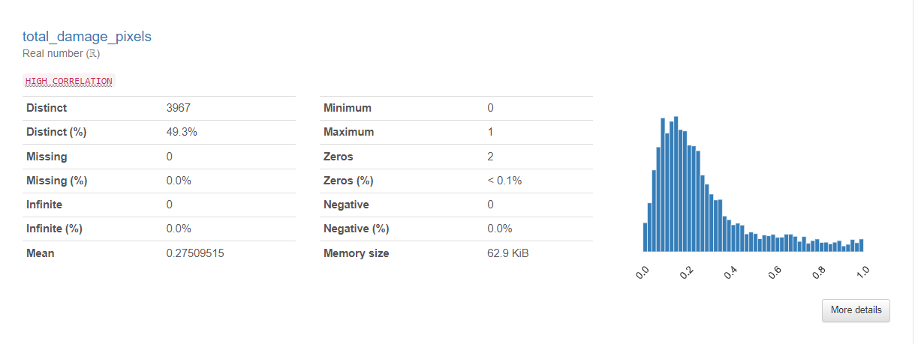

Figure 3.7.6‑6 Overview of new total_damage_pixels

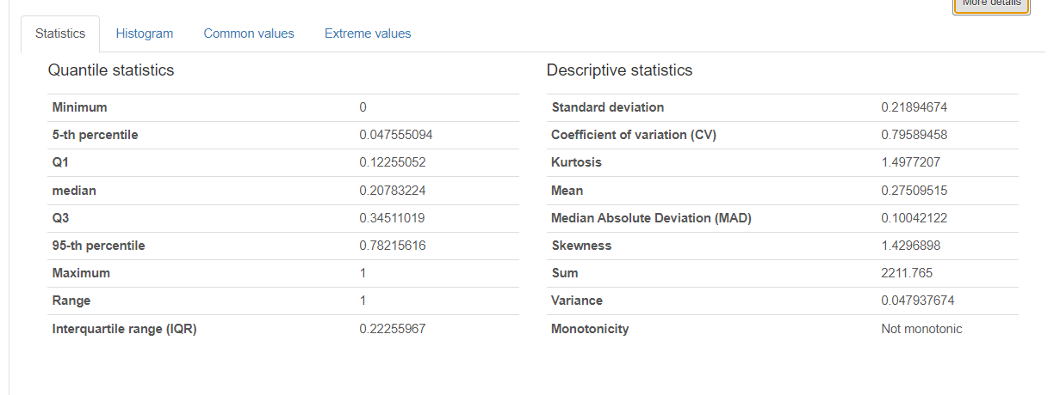

Figure 3.7.6‑7 Detailed Statistics of new total_damage_pixels

The new standard deviation for total_damage_pixels is 0.2189 which is previously 14346.266.

For number_of_contour, average_size_of_contour, and total_damage_pixels which are extracted directly from contour detection, normalization is not really needed since it’s the true value from the image. However, for model building purposes, both version of the data will be tested to see whether it affects the accuracy/performance of the model or not.

#### Average_size_of_contour (Outliers and Skewness Transformed)

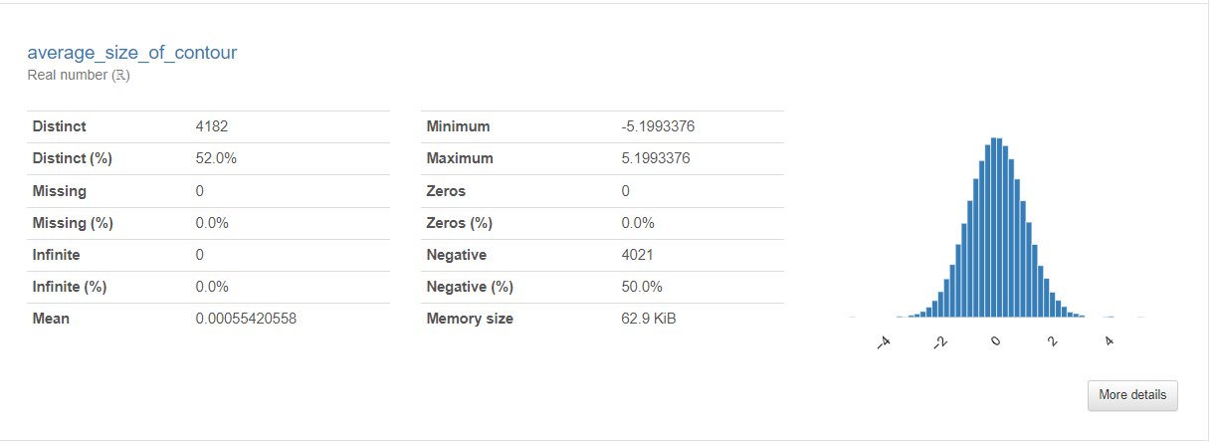

Figure 3.7.6‑8 Overview of Transformed average_size_of_contour

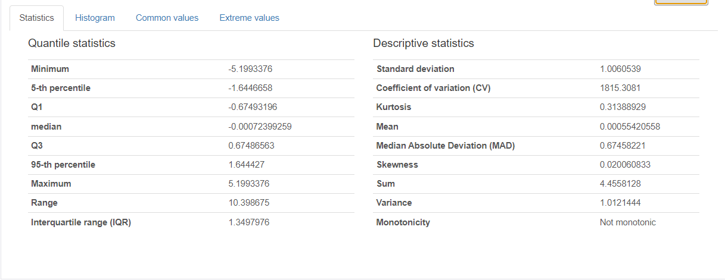

Figure 3.7.6‑9 Detailed Statistics of Transformed average_size_of_contour

Based on the figures above, the skewness issue has also been fixed where it now has the value of 0.02 which shows a normal distribution proven from the graph as well. The median and mean is also close to each other with both value close to 0.

However as mentioned, this modification only serve as improving the statistical data while the actual meaning of the data has now been altered. In part 2 of the project, both data(original variable without normalization and transformation, and the transformed data) will be tested out based on the model performance.

#### Contrast

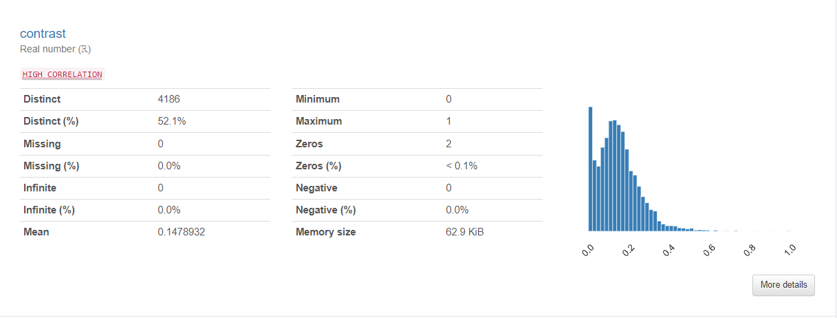

Figure 3.7.6‑10 Overview of new contrast

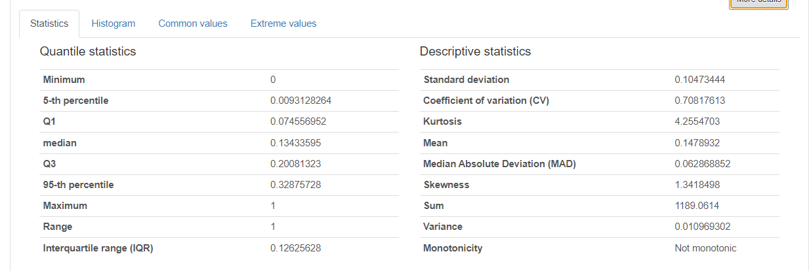

Figure 3.7.6‑11 Detailed Statistics of contrast

Contrast has now been scaled to 0-1 value following the other Haralick feature. The stand deviation of the new contrast is 0.1 with IQR of 0.07-0.2.

#### Red_to_green

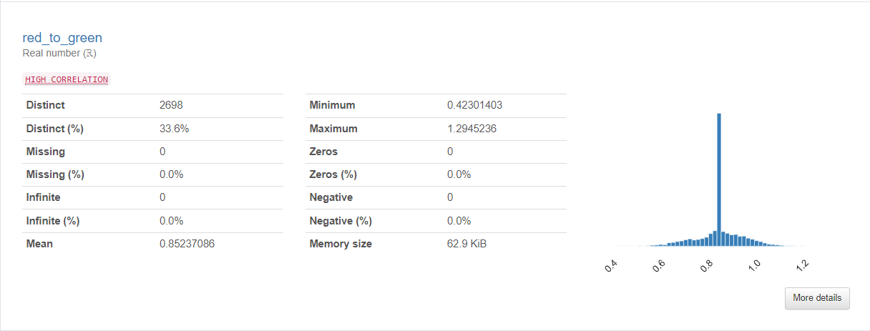

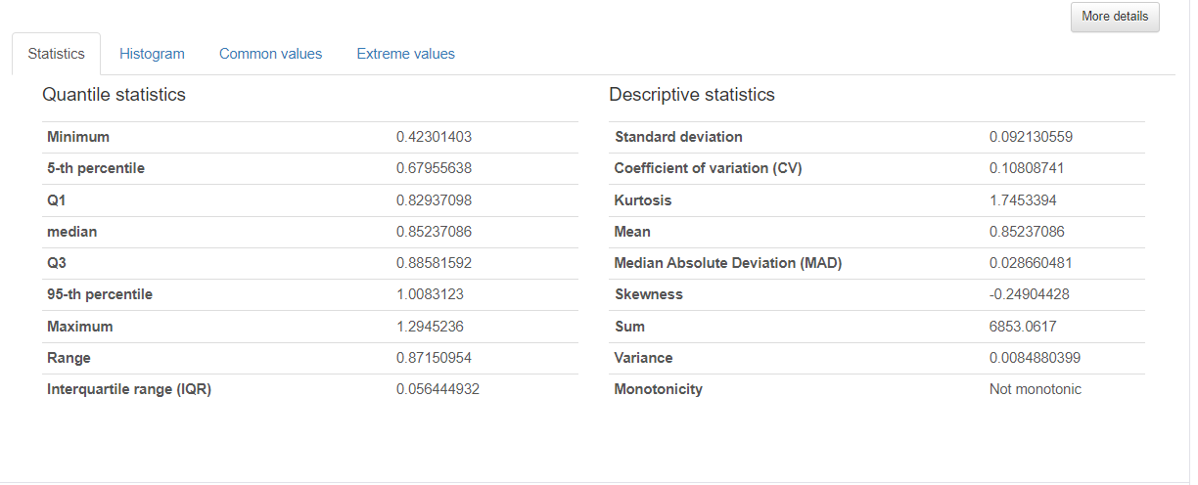

Figure 3.7.6‑12 Detailed Statistics of red_to_green

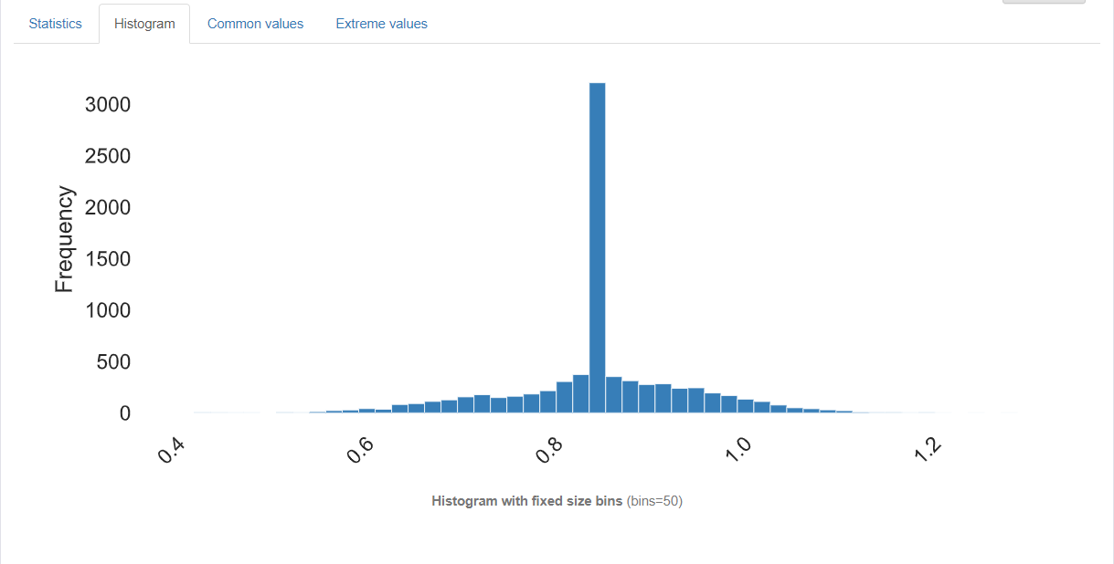

Figure 3.7.6‑13 Histogram of red_to_green

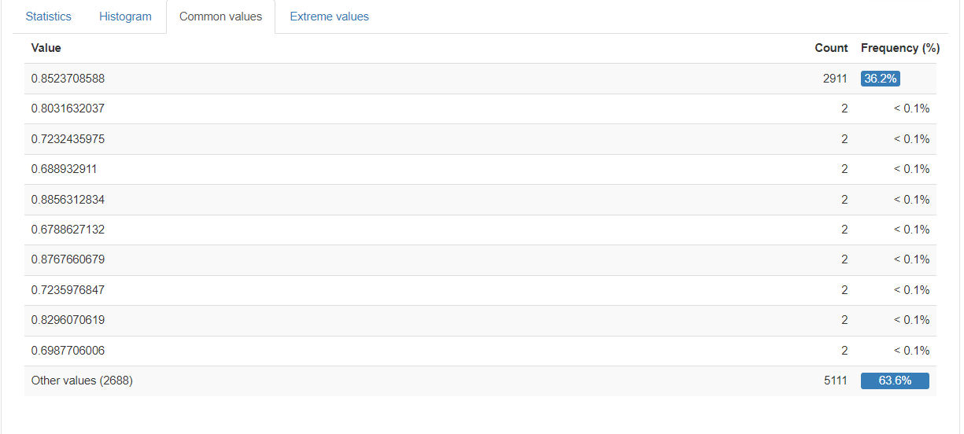

Figure 3.7.6‑14 Common values of red_to_green

The previously error and invalid values such as missing and infinite numbers within this variable has been fixed through imputing the missing value. However, due to the nature of KNNIMPUTER, a huge sum of the invalid values are replaced by 0.8523708588, which is the new mean value. The IQR of the graph now ranges from around 0.82 to 0.88.

#### Blue_to_green

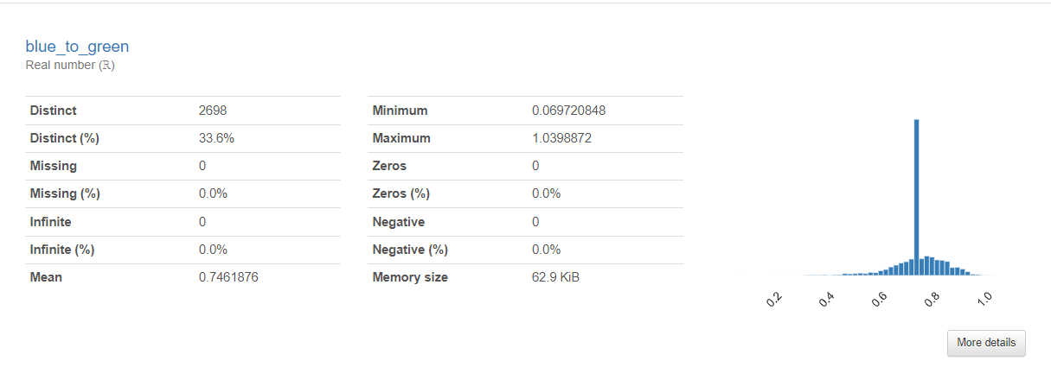

Figure 3.7.6‑15 Overview of blue_to_green

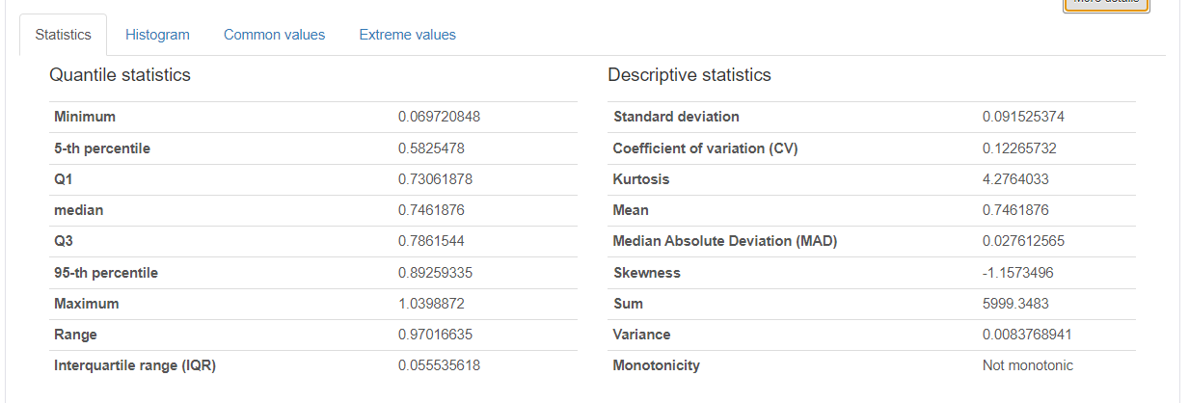

Figure 3.7.6‑16 Detailed Statistics of blue_to_green

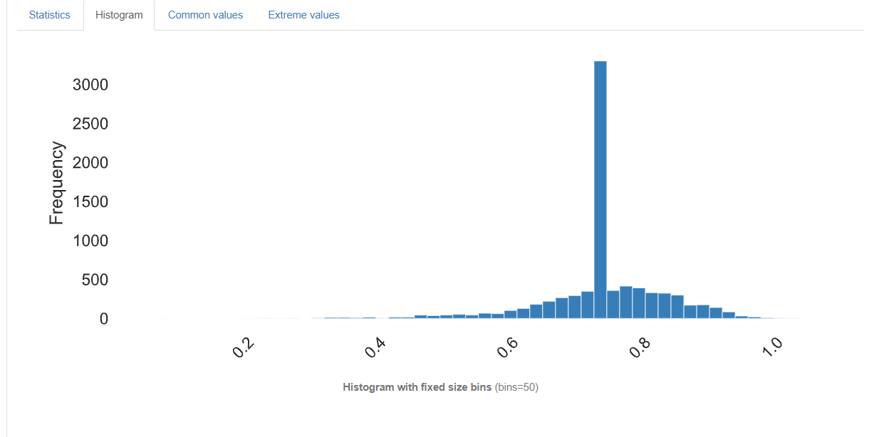

Figure 3.7.6‑17 Histogram of blue_to_green

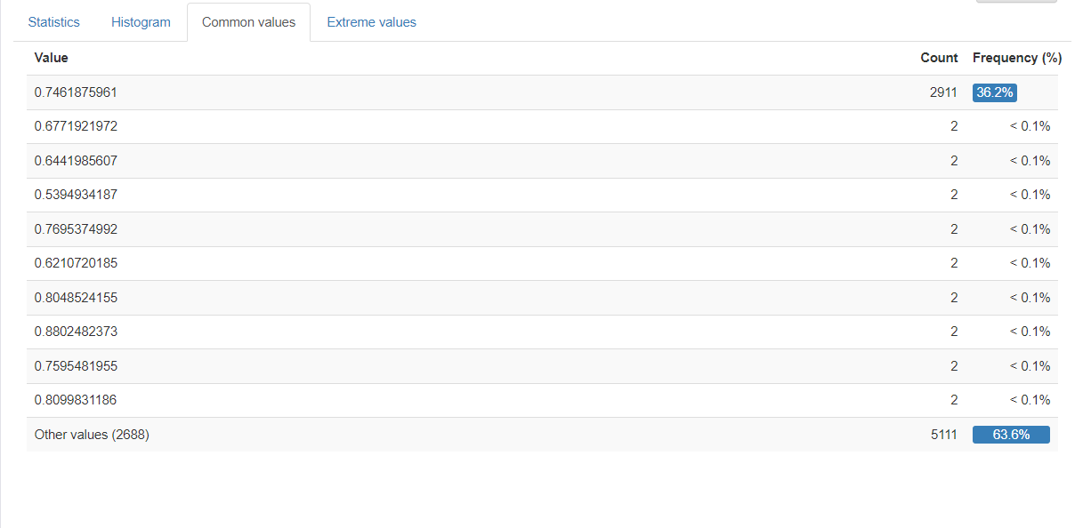

Figure 3.7.6‑18 Common values of blue_to_green

Similar finding can also be perceived from the blue_to_green column where it also utilizes KNNIMPUTER to replace invalid values with the new mean of the dataset, 0.7461876. The IQR of the variable ranges from around 0.73 to 0.78.

# Conclusion

## Achievement of the Investigation Report

The first part of the project, Investigation Report mark the achievement of understanding and researching thoroughly the effect and importance of using technology and data driver solution to perform disease predictions on corn crop disease. The researcher has succeeded in collecting 2 image datasets on corn diseases. These include Blight, Common Rust, Gray Leaf Spot, and also healthy leaves.

Literature Review is done where detail research about the problem of corn disease, how technology can improve and mitigate corn disease alongside deeper and more technical journal review about the technique chosen, model, and workflow of image predictions. Based on the literature review, data exploration and preprocessing including feature extraction which will be the input for the model building part has also been achieved.

The exploration includes performing EDA on the image dataset to find out pattern or even error within the dataset. After fixing and normalizing the images, it is then extracted into valuable features which are then re-explore by performing univariate analysis to find further statistical information on the extracted features. These also include another pre-processing which include imputing missing value, normalizing some variables, fixing outliers, skewness, and also undersampling the dataset to mitigate class imbalance. This step and output is crucial as the quality of the data highly contributes to the model building process in second part of the Final Year Project. It is also important to note that the effectiveness of the model can contribute to solving the SDG 15 issue and helps reduce the effects of corn disease through early detection and intervention which are made possible through this project.

## Justification of the Investigation/Research

Throughout the Investigation Report, the researcher has gone through many investigations regarding the problem statement including many literature and journal reviews of past work alongside many options on solving the issue. The researcher has also investigated further into the effect of corn disease in relation to SDG 15: Life on Land including how the disease can affect the ecosystem and terrestrial life.

Deep research into techniques needed to achieve the project objectives are also done. These include the exploration of image based methods such as image classification, image segmentation, and also object detection in relation to the domain. Knowledge of steps such as feature extraction which is one of the crucial part of the project proves that the researcher has done thorough and adequate research on the domain. Moreover, deeper understanding of framework, models, and techniques of object detection have also been covered in the literature review. The chosen machine learning algorithms are also based on the comparison of advantages and weaknesses stated by past researchers who have worked on a similar system, further showing that comprehensive research has been done for this project.

## Further Exploration and Improvement

Despite the investigation done by the researcher being adequate, there are always area that can be further explored and improved. These include model deployment process and even deeper image processing techniques that have yet to be explored above.

1. **Image Processing and Other Feature Extraction Techniques**

The researcher has covered several techniques of image processing and also feature extraction methods such as Color Extraction, Gabor Feature and Gray Level Cooccurrence Matrix. However, there are still other techniques that have yet to be explored which might or might not affect the quality of the final data which can also affect the model result. Moreover other image processing techniques such as noise reduction and Gaussian blur have yet to be explored. These are only some of the examples out of many more techniques that have been applied by past researchers on other domain as well.

1. **Limitation of Data and Future Exploration on Video Data**

This project only revolves around image datasets and have yet to apply video dataset. As there are no adequate data on the latter, the researcher is not able to validate and test the model with a video environment. This will be explored further in the future if the proper data is acquired.

1. **Model Deployment Skill on Video Hardware or Smartphone**

Integrating the machine learning models into real world system or hardware requires extensive knowledge. Apart from data science, machine learning, and computer vision skills required to build the models, knowledge on software development and software engineering are also required to integrate the model into IoT devices or even web application which aligns with industry standard.

# References

Aouat, S., Ait-hammi, I., & Hamouchene, I. (2021). A new approach for texture segmentation based on the Gray Level Co-occurrence Matrix. Mutlimedia Tools and Applications, 80, 24027-24052. https://doi.org/https://doi.org/10.1007/s11042-021-10634-4

Barbedo, J. G. (2018). Plant disease identification from individual lesions and spots using deep learning. Biosystems Engineering, 180, 96-107. https://doi.org/https://doi.org/10.1016/j.biosystemseng.2019.02.002

Cao, C. Q., Wang, B., Zhang, W. R., Zeng, X. D., Yan, X., Feng, Z. J., Liu, Y. T., & Wu, Z. Y. (2019). An Improved Faster R-CNN for Small Object Detection. IEEE Access. https://doi.org/ 10.1109/ACCESS.2019.2932731

Chandra, M. A., & Bedi, S. S. (2021). Survey on SVM and their application in image classification. International Journal of Information Technology, 13, 1-11. https://doi.org/https://doi.org/10.1007/s41870-017-0080-1

Chandrasekaran, K. (2022, January 5). Basic Operations on Images using OpenCV — Python - Koushik Chandrasekaran - Medium. Medium. <https://medium.com/@koushikc2000/basic-operations-on-images-using-opencv-python-cb0d60d11911>

Compare the effect of different scalers on data with outliers. (n.d.). Scikit-learn. <https://scikit-learn.org/stable/auto_examples/preprocessing/plot_all_scaling.html#minmaxscaler>

Create gray-level co-occurrence matrix from image - MATLAB graycomatrix. (n.d.). <https://www.mathworks.com/help/images/ref/graycomatrix.html>

Deshpande, H., Singh, A., & Herunde, H. (2020). Comparative analysis on YOLO object detection with OpenCV. International journal of research in industrial engineering, 9(1), 46-64. https://doi.org/https://doi.org/10.22105/riej.2020.226863.1130

Du, L., Sun, Y. Q., Chen, S., Feng, J. D., Zhao, Y. D., Yan, Z. G., Zhang, X. W., & Bian, Y. C. (2022). A Novel Object Detection Model Based on Faster R-CNN for Spodoptera frugiperda According to Feeding Trace of Corn Leaves. Spodoptera frugiperda According to Feeding Trace of Corn Leaves. Agriculture, 12(2), 248. https://doi.org/https://doi.org/10.3390/agriculture12020248

Garcia-Lara, S., & Serna-Saldivar, S. (2019). Corn history and culture.

GfG. (2018, August 29). Python random.sample() function. GeeksforGeeks. <https://www.geeksforgeeks.org/python-random-sample-function/>

GfG. (2020b, April 25). How to use Glob() function to find files recursively in Python? GeeksforGeeks. <https://www.geeksforgeeks.org/how-to-use-glob-function-to-find-files-recursively-in-python/>

GfG. (2021, December 16). NumPy.histogram() Method in Python. GeeksforGeeks. <https://www.geeksforgeeks.org/numpy-histogram-method-in-python/>

GfG. (2022, November 4). os.walk() in Python. GeeksforGeeks. <https://www.geeksforgeeks.org/os-walk-python/>

GfG. (2022a, March 28). Numpy.ravel() in Python. GeeksforGeeks. <https://www.geeksforgeeks.org/numpy-ravel-python/>

GfG. (2022a, May 26). Shutil module in Python. GeeksforGeeks. <https://www.geeksforgeeks.org/shutil-module-in-python/>

GfG. (2023, January 21). What is an IDE? GeeksforGeeks. <https://www.geeksforgeeks.org/what-is-ide/>

GfG. (2023b, January 3). Python OpenCV Canny() Function. GeeksforGeeks. <https://www.geeksforgeeks.org/python-opencv-canny-function/>

GfG. (2023b, March 29). Reading an image in OpenCV using Python. GeeksforGeeks. <https://www.geeksforgeeks.org/reading-image-opencv-using-python/>

GfG. (2023d, February 8). Image thresholding in Python OpenCV. GeeksforGeeks. <https://www.geeksforgeeks.org/image-thresholding-in-python-opencv/>

Goal 15: Life on land - The Global Goals. (2024, January 23). The Global Goals. <https://www.globalgoals.org/goals/15-life-on-land/>

Grandini, M., Bagli, E., & Visani, G. (2020). METRICS FOR MULTI-CLASS CLASSIFICATION: AN OVERVIEW. Arxiv. https://doi.org/https://doi.org/10.48550/arXiv.2008.05756

Hao, J. G., & Ho, T. K. (2019). Machine Learning Made Easy: A Review of Scikit-learn Package in Python Programming Language. Journal of Educational and Behavioral Statistics, 44(3), 348-361. https://doi.org/https://doi.org/10.3102/1076998619832248

Hari, S. (2023, January). Best Machine Learning Frameworks(ML) for Experts in 2024. Hackr.io. <https://hackr.io/blog/machine-learning-frameworks>

Hotz, N. (2023, January 19). What is CRISP DM? - Data Science Process Alliance. Data Science Process Alliance. <https://www.datascience-pm.com/crisp-dm-2/>

Humeau-Heurtier, A. (2019). Texture Feature Extraction Methods: A Survey. IEEE Access, 7, 8975-9000. https://doi.org/10.1109/ACCESS.2018.2890743

Hussain, M., Bird, J. J., & Faria, D. R. (2019). A Study on CNN Transfer Learning for Image Classification. Advances in Computational Intelligence Systems, 840, 191-202. https://doi.org/https://doi.org/10.1007/978-3-319-97982-3_16

Kaur, S., Pandey, S., & Goel, S. (2019). Plants Disease Identification and Classification Through Leaf Images: A Survey. Archives of Computational Methods in Engineering, 26, 507-530. https://doi.org/https://doi.org/10.1007/s11831-018-9255-6

Khan, A. I., & Al-Habsi, S. (2020). Machine Learning in Computer Vision. International Conference on Computational Intelligence and Data Science (ICCIDS 2019), 48-72. https://doi.org/DOI: 10.4018/978-1-7998-7776-9.ch002

Kumar, A., & Srivastava, S. (2020). Object Detection System Based on Convolution Neural Networks Using Single Shot Multi-Box Detector. Procedia Computer Science, 171, 2610-2617. https://doi.org/https://doi.org/10.1016/j.procs.2020.04.283

Kumar, A., Zhang, Z. J., & Lyu, H. (2020). Object detection in real time based on improved single shot multi-box detector algorithm. J Wireless Com Network, 2020(204). https://doi.org/https://doi.org/10.1186/s13638-020-01826-x

Kuznetsova, A., Rom, H., Alldrin, N., Uijlings, J., Krasin, I., Point-Tuset, J., Kamali, S., Popov, S., Malloci, M., Kolesnikov, A., Duerig, T., & Ferrari, V. (2020). The Open Images Dataset V4. Int J Comput Vis, 128, 1956-1981. https://doi.org/https://doi.org/10.1007/s11263-020-01316-z

Luque, A., Carrasco, A., Martin, A., & Heras, A. D. (2019). The impact of class imbalance in classification performance metrics based on the binary confusion matrix. Pattern Recognition, 91, 216-231. https://doi.org/https://doi.org/10.1016/j.patcog.2019.02.023

Mahadevkar, S. V., Khemani, B., Patil, S., Kotecha, K., Vora, D. R., Abraham, A., & Gabralla, L. A. (2022). A Review on Machine Learning Styles in Computer Vision - Techniques and Future Directions. IEEE Access, 10, 107293 - 107329. https://doi.org/10.1109/ACCESS.2022.3209825

Mahony, N. O., Campbell, S., Carvalho, A., Harapanahali, S., Hernandez, G. V., Krpalkova, L., Riordan, D., & Walsh, J. (2019). Deep Learning vs. Traditional Computer Vision. Advances in Computer Vision: Proceedings of the 2019 Computer Vision Conference (CVC), 943, 128-144. https://doi.org/https://doi.org/10.1007/978-3-030-17795-9_10

Martinez-Plumed, F., Contreras-Ochando, L., Ferri, C., Hernandez-Orallo, J., Kull, M., Lachiche, N., Ramirez-Quintana, M. J., & Flach, P. (2019). CRISP-DM Twenty Years Later: From Data Mining Processes to Data Science Trajectories. IEEE Transactions on Knowledge and Data Engineering, 33(8), 3048-3061. https://doi.org/https://doi.org/10.1109/TKDE.2019.2962680

Minaee, S., Boykov, Y., Porikli, F., Plaza, A., Kehtarnavaz, N., & Terzopoulos, D. (2022). Image Segmentation Using Deep Learning:. IEEE Transactions on Pattern Analysis and Machine Intelligence, 44(7), 3523-3542. https://doi.org/10.1109/TPAMI.2021.3059968

Mishra, S., Sachan, R., & Rajpal, D. (2020). Deep Convolutional Neural Network based Detection System for Real-time Corn Plant Disease Recognition. Procedia Computer Science, 167, 2003-2010. https://doi.org/https://doi.org/10.1016/j.procs.2020.03.236

Mittal, M., Verma, A., Kaur, I., Kaur, B., Sharma, M., Goyal, L. M., Roy, S., & Kim, T. H. (2019). An Efficient Edge Detection Approach to Provide Better Edge Connectivity for Image Analysis. IEEE Access, 7, 33240-33255. https://doi.org/10.1109/ACCESS.2019.2902579

Mittal, N., Vaidya, A., & Kapoor, S. (2019). Object Detection and Classification Using Yolo. International Journal of Scientific Research & Engineering Trends , 5(2), 2395-566X.

Models & datasets. (n.d.). TensorFlow. <https://www.tensorflow.org/resources/models-datasets>

Mohammed, L., & Yusoff, Y. (2023). DETECTION AND CLASSIFICATION OF PLANT LEAF DISEASES USING DIGTAL IMAGE PROCESSING METHODS: A REVIEW. Asean Engineering Journal, 13(1), 1-9. https://doi.org/https://doi.org/10.11113/aej.v13.17460

Mueller, D. S., Wise, K. A., Sisson, A. J., Allen, T. W., Bergstrom, G. C., Bissonnette, K. M., Bradley, C. A., Byamukama, E., Chilvers, M. I., Collins, A. A., Esker, P. D., Faske, T. R., Friskop, A. J., Hagan, A. K., Heiniger, R. W., Hollier, C. A., Isakeit, T., Jackson-Ziems, T. A., Jardine, D. J., Kelly, H. M., . . . Wiebold, W. J. (2020). Corn Yield Loss Estimates Due to Diseases in the United States and Ontario, Canada, from 2016 to 2019. Plant Health Progress, 21(4), 238-247. https://doi.org/https://doi.org/10.1094/PHP-05-20-0038-RS

Nixon, M. S., & Aguado, A. S. (2019). Feature Extraction and Image Processing for Computer Vision.

Oghaz, M. M., Maarof, M. A., Rohani, F. M., Zainal, A., & Shaid, S. Z. (2019). An optimized skin texture model using gray-level co-occurrence matrix. Neural Computing and Applications, 31, 1835–1853. https://doi.org/https://doi.org/10.1007/s00521-017-3164-8

OpenCV: Contours : Getting started. (n.d.). <https://docs.opencv.org/3.4/d4/d73/tutorial_py_contours_begin.html>

Pang, B., Nijkamp, E., & Wu, Y. N. (2019). Deep Learning With TensorFlow: A Review. Journal of Educational and Behavioral Statistics, 45(2), 227-248. https://doi.org/https://doi.org/10.3102/1076998619872761

Panigrahi, K. P., Das, H., Sahoo, A. K., & Moharana, S. C. (2020). Maize Leaf Disease Detection and Classification using Machine Learning Algorithms. Progress in Computing, Analytics, and Networking, 1119, 659-669. https://doi.org/https://doi.org/10.1007/978-981-15-2414-1_66

Panja, A., Jackson, C. J., & Md, A. Q. (2021). An Approach to Skin Cancer Detection Using Keras and . Journal of Physics: Conference Series, 1911(1), 012032. https://doi.org/10.1088/1742-6596/1911/1/012032

Pyplot tutorial — Matplotlib 3.8.3 documentation. (n.d.). <https://matplotlib.org/stable/tutorials/pyplot.html>

Raschka, S., & Mirjaili, V. (Python machine learning: Machine learning and deep learning with Python, scikit-learn, and TensorFlow 2). 2019. Packt Publishing Ltd.

Ren, S. Q., He, K. M., Girshick, R., & Sun, J. (2017). Faster R-CNN: Towards Real-Time Object Detection with Region Proposal Networks. IEEE Access, 39(6), 1137-1149. https://doi.org/10.1109/TPAMI.2016.2577031

Salau, A. O., & Jain, S. (2019). Feature Extraction: A Survey of the Types, Techniques, Applications. 2019 International Conference on Signal Processing and Communication (ICSC), 158-164. https://doi.org/10.1109/ICSC45622.2019.8938371.

Sanchez, S. A., Romero, H. J., & Morales, A. D. (2020). A review: Comparison of performance metrics of pretrained models for object detection using the TensorFlow framework. IOP Conference Series: Materials Science and Engineering, 844. https://doi.org/10.1088/1757-899X/844/1/012024

Sapre, A., & Vartak, S. (2020). Scientific Computing and Data Analysis using NumPy and Pandas. International Research Journal of Engineering and Technology (IRJET), 7(12), 1334-1346.

Schröer, C., Kruse, F., & Gomez, J. M. (2021). A Systematic Literature Review on Applying CRISP-DM Process Model. Procedia Computer Science, 181, 526–534. <https://doi.org/10.1016/j.procs.2021.01.199>

Sheykhmousa, M., Mahdianpari, M., Ghanbari, H., Mohammadimanesh, F., & Homayouni, S. (20202). Support Vector Machine Versus Random Forest for Remote Sensing Image Classification: A Meta-Analysis and Systematic Review. IEEE Journal of Selected Topics in Applied Earth Observations and Remote Sensing, 13, 6308-6325. https://doi.org/10.1109/JSTARS.2020.3026724

Sibiya, M., & Sumbwanyambe, M. (2019). An Algorithm for Severity Estimation of Plant Leaf Diseases by the Use of Colour Threshold Image Segmentation and Fuzzy Logic Inference: A Proposed Algorithm to Update a “Leaf Doctor” Application. AgriEngineering, 1(2), 205-219. https://doi.org/https://doi.org/10.3390/agriengineering1020015

Sinha, A., & Shekhawat, R. S. (2020). Review of image processing approaches for detecting plant diseases. IET Image Processing, 14(8), 1427-1439.

Siregar, W. H., & Hutagaol, M. R. (2023). Pollinating insects in honey pumpkin (Cucurbita moschata Dusch) and sweet corn (Zea mays L. saccharata Sturt) agroecosystems. AIP Conference Proceedings, 2583(1). https://doi.org/https://doi.org/10.1063/5.0116313

*sklearn.preprocessing.QuantileTransformer*. (n.d.). Scikit-learn. <https://scikit-learn.org/stable/modules/generated/sklearn.preprocessing.QuantileTransformer.html>

Subramanian, M., L. V., P. N., B., J., A., M. B., & VE, S. (2022). Hyperparameter Optimization for Transfer Learning of VGG16 for Disease Identification in Corn Leaves Using Bayesian Optimization. Special Section on Big Data Analytics for Agricultural Disaster Management, 10(3), 215-229. https://doi.org/https://doi.org/10.1089/big.2021.0218

Tendeng, E., Labou, B., Diatte, M., Djiba, S., & Diarra, K. (2019). The fall armyworm Spodoptera frugiperda (J.E. Smith), a new pest of maize in. International Journal of Biological and Chemical Sciences, 13(2), 1011-1026. https://doi.org/10.4314/ijbcs.v13i2.35

Tharwat, A. (2020). Classification Assesment Methods. Applied computing and informatics, 17(1), 168-192. https://doi.org/https://doi.org/10.1016/j.aci.2018.08.003

Torres, J. V., Ross, T. J., Plewa, D., Avellaneda, M. C., Check, J., Chilvers, M. I., Cruz, A. P., Lana, D. F., Groves, C., Canul, C. G., Dole, L. H., Jamann, T., Kleczewski, N., Lipps, S., Malvick, D., McCoy, A. G., Mueller, D. S., Paul, P. A., Puerto, C., Schloemer, C., . . . Cruz, C. D. (2020). Tar Spot: An Understudied Disease Threatening Corn Production in the Americas. Plant Disease, 104(10), 2541-2550. https://doi.org/https://doi.org/10.1094/PDIS-02-20-0449-FE

Tosi, S. (2009). Matplotlib for Python Developers. PACKT publishing.

Waheed, A., Goyal, M., Gupta, D., Khanna, A., Hassanien, A. E., & Pandey, H. M. (2020). An optimized dense convolutional neural network model for disease recognition and classification in corn leaf. Computers and Electronics in Agriculture, 175, 105456. https://doi.org/https://doi.org/10.1016/j.compag.2020.105456

Wang, J. W., Li, L., & Zeller, A. (2020). Better Code, Better Sharing: On the Need of Analyzing Jupyter Notebooks. 2020 IEEE/ACM 42nd International Conference on Software Engineering: New Ideas and Emerging Results (ICSE-NIER), 53-56. https://doi.org/https://doi.org/10.1145/3377816.3381724

Wang, Z. J., Turko, R., Shaikh, O., Park, H. K., Das, N., Hohman, F., Kahng, M., & Horng, D. (. (2021). CNN EXPLAINER: Learning Convolutional Neural Networks with Interactive Visualization. IEEE Transactions on Visualization and Computer Graphics, 27(2), 1396-1406. https://doi.org/10.1109/TVCG.2020.3030418

Working with Jupyter Notebooks in Visual Studio Code. (2021, November 3). <https://code.visualstudio.com/docs/datascience/jupyter-notebooks>

Xing, W. C., & Bei, Y. L. (2020). Medical Health Big Data Classification Based on KNN Classification Algorithm. IEEE Access, 8, 28808-28819. https://doi.org/10.1109/ACCESS.2019.2955754

Yu, H. L., Liu, J. W., Chen, C. C., Heidari, A. A., Zhang, Q., Chen, H. L., Mafarja, M., & Turabieh, H. (2021). Corn Leaf Diseases Diagnosis Based on K-Means Clustering and Deep Learning. IEEE Access, 9, 143824-143835. https://doi.org/10.1109/ACCESS.2021.3120379

Yu, H. L., Song, J. M., Chen, C. C., Heidari, A. A., liu, J. W., Chen, H. L., Zaguia, A., & Mafarja, M. (2022). Image segmentation of Leaf Spot Diseases on Maize using multi-stage Cauchy-enabled grey wolf algorithm. Engineering Applications of Artificial Intelligence, 109. https://doi.org/https://doi.org/10.1016/j.engappai.2021.104653

Yuan, C. H., & Yang, H. T. (2019). Research on K-Value Selection Method of K-Means Clustering Algorithm. J, 2(2), 226-235. https://doi.org/https://doi.org/10.3390/j2020016

Zhang, J. H., Li, M., Feng, Y., & Yang, C. G. (2020). Robotic grasp detection based on image processing and random forest. Multimedia Tools and Applications, 79, 2427-2446. https://doi.org/https://doi.org/10.1007/s11042-019-08302-9

Zou, Z. X., Chen, K. Y., Shi, Z. W., Guo, Y. H., & Ye, J. P. (2023). Object Detection in 20 Years: A Survey. Proceedings of the IEEE, 111(3), 257-276. <https://doi.org/10.1109/JPROC.2023.3238524>

# Appendix

## Appendix A: PPF



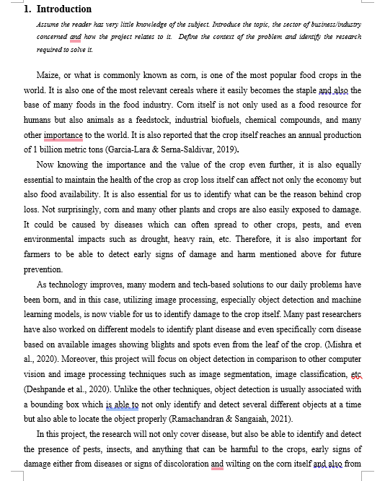

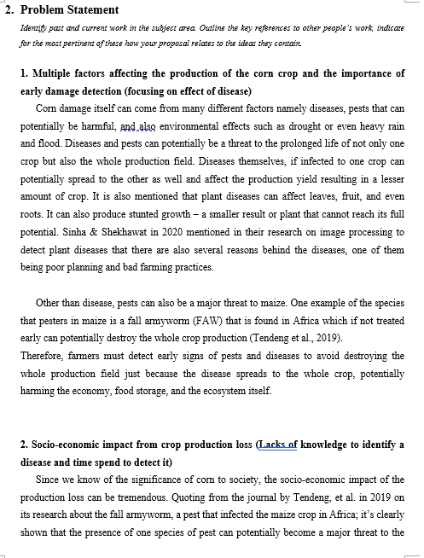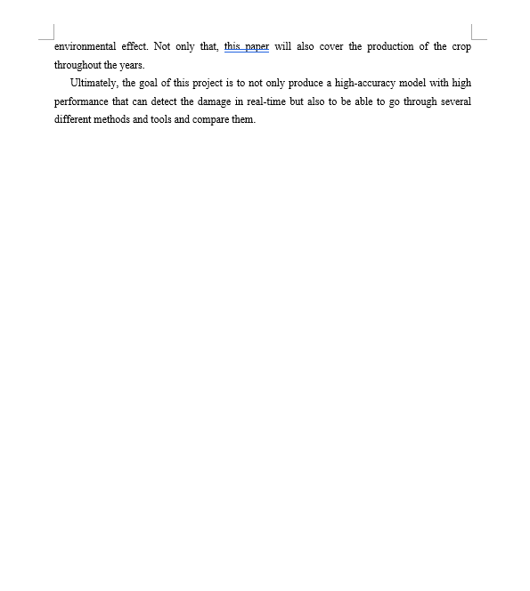



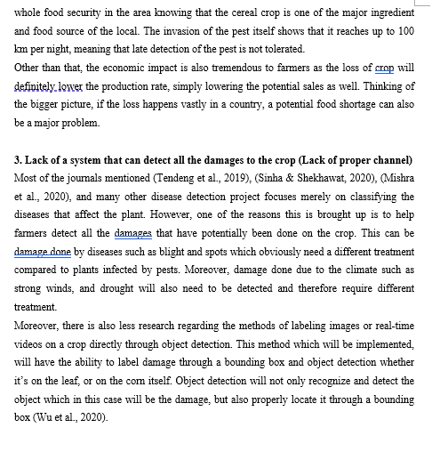



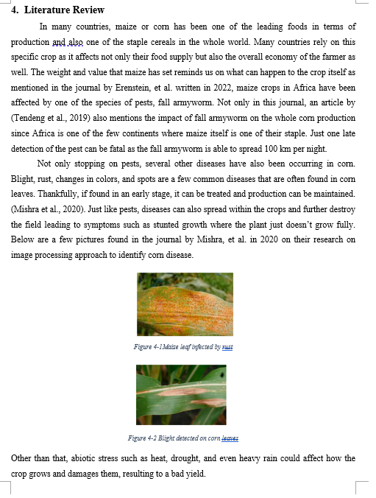

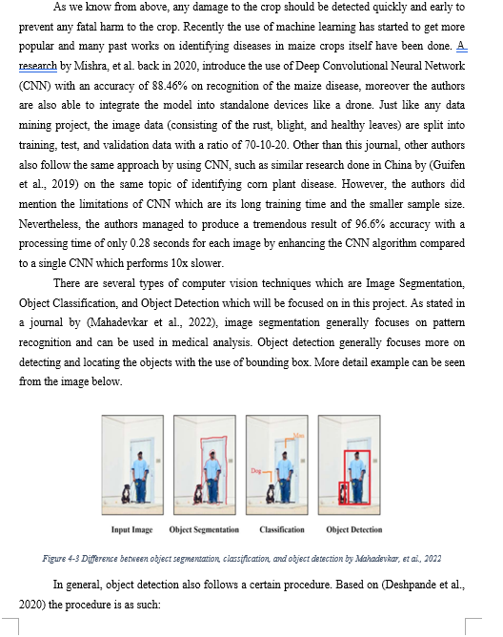

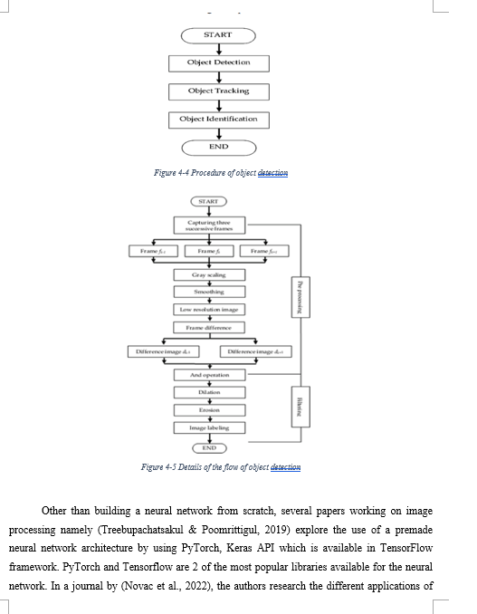

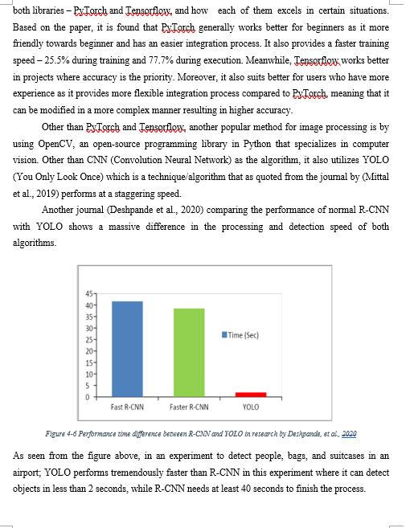

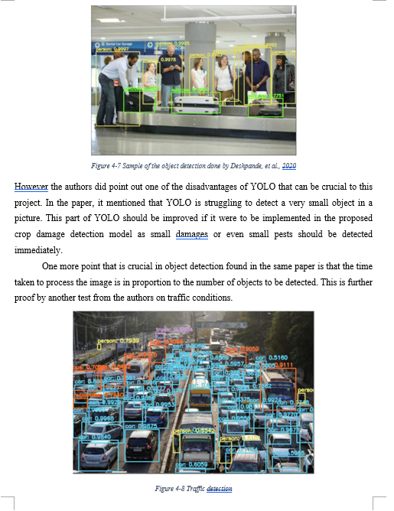

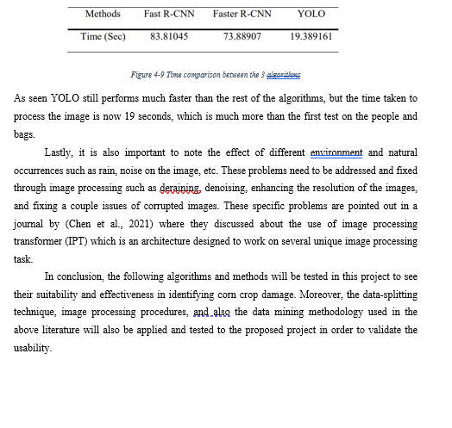

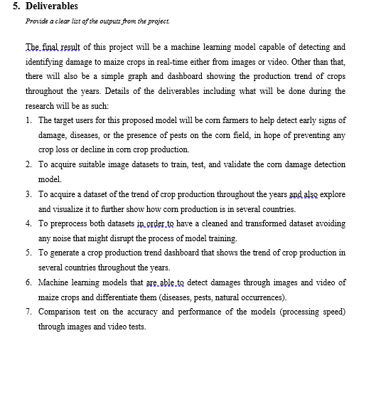

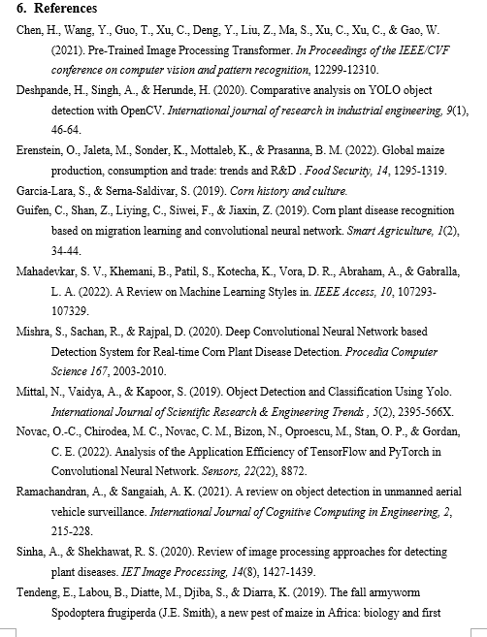

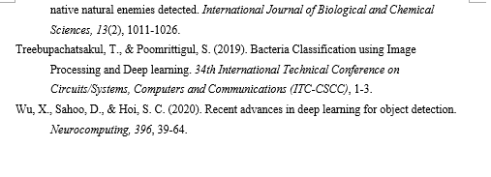

## Appendix C: Log Sheets



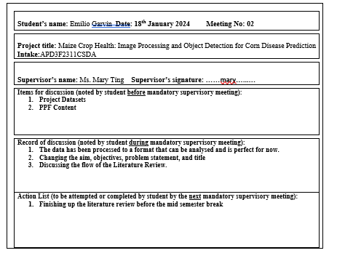

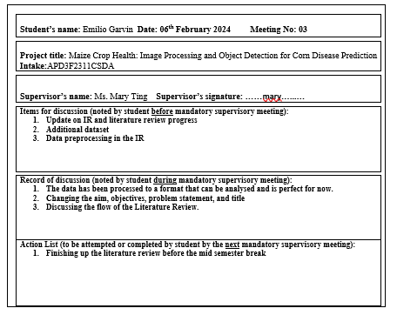

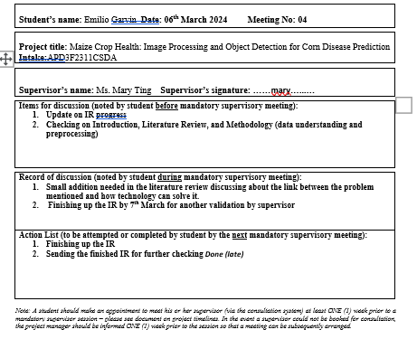

## Appendix B: Fast Track Ethics Form











## Appendix D: Gantt Chart





Figure 6.4‑1 Gantt Chart for Investigation Report Plan